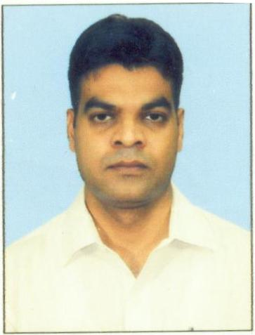
Curriculum Vitae

Badiuzzaman Khan

Mobile Number: +91-8507239525/7903957588 Email Id: kbadiuzzaman5@gmail.com

Career Objective

To work in a challenging atmosphere by exhibiting my skills with utmost sincerity and dedicated smart work for the growth of your esteemed organization along with mine.

Professional Experience
Three years of experience in Remote Sensing and Geographical Information System.

Areas of Expertise

- Experience in using the ESRI ArcGIS, Erdas Imagine ,ENVI,SNAP & Google Earth.
- Satellite data downloading, Geo-referencing, Geo-rectification and Mosaicing for its further satellite image interpretation using digital processing softwares.

- Able to calculate NDVI, NDWI, NDBI.

- Classification of Crops using Optical and SAR data.

- Preparing Land Use/Land Cover Map.
- Designing and generating spatial variability map using Geostatistical Analyst tools.

- Knowledge of image processing end to end process of RS & GIS.

- Experience in Geo-referencing, Digitization and Cartography.
- Ability to handle and delivery the high end projects on time.

- GIS layer maintenance, update and maintain mapping layers; verify digitized data for accuracy.

- Interpret detailed plans, photographs, and maps to update GIS layers, GIS data, and map products.

- Create and edit features and the associated attributes.

- Provide quality control by ensuring data is filled in the proper location.

Work Experience- Training and Projects

- Worked as a Junior Research Fellow in Agro Ecosystem and Crop Modelling Division in Punjab Remote Sensing Centre, Ludhiana, Punjab. (3rd October 2017 to 31st July 2019).

- Worked as a Junior Research Fellow in Department of Remote Sensing , Birla Institute of Technology, Mesra,Ranchi,Jharkhand on NRSC,ISRO sponsored project "National Wasteland Change Analysis".(6th September,2016 to 31st August 2017).

- One month Internship from Indian Institute of Remote Sensing (IIRS), ISRO, Dehradun, on the topic “Understanding Statistical Image Texture.”(8th Jun to 15th July,2015).

- 1 Year M.Tech Thesis on "Identification of Desakota Region and Urban Growth Potential Areas in Patna City, India Using Satellite Remote Sensing Data" (July-2015 to May-2016).

- 6 Months P.G Diploma in Remote Sensing & GIS Project on "Urban Sprawl Analysis of Gaya City Between 1989 to 2014 Using Remote Sensing and GIS Techniques" (January-2014 to May-2014).

Technical Training

- Off campus outreach certificate program on “Remote Sensing, Geographical Information System & Global Navigation Satellite System”, conducted by ‘India Institute of Remote Sensing’, Indian Space Research Organization (ISRO), Department of Space, Government of India during the period of 4th August, 2014 to 14th November, 2014.

- Off campus outreach certificate program on “Applications of Remote Sensing & GIS for Natural Resources”, conducted by ‘IIRS’, Indian Space Research Organization (ISRO), Department of Space, Government of India during the period of 27th January, 2015 to 27th March, 2015.

- 16th IIRS Outreach Program on "Geospatial Technologies for Urban Planning", conducted by ‘India Institute of Remote Sensing’, Indian Space Research Organization (ISRO), Department of Space, Government of India (Duration: February 11th March 15th, 2016)

- One day workshop on "Open Source Remote Sensing & GIS" at the National Seminar on Remote Sensing & Environment organized by the School of Oceanographic Studies, Jadavpur University in Collaboration with the Council and Department of Science & Technology, Government of West Bengal, on 19th March, 2014.

Educational Qualification

Degree/Certificate | Institute | Board / University | Year of | %Marks | Division
 |  |  | Passing
M.Tech | Birla Institute of | Birla Institute of Technology, | 2016 | 83.50% | 1st Div
(Remote Sensing) | Technology, Mesra, | Mesra,Ranchi,Jharkhand
 | Ranchi
P.G Diploma in Remote | School of Oceanographic | Jadavpur University, Kolkata | 2014 | 76.00% | 1st Div
Sensing and GIS | Studies.Jadavpur | (W.B)
 | University, Kolkata
M.A  (Geography) | P.G Deptt.Magadh | Magadh University Bodh-Gaya | 2012 | 67.44% | 1st Div
 | University, Bodh- Gaya | (Bihar)
B.A  (GeographyHons.) | Gaya College, Gaya | Magadh University Bodh-Gaya | 2008 | 66.88% | 1st Div
 |  | (Bihar)
10+2 | S.P.Y College, Gaya | B.I.E.C,Patna (Bihar) | 2001 | 72.88% | 1st Div
10th | Samta High School, | B.S.E.B,Patna (Bihar) | 1999 | 64.00% | 1st Div
 | Kranti Nagar,Guraru,
 | Gaya
Language Known English, Hindi &Urdu
Personal Details
Date of Birth |  | 25-Feb-1985
Father’s Name |  | Md.Shakir Khan
Marital status |  | Single
Permanent Address |  | Road No:08, Mohalla: New Karim Ganj ,Dist: Gaya(Bihar),India,Pin:823001
Passport No. |  | P 1686447
Place of Issue |  | Patna
Date of Issue |  | 17-10-2016
Date of Expiry |  | 16-10-2026
Name BADIUZZAMAN KHAN

Declaration

I do here by solemnly affirm that all the above information furnished by me is true to the best of my knowledge and conviction.
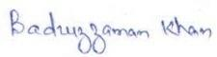

Date: 16-09-2019
Place: Ludhiana Badiuzzaman Khan

