RESUME
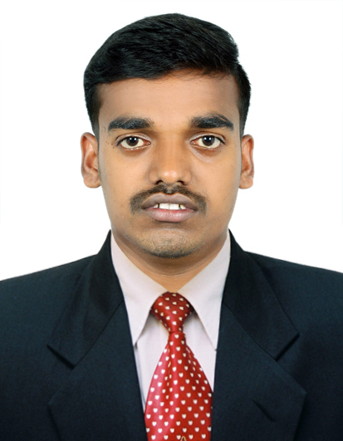
M.PANDIAN
S/O K.MURUGAN,
RAMAN CHETTI PATTI,
KONAPATTI (PO),
SANARPATTI (VIA),
DINDIGUL-624304
Email: pandianremotesensing@gmail.com
Mobile : +91-7356828684,+91-7907086676

OBJECTIVE

My objective is to join in a progressive organization where I shall improve my professional skill for the benefit of the organization and my career as a GIS specialist. I am interested to work in a challenging and learning atmosphere, where I shall get an opportunity to deliver the best out of me.

ACADEMIC DETAILS

Course | Institution | Percentage | Year of passing
M.Sc  ERS & GIT | Madurai Kamaraj University, Madurai. | 79.5 | May 2014
B.Sc  Physics | N.P.R Arts and Science college Natham, Dindigul. | 72 | Apr 2012
H.S.C | St.Antonys Hr Sec School  Kosavapatti,Dindigul | 61.75 | March 2009
SSLC | St.Antonys Hr Sec School Kosavapatti,Dindigul | 73.2 | March 2007

SOFTWARE PROFICIENCY

In the field of Geo Spatial Technology includes Remote Sensing, GIS, Digital Image Processing and GPS. I have freshest knowledge from my academic learning environment, however it will reflect as much as best, I could.
GIS software

- Arc GIS 10.1 and 10.3 (ArcMap and ArcCatalog),Q-GIS v2.8.1
Image Processing Software

  - ERDAS Imagine 9.2v.
3D Software

- Arc GIS 10.3(ArcScene)
- Microstation V8i
- Cloud CompareV2.8

AREA OF INTEREST

- Mapping and Analysis of the Geographical Data
- GPS Survey
- Working in 3D environment

STRENGTH

- Hardworking and motivating.
- Able to work under pressure.
- Expert in handling and quickly learn the GIS softwares.

SPECIAL TRAINING

- Attended Three month EDUSAT Training Programme on “Remote Sensing Geographical Information System and GNSS” conducted by IIRS, organized by Dept of Space, Govt of India, Dehra Dun.
- Attended Three month Training Programme on “GEOWEB SERVICES-TECHNOLOGY AND APPLICATIONS” conducted by IIRS, organized by Dept of Space, Govt of India, Dehra Dun.

PROJECT STUDIES

Project on “MAPPING THE SERVICE AREA OF POST OFFICE: using GeoInformatics”. To map the Post office service area and Land Use land cover study.Interpertation the Satellite image (LISS-IV). To map the POST BOX locations and Sub Post Office Locations using GPS Survey.

EXPERINCE

EDR CONTINOUS INFORMATION Pvt. Ltd. CHENNAI. (June-2014 to july-2015) Working GIS ORTHO.
NeST INFORMATION TECHNOLOGIES Pvt. Ltd, Cochin Kerala.
(Sep-2015 to still working)

Experience Summary
- ORTHO MEMBER - Geo-Rectify the low altitude ORTHO AERIAL PHOTOGRAPH using Arc GIS for the Multi Temporal studies –UNITEDSTATES DEPARTMENT OF AGRICULTURE.
- To digitize the 2D Road features like a Road center line, Sign boards, median, for implementing the Driver less TAXI, For United States of America.

- Associate.GIS ENGINEER- Fiber to the Home (FTTH) ,Using a LIDAR point cloud (3D) to capture the Electric Pole and features for checking the maximum pole weightage Capacity and to determine the Suitable place For Attach the Fiber Cable Using MICROSTATION and Open Source CLOUD COMPARE Software.

- 2D LAND BASE UPDATION form the Given Asseser Maps using ArcGIS V10.1

- The Project Name: MEW, Kuwait, The scope of this project involves in the data conversion of water network components into GIS with the reference of the input provided for whole Kuwait using ArcSDE technology. Input contains Open ware and PACI parcels data, Satellite Imagery, Scanned drawings, CAD drawings, Single line diagrams, Geodatabase template, Data conversion guidelines document,

- SEC-Saudi Electrical Company, the Scope of the project involves the conversion of Electrical network components into GIS with the reference of the input provided for whole Saudi Arabia From the Power Generation to Subsatation , Substation to Minipillar and Minipillar to the Service Area Connections.. Input contains Open ware and PACI parcels data, Satellite Imagery, Scanned drawings, CAD drawings, Single line diagrams, Geodatabase template.

ACHIEVEMENTS

- BEST PERFORMER Certificate in the entire GIS DATA TANIS Team in the period of November 2015 to January 2016 and January 2018 to March 2018 at NeST INFORMATION TECHNOLOGIES Pvt. Ltd, Cochin, and Kerala.

PERSONAL DETAILS
Name : M.Pandian

Father’s Name : Mr. K.Murugan

Date of Birth : 10-05-1992

Marital Status : Single

Nationality : Indian

Languages known : Tamil, English, Malayalam.

DECLARATION

I hereby assure that all the above given information is true to my knowledge and belief.

Date:
Place:

(M. PANDIAN)

