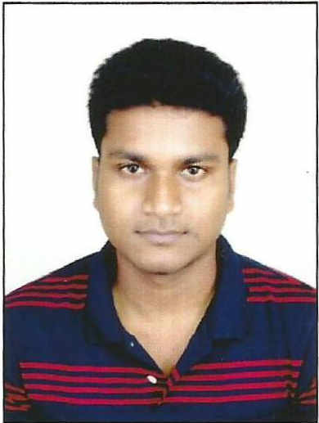
RESUME

PREMANANDA BERA
Garia, Panchpota
Giribala School Link Road, Nabagram
Near Garia Station
KOLKATA - 700 152
WEST BENGAL
INDIA
  : 9051578566 E-Mail : preams143@gmail.com

Objective:
To work in a company where I can utilize my knowledge, sharpen my skills and where I can have the responsibility to extend the boundaries for the benefit of both the company and myself.

Personal Details:
Born on : 04.04.1990

Father’s Name : Mr. Ganes Chandra Bera
Nationality : Indian
Religion : Hindu

Academic Qualification:

QUALIFICATION | BOARD/UNIV | YEAR OF  PASSING | % /GRADE | DIV
Secondary Exam. | W.B.B.S.E | 2006 | 78% | 1ST
H.S. Exam. (Arts) | W.B.C.H.S.E. | 2008 | 77% | 1ST
B.A (Geography) | C.U. | 2011 | 56.12% | 2ND

Professional Qualification:

QUALIFICATION | INSTITUTION | YEAR OF  PASSING | % /GRADE
Diploma in Office Management | Usha Computer Centre(Khanakul) | 2007 | “A”(Above 75%)
Post Graduate Diploma in Applied GIS and Remote Sensing | Jadavpur University | 2013 | 76%

Professional Experience:

NAME OF  ORGANISATION | DESIGNATION HELD | PERIOD OF SERVICE  FROM  TO | NATURE OF DUTY
PSP Financial Consultant Pvt. Ltd. | GIS Associate | 17-04-13  10-08-13 | GIS Based Property Tax Mapping(Worked As Contractual Basis)
Sreemudranalaya Technology Pvt. Ltd. | GIS Personnel | 05-03-14  15/11/14 | Map Digitization & Making Landuse map for RAY Project  Digitization and updation of cadastral map
Engineering Consultancy Services | GIS Personnel | 01-01-15  30-04-17 | Preparation of topographical map of Digha & Kankarbagh(Bihar)  Team handle.
VAS TECHNOLOGIES. | Junior GIS Data Analyst | 02-05-17  15-09-17 | Working for CYIENT LTD. At GSI building Kolkata.Preparation of Geological Map  And Georeferencing.(recruited as contractual basis)
GEOWISE TECHNOLOGIES PVT.LTD. | FREELANCING | 16-09-17  14-11-17 | PERCEL DRAWING
TECH SPATIAL SERVICE | FREELANCING | 01-11-17  30-06-18 | ELECTRICAL NETWORK MAPPING OF UTTAR PRADESH.
GANESH PANCHARTNAM INDIA LTD. | GIS ANALYST | 29-06-18  TILL DATE | MAKING LOCATION MAP AND PLANNING BASED ON MOUZA MAP.

Software Skill :

- Mapinfo 8.5 and 10.5
- ERDAS Imagine 9.2
- Auto Cad Map 3D, Auto Cad 2010 & upper
- ArcGIS 9.2 and 10.0
- Geomatica 10.1
- Oracle 11g
- Microsoft Office
- Plex earth
- Global Mapper

I do hereby declare that the statements made by me in the above are true to the best of my knowledge and belief.

Place: KOLKATA
Date: 19/01/19
(PREMANANDA BERA)

