CURRICULUM VITAE

Objective

To achieve a successful position in the field of Remote Sensing & GIS and work in a upgrading and competitive world which will help me to explore myself fully and realize my potential.

Personal Information

Mr. RAJKUMAR HAZARI Address
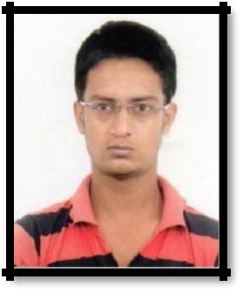

C/O- Mr. ADITYA HAZARI Vill: Demushnya

Date of Birth: 1 ^{st} Day of April, 1993 P.O: Satpatta

P.S: Raipur

Marital status: Unmarried Dist: Bankura

Religion: Hindu State: West Bengal

Nationality: India Pin:722134

Mob- 7602573628

Email ID- rajkumarhazari047@gmail.com

Academics Information

M.Sc. in Remote Sensing & Geographical Information System

- Year of passing- 2017

- University: - Vidyasagar University, West Bengal, India

Merit List: - 1 ^{st}Class

Dissertation Topics- “Spatio-temporal pattern of Agricultural Drought in Western part of West Bengal ; A study based on long term SPOT-VGT data set” in 4th Semester.
Special Paper – Coastal Management & Earth Science in 3rd Semester.

B.A. in Geography(Honors)

- Year of passing- 2015

- University: - Vidyasagar University, West Bengal, India

Merit List: - 2 ^{nd} Class.

Higher Secondary (W.B.C.H.S.E.)

School (Board) : - (W.B.C.H.S.E.) West Bengal India (2011)
Merit List:- Grade A

Secondary (W.B.B.S.E.)
School (Board) :- (W.B.B.S.E.), West Bengal, India (2009)
Merit List:-Grade A

Software Skills

- ArcGIS

- PCI Geometica

- Map Info

- ERDAS Imagine

- ENVI

- QGIS

- Auto Cad Map

Instrumental Skills

- Global Positioning System(GPS) and also Total Station.

- Field Instrument (Dumpy Level, Theodolite, Prismatic Compass)

- Hygrometer, Barometer

Other Skills

- Good Analytical & Quantitative Skills.

- Hardworking and Good team player.

- Commitment towards goal.

- Ability to learn.

Area of Interest

Map production, Geospatial data Development Management & Processing, Spatial analysis, Site selection & Planning, Short rout analysis, LULC Classification & Management, Image processing, Monitoring, Impact & Management of any Environmental problem, Advance Remote Sensing.
Working Experience

- Worked as junior GIS data Analyst at CYIENT limited at GSI, Jaipur, Rajasthan.

- Now I am working as GIS EXECUTIVE at Genesys international,Jaipur

Your’s faithfully
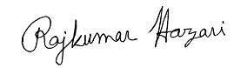

(Rajkumar Hazari)

Thank You

