RESUME  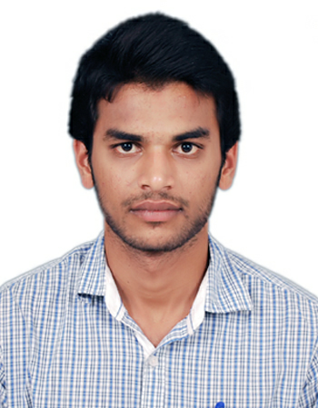  SESHADRI. B  Contact No:  ☎  +919994744665  9488853486  E-Mail:  Sheshu.vs@gmail.com  Address:  No. 2/741,  kooganur ( vil)Uddanapalli(post),  Hosur-635109,  Krishnagiri -(dist),  Tamilnadu.  Personal Profile:  Father’s Name : M.Buttappa  Date of Birth : 5th May,1992  Age : 25  Gender : male  Nationality : Indian  Marital Status : Single  Linguistic abilities:  - English-R,W,S  - Kannada-S  - Tamil-R,W,S  - Telugu-S  (R-Read, W-Write, S-Speak)  My strengths:  - Planning and Organizing.  - Willingness to learn.  - Easily friend with others.  - Want to be unique in all.  - Adaptable  .  GAMES:  - Volley ball(player),  - cricket(captain),  - chess.  HOBBIES:  - Playing  - Listening music’s  - Reading story’s  Y | Career Objective:  Seeking for an innovative career, where I could prove my abilities and work for the upliftment of the organization, I work for.  Academic Profile  ME. STRUCTURAL ENGINEERING  2016 Sapthagiri college of engineering  Dharmapuri.  BE CIVIL ENGINEERING  2014 Adhiyamaan College Of Engineering  Hosur.  Percentage Secured: 76%  DCE DIPLOMA IN CIVIL ENGINEERING  2011 Adhiyamaan polytechnic College  Hosur .  Percentage Secured : 80%  HSC R.V boys Higher Sec School,  2009 Hosur.  Percentage Secured: 53%  SSLC  2007 Government High School,uddanapalli,  Hosur.  Percentage Secured : 55%  Software Known :  - AUTO CAD  - ARC GIS  - MICRO STATION  - E SURVEY  - MS OFFICE  - SPATIAL NET  - PRIMAVERA  Area of Interest:  - STRUCTURAL ENGINEERING  - HIGHWAY ENGINEERING  Experience:  I were worked at PIXEL SOFTECH PVT LTD, As a Assistant Engineer since Aug 2014 to July 2017 .I performed well in cad drafting,BOQ and Mapping.  Currently working in SOMA Enterprises PVT LTD as a senior design engineer since Aug 2017  · Total Exp:4.0years  · Current CTC (Basic + Gross + other benefits):380000  · Expected CTC : (Basic + Gross) 450000  · Notice Period :minimum 15 days  Achievements:  - A project done as per TN BOARD curriculum under the title of  Main project: PLANNING AND DESIGNING OF A LODGING & RESTAURENT.  - Analysis of plastic shuttering panel formwork coupled with runners.  - DPR of canals and roads under KRRDA,CNNL,PWD in Karnataka  - Mapping of IITM campus chennai using FME integration with AutoCAD  Declaration:  I hereby declared that all the statements made in the above application are true and correct to the best of my knowledge and belief.  Date:  Place:  (SESHADRI.B)

