RESUME

NAME:  RAJNATH MISHRA  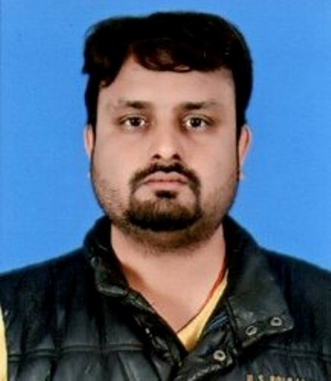  Email:  monurajnath@gmail.com  Phone no:  Mob: +91-9451507348  +91-9599609259  Address:  PANCHSHEEL  CROSSING REPUBLIC  GHAZIABAD  110096  Personal Strengths:  Self Motivated  Positive Attitude  Enjoy working in Team  Keen to learn new things  Good Speaker & Listener.  Hobbies:  Playing cricket, , Listening to Music & Watching movies.  Personal Data:  Father’s Name : Rajmani Mishra  Date of Birth : 08 July 1989  Sex : Male  Nationality : Indian  Marital Status : Single  Proficiency : English, Hindi | CAREER OBJECTIVE  To secure a challenging position where I can effectively contribute my skills as software professional.  ACADEMIC QUALIFICATIONS  COMPUTER SKILLS  - Programming Languages: C, C#.JAVA  - Web Technology: Asp.Net 4.0, HTML, JavaScript, JQuery.  - Operating System: Windows XP, 7, 8.  - Packages: Microsoft Office and (Good Knowledge of Excel).  - Frontend :Microsoft Visual Studio 2010  - Backend: SQL SERVER 2008 r2  - Methodology: Agile, SDLC  EXPERIANCE  - One Year Experience Software developer(Rexnamo.pvt.ltd)  - Two Year Experience software developer(RMA ZEAL IT SOLUTION PVT.LTD}  - 1-Years Experience in Teaching  TRAINING  - Completed Six Month Training in ASP.NET language  - One Month Training in ITC, LB(EARS)  - Two month Training in Java at DAUCAT Ghaziabad  ACADEMIC PROJECTS  - Project : Hiretheexpert (Team Of 4 Member)  Language of Implementation : ASP.NET  Front Hand Tools: ASP.Net 4.0 with C#, Ajax, JQuery.  Data Base: SQL Server 2008 r2  My Role: participated in the project design and development phase.  Project Description :  HireTheExperts.com is a freelance website. Project contain two parts, Admin panel for manage the system and Website for real word users. There are three types of users in the website: Service Buyer, Service Provider and Admin. If anyone needs a service then he/she can post their need as a project. Same way if you are a service provider you can bid at the project.  DECLARATION  I hereby declare that the above-mentioned information is correct up to my knowledge and I bear the responsibility for the correctness of the above-mentioned particulars.  Place: Ghaziabad  Date: ( NAME )  RAJNATH MISHRA
  Standard | University | Percentage (%)
  M.Tech(CSE) | UPTU | 70
  B.Tech(CSE) | UPTU | 67
  12th | UP BOARD | 65
  10th | UP BOARD | 61

