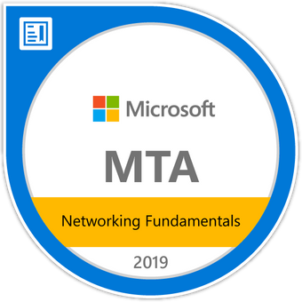

RASHED AHMED KHAN
E-mail Id: Homehappy08@gmail.com
Contact No: +91 9030183963

Career Objective

Seeking an opportunity for professional growth and increasing responsibility as Networking professional in an organization where team spirit and personal skill is recognized and rewarded.

Educational Qualifications
B. Tech | Brilliant Institute of Engineering and Technology- JNTUH | 57.02%
Intermediate | Board of Intermediate Education | 79.03%
SSC | Board of Secondary Education | 62.05%

Technical Skills

Operating System supporting skills
- Installation of application Windows, Linux
- Managing Local Users and Groups, Files and Folder, Desktop settings
- Working with Disk Management, Back Up and Restoring Data
- Basic Linux Commands
Networking Skills
- Connecting systems in Local Area Network
- Configuring IP Address and sharing the devices in the Network
- Configuring Cisco Routers and Switches
- Configuration of Routing Protocols: STATIC, RIP, RIP2, EIGRP, OSPF

Strength
- Good Communication
- Time management
- Good communication
- Teamwork skills
- Problem-solving

Certifications
MTA: Networking Fundamentals - Certified 2019 Issued by Microsoft
Introduction to Cybersecurity by Cisco Networking Academy
Linux by Ni-msme

LinkedIn Profile

- :https://www.linkedin.com/in/rashedahmedkhan2005/

Personal Details

Name : RASHED AHMED KHAN
Fathers Name : LATE SATTAR AHMED KHAN
Date of Birth : 20-MAY-1996
Languages Known : English, Hindi
Nationality : Indian
Marital Status : Single

Declaration

I, hereby confirm that the information given above is true to the best of my knowledge

Place : HYDERABAD
Date : ( RASHED AHMED KHAN)

