Curriculum Vitae 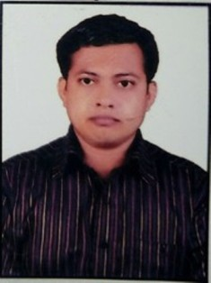

Name in Full : DEBASISH DEY
Mobile No. : +918473994078, 7670060465
Email : debasish.dey227@gmail.com

OBJECTIVE:
- Being a IT Trainer, I always want to give my best and that also helps me utilize my present skill and gives me opportunity to learn new things too. I always want to keep positive attitude towards organizations.
- Seeking Innovative and challenging career where I can implement my skills and increase my knowledge. It should be a challenging and a promising career it should also provide me with growth prospects.

Academic Education:-

NAME OF EXAM | BOARD | YEAR OF PASSING | PERCENTAGE
SECONDARY EXAMINATION | S.E.B.A | 2005 | 45%
HIGHER SECONDARY EXAMINATION | A.H.S.E.C | 2008 | 42.06%

Professional Education-

BSc(IT) | KUVEMPU UNIVERSITY | 2012 | 58 %

MCA | SHRIDHAR UNIVERSITY | 2014 | 60.3%

COMPUTER SKILLS:
Installing Operating System- Windows 7,8,10, M.S Office, Windows Server 2003.
Assembling and Disassembling Computer Hardware.
*6 month diploma course from NIIT for A++.

PROJECTS AND TRAININGS:
>ISAS PRESENTATION ON ASP.NET (BATCH CODE: B080185).
> SOFTWARE DEVELOPMENT ON CALL CENTER MANAGEMENT.
> ISAS PRESENTATION ON BLUETOOTH TECHNOLOGY.

SOFTWARE DEVELOPMENT:-

* JAVA * HTML
* C * C#
* UNIX & SHELL PROGRAMMING * WEB PROGRAMMING
* ALGORITHS * BASIC OF.NET
* XML * E- COMMERCE
* COMPUTERS NETWORK * D.B.M.S
* COMPUTER ETHICS * SQL
* VISUAL BASIC * A+

EXPERIENCE: Worked as a Computer Teacher at V.K.V. and also have an office work experience from
(2/04/2013 to 15/03/2016).

CERTIFICATE: (1) I have got CCE Certificate as I have finished training on CBSE GUIDELINE SYSTEM.
(2) One year diploma course from Frankfinn Institute of Airhostess Training.
(3) N.O.S certificate from PVM Lumding as Class in Charge.

Objective Under Skill India: Working under Skill India is such an opportunity that has given me a flat form to

involve my Skill as IT Technician. I involve myself in CCTV Installation, CCTV
Backup, LAN maintenance, Mobilization, Administration work, OJT work,
Placement and Many more according to SOP. Under DDU-GKY Project.

EXPERIENCE: (1) Worked as a IT Trainer under DDU-GKY PROJECT from (4/01/2017 to 30/11/2017)
And working knowledge as a Center Manager, under NIIT YUVA JYOTI LTD.

(2) Working as a DDEO Trainer under DDU-GKY PROJECT from (5/12/2017 till to
date) under Empower Pragati.

CERTIFICATE: (1) Waiting for certificate from NESSCOM for being trained under SSC (IT &ITES)
INDIA.
(2) SOP Certificate as a Operations (Professional Level) Under DDU-GKY Project from
NIIT YUVA JYOTI LTD.

(3) TOT Certificate Of Trainer on IT by Master Trainer, Under NIIT YUVA JYOTI LTD.

(4) TOT Certificate Under Reading Wise International on IT, by Head, Employability and Skill
Training.

ACTIVITIES: Surfing Net, Driving, Playing Cricket & Traveling.

STRENGTHS:
*Smart and a positive approach towards problems.
*Hardworking and Quick Learner.
*Friendly with People.
*Loyal to my work and a good social person.

REFERE2NCE:
Mr. Arindam Borthakur
(Training Co-ordinator) Under Kuvempu University.
E-mail- arinjune_2005@redifmail.com.
.

PERSONAL PROFILE:-
Father Name : Mr.KISHORE RANJAN DEY
Mother Name : Mrs. TRIPTI DEY
Date of Birth : 22/09/1987
Sex : Male
Languages Known : English, Hindi, Assamese, Bengali and Punjabi.
Marital Status : Married.

PERMANENT ADDRESS :-
C/o:- Mr. KISHORE RANJAN DEY
JHULANPOOL ROAD, SHIV PATH,
P.S, P.O. LUMDING, Pin Code: 782447
Dist:-NAGOAN, State:- ASSAM

Declaration:-

I, hereby, declare that I meet the qualification & experience criteria specified for this post and the entries made by me in the loop Curriculum Vitae are complete and true to the best of my knowledge and based on records

Date: 02/01/2019
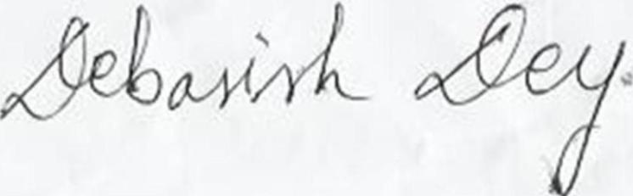
Place: Guwahati Signature

