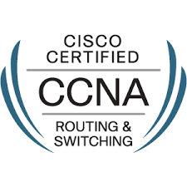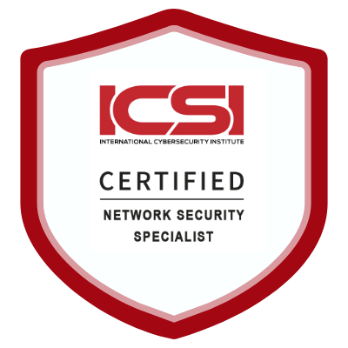
CISCO 13265921 C.N:18762882 C.N:1447-17817480 C.N: RL156229

AJAY KUMAR SAINI H. No-14, Sector 39
Jharsha Road Gurgaon Haryana,
Contact No.: +91-9821317018
E-Mail: aksainijniteic@gmail.com

CAREER OBJECTIVE

Looking for a challenging career in competitive environment which demands the best of me
Professional ability in terms of technical and analytical skills and helps me in broadening and enhance my current skill and knowledge.

SUMMARY

- More than 4 years of overall experience in IT Industry as a Network Engineer.
- Currently working in Team computers Pvt. Ltd. as Network & Security engineer at NOC
- Performing Remote support (overseas and domestic) for problems related to WAN & LAN from NOC
- Troubleshooting & configuration of Cisco Routers & Switches, Firewall (ASA 5508-x)
- Hands Experience & Knowledge in OSPF, BGP, Basic MPLS & IPSEC Site-to-site VPN, ACL, STP, RSTP, VLAN, NAT, HSRP, Access Point, Wi-Fi controller, Meraki SDWAN, DHCP & DNS server
- Experience in Singtel VPN and Zscaler Proxy Network

PROFESSIONAL EXPERIENCE

Company : Team computers Pvt. Ltd. [Client – DB Schenker India ]
Position : Network & Security Engineer
Duration : Sep-2019 to Now.

Job Responsibilities:

- Managed daily operations of a 100+ Branches, multi-network, multi-vendor client base.
- Provided SLO level support on 24/7 and work on shifts.
- Install wide range of network equipment & keep network infrastructure up-to-date and secured.
- Implementation of required change in network devices by following change management process. Implement change on ASA firewall.
- IP address planning and implementation
- Configuring Firewall rules and Provide access to the users as per the user requirement.
- ASA security Appliance (5500 series), Initializing Basic setup, failover, Device Management, Static route Tracking, Nat on ASA .
- As a member of NMS coordinating with ISP and remotely support to FMS engineer
- Configuration and Maintenance of Cisco Routers & switches.
- Troubleshooting the occurring issues in WAN, LAN & Internet connectivity.
- Monitoring & Troubleshooting Alerts generated by monitoring tools Solar Winds.
- Service Delivery understanding and remote support exposure, Router Management and configuration knowledge/ experience.
- Installing and configuring of the networking devices (Cisco Router, switches) Implementing Static & Dynamic routing (OSPF,BGP), Implementation of Redundancy protocols on L3 Switches/Router (HSRP).
- Installing and Configuring the VLAN, Managing VLANs and Implementation of Inter VLAN Routing. 10/100/1000 Mbps Network hubs/switches maintenance and deployment. ACL, Interface Changes, Port-Security and Mac binding on network devices.

Project : Oriental bank of commerce (Head Office Gurgaon, Haryana)
Company : Dimension Data India Pvt. Ltd. (NTT Group)
Position : Network Engineer at NOC
Duration : Sep- 2017 -Sep-2019

Job Responsibilities:

- Troubleshooting the occurring issues in WAN, LAN & Internet connectivity.
- Monitoring & Troubleshooting Alerts generated by monitoring tools PRTG and ITSM.
- Installing and configuring of the networking devices (Cisco Router, switches)
- Implementing Static & Dynamic routing (BGP, OSPF), Implementation of Redundancy protocols on L3 Switches/Router (HSRP).
- Take backup configuration of all core links using Hyper terminal & Putty.
- Monitoring the network by using whatsup Gold tools.
- Link & device inventory management.
- Configuring IP Schema for new Lease Lines
- Responsible for providing 24 hours connectivity on OBC core Network

Project : Oriental Bank of commerce
Company : IMSI India Pvt. Ltd. (An IBM servicer partner)
Position : Network Engineer
Duration : Oct-2016 to Sep-2017

Job Responsibilities:

- Worked as Network engineer perform primary label troubleshooting sitting in NOC.
- Primary troubleshooting with the help of NMS tools and customer and provide solution within committed SLA.
- NMS Tool: WhatsUp Gold, Putty, Hyper terminal, PRTG
- As a member of NMS coordinating with ISP and remotely support to FMS engineer
- Perform MPLS migration
- Configuration and Maintenance of Cisco Routers & switches.
- Installation of Cisco routers, Switches, Modem, NTU, PC
- Take backup configuration of all core links using Hyper terminal & Putty.
- Monitoring the network by using whatsup Gold tools.
- Link & device inventory management.
- Configuring IP Schema for new Lease Lines
- Responsible for providing 24 hours connectivity on OBC core Network.

FUNCTIONAL EXPERTISE

TRANSMISSION TECHNOLOGY: -
Media like OFC , Lease line and MPLS, PRI.
Routers: -
Work on Cisco Router Series 800, 1700, 1800, 1900, 2600, 4200, 4300, 3800, 3900,7600, ASR-1000 series, HP Router-MSR 2000, Huawei AR151
Switches: -
Work on Cisco switches SG-300, SG-350, SG-500,2900,3500 ,3700,3850 -Catalyst Switches.
AP Model: – Aruba, Cisco Meraki AP MR-54, MR74
Cisco Wi-Fi Controller: - 2500 Series

Cisco Firewall: - ASA 5506-x ,5508-x

Cisco firepower -1000

Monitoring Tools: - What up Gold, PRTG , Solar Winds

Ticketing Tool: - ITSM

Knowledge About: - Routing & Switching

- OSI & TCP/IP reference model
- Routers, its components and its function
- Routing Configuration static and dynamic using the protocol OSPF, BGP
- Password Recovery on a Cisco Router and Switch
- IOS upgradation on Roman and user mode
- Configuring Cisco router & switches
- HSRP.
- Basic MPLS & VPN
- IPSEC VPN configuration (Site-to-site)
- Ethernet Technologies and Cabling
- IP addressing & Subnetting
- STP, RSTP and VLAN
- Access lists (Standard & extended)
- NAT (Static & Dynamic)
- Basic Linux

ACADEMIC CREDENTIALS

- B. Tech in EIC from JNIT College under RTU, Jaipur in 2012 with 65%.
- 12th from Government Senior Secondary School under Rajasthan Ajmer Board in 2008 with 67%.
- 10th from Government Senior Secondary School under Rajasthan Ajmer Board in 2006 with 55%

PERSONAL DETAILS

Father’s Name : Mr. Babu Lal Saini
D.O.B : 11th Aug. 1988
Gender : Male
Marital Status : Married
Language knows : English & Hindi
Permanent Address : Ward no 19 Khetri Tehsil, Jhunjhunu District
Rajasthan Pin code - 333503
Passport No : K6633231, Valid: 2-12-2022

Declaration

I hereby declare that above-mentioned information is true to best of my knowledge.

Place- Gurgaon Signature
Ajay Kumar Saini

