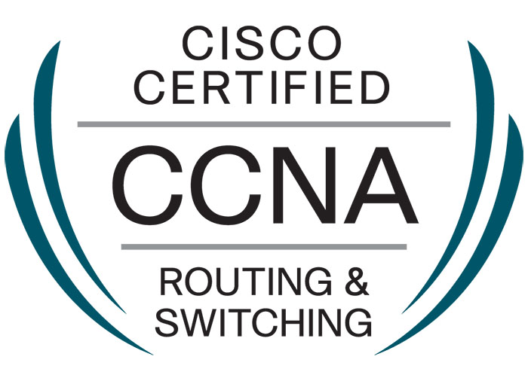
DINESH KUMAR
Mobile: +91-9971782561 | E-mail:dinesh.kumarmcse@gmail.com
Objective

A technology adaptable and innovation oriented Network Engineer, Customer Support engineer, seeking a challenging career where knowledge and solution-oriented skills may significantly contribute to the organization’s development and progress with more than 6 years of experience of Networks & Systems.

TECHNICAL SKILL

- Routing Protocols : RIP, EIGRP, OSPF, BGP
- Switching: STP, PVST, RSTP, MST, CST, VLAN, VTP, Ether channel
- Network Security: ACL, Port Security, Firewalls,
- NAT: Static NAT, Dynamic NAT and PAT.
- Sound knowledge of GRE, DMVPN, MPLS, VPN4, F5 Load Balancer.
- Good Hands on Knowledge on Real Time Routers and Switches.
- IP Service NAT, PAT, CEF, PBR, HSRP, VRRP, GLBP, VSS.
- Knowledge of MPLS & point to Point circuit connectivity
- Good knowledge of Monitoring tool like free ping, PRTG Network monitor etc.
- Well Versed with LAN & WAN Implementation.
- Cisco Router Series ISR 4400, 3700, 3600, 2600
- Cisco Switches Catalyst 6509, 4506, 4503, 3550, 3560, 3570, 2960, 2950, 2940
- Firewalls Cisco ASA 5540, Fortinet, Checkpoint , Sonicwall

Work Experience:
Currently I have been working as Network/IT Engineer with G. D GOENKA PUBLIC SCHOOL ROHINI since May, 2013 to till date.
Work functionality of current organization:
- Manage Fortigate firewall/security systems by establishing and enforcing policies; defining and monitoring access
- Provide network support for troubleshooting and resolving network related incidents.
- Local & Wide Area Network and Network Security Support
- Ensure network connectivity of all servers, workstations, VPN connectivity and other network appliances.
- Check configuration parts of routers & switches to Manage practical laboratory
- Manage wireless routers i.e TP-Link, NETGEAR to insure Wi-Fi connectivity for mobile and laptop users.
- Manages the load configuration of a central data communication processor and makes recommendations for purchase or upgrade of data networks
- Coordinate with ISPs (BHARTI AIRTEL & TATA) for WAN Link issues.

System Support
- Manage and support for FTP, DNS, DHCP and Smart classes Server.
- Senior Tech. Support for Servers, Desktops, Laptops & Peripherals in Accordance with the operational requirements.
- Updating the windows, software’s and Antivirus to protect the virus attack time to time.
- Managing & Maintenance of Attendance Management Software and Biometric devices.
Previous organization summary
- Worked as System admin with Targus Technologies Pvt. Ltd. working site is Li & Fung (INDIA) PVT.LTD. From Feb 2011 to April 2013.
- Worked as System Engineer with Wipro InfoTech (Site:-Usha International Pvt. Ltd. Gurgaon) on the payroll of RENOVISION Automations Pvt. Ltd. (from April 2009 to February 2011).

Job Responsibility:
Monitor and test network performance and provide network performance statistics and reports.
Install and configure storage devices
Support for windows base PCs, Laptops and their hardware and software issues. Include administration of windows server domains. Installation, configuration and troubleshooting of Local Printers & network Printers, client machines with Lotus Notes as mail client. Also responsible for antivirus updates, Server backup (mail, database and other data) using NTBackup. Managed TCP/IP addressing and Subnetting.
Installation, configuration, administration and support of DNS, DHCP, Active Directory.
Supporting clients remotely with the help of Remote support tools such as Net meeting, Remote Desktop Connection, Team Viewer etc.
Provide network and workstation support.

AREA OF KNOWLEDGE

- Cisco Routers * Cisco Switches * Network Management *Routing
- Switching * Monitoring * Client Support * Troubleshooting
- Team Handling * Maintenance

Professional Certification /Trainings

- CISCO CCNA Certification (CISCO ID - (CSCO13176850)
- Cisco Certified network Professional (CCNP) Training from Garud InfoTech Gurgaon.
- One Year Advance Hardware & Networking Diploma from IACM, New Delhi in 2008.

ACADMIC QUALIFICATION

- MSc.IT from Sikkim Manipal University in 2014.
- BSc.IT from Sikkim Manipal University (New Delhi).
- 12th (PCM) from Rishikulvidyapeeth inter college (U.P. Board) in 2007.
- 10th from Rishikulvidyapeeth inter college (U.P. Board) in 2005.

STRENGTHS
- Quick in adapting to any situation
- Team Work
- Customer Handling
- Leadership

PERSONAL DOSSIER
Name Dinesh Kumar
Fathers Name Sh. Mange Ram
Date of Birth 01/05/1989
Marital Status Married
Language Known Hindi & English
Address Flat No. 189, II Floor Pocket B3, Sector-6 Rohini, New Delhi
Phone +91-9971782561
E-mail dinesh.kumarmcse@gmail.com

DECLARATION:
I hereby declare that the details provided by me in this resume are correct to the best of my knowledge.

Signature – Dinesh Kumar
Place – Delhi.

