CURRICULUM VITAE
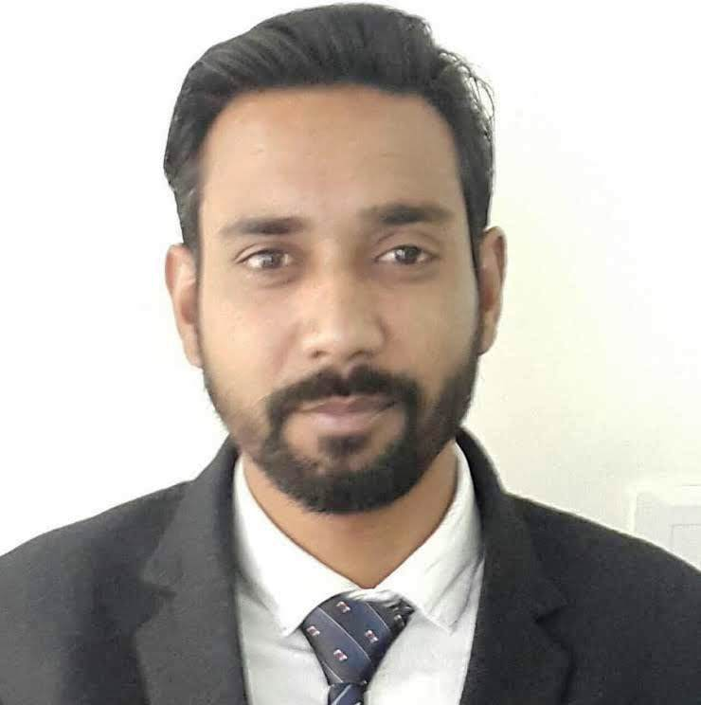

Ajay Sharma

E-mail:- kumarajaysharma16@gmail.com
Add: - Mohalla Preet Nagar, Near Jhanda Mal School,
Kapurthala,Punjab,India.
+91-9855002221

Career objective:-

To secure employment in an organization that allows me the opportunity to utilize my education and experience for individual and progressive professional growth.

Work Experience:-

- Presently working as a State Head with JITM Skills Pvt Ltd. in Kapurthala from Oct 2018 to present.

Job Profile:-
- Manage 6 centers operations in the state.
- Manage, coordinate and supervise overall training program, implemented in the state.
- Coordinate and communicate about the program to the government department officials, extension workers, State Universities, etc. and develop a resource team for the project
- Network with the local people and implement the training programs along with them
- Understand the course content, plan and conduct Training of Trainers who in turn delivers it to the students within a given time frame.
- Give feedback on the course content and other training materials to ensure that the information students receive remains relevant, accurate and up to date.
- Take feedback from trainer on content and assisting Content Development team in developing the course content.
- Ensuring that training/revenue targets for the center are met in a timely manner.
- Timely preparation and submission of the activity/ budgetary/performance reports.
- Participating in strategy planning with Project Coordinator and Project Manager for maximizing the reach of the program, increasing revenue for the center and creating new opportunities.
- Ensuring the trainers follow the course content prescribed by the Head Office.
- Working hand in hand with the Project Coordinator/Manager for 'Train the Trainer' program relevant for the staff training, conducting assessments and certifications for the trainees and placement of the trainees.
- Placement of the trainees and recruitment of the trainers and center staff.
- Single point of contact for overall management for specific center.
- Liasoning related to state Government Scheme.
- I worked as an Sales Manager with Nimble Educare in Jalandhar from Feb 2015 to Sep 2018.

- I worked as an Centre Manager with NIIT Yuva Jyoti Ltd. in Jalandhar from Jan 2014 to Jan 2015.

- I worked as an Centre Manager with GRAS Education and Training Services Pvt. Ltd. in Jalandhar from Sep. 2012 to Jan 2014.

- I worked as an BDM with HCL Info systems in Jalandhar from Sep. 2009 to Sep 2012.

- Experience in HR Dep. as well as project completion for fulfilled of MBA degrees in MAHAVIR YARN AND THREAD MILLS Company, HOSHIARPUR.

Career SNAPSHOTS:-

- Skilled in multitasking.
- Skilled in increasing the sales.
- Skilled in developing strategies that increase participation & business revenue.
- Skilled in team management, motivation & achieving results.
- Organizing promotional activities like campaigns, camps, promotions for enhancing market visibility & achieving better market reach.
- Executing retail sales plan by analyzing the market response/ requirements and communicating the same to the marketing teams for coming up new applications.

Professional PROFILE:-

- Excellent communication and collaboration skills.
- Proven effectiveness in coordinating and team work.
- Productive and responsible, willing to learn and handle any task.
- Excellent technical ability for performing precision work.
- Possess a high degree of professionalism and work well under pressure.

EDUCATIONAL QUALIFICATION :-

- MBA in Human Resource from St. Soldier Mgt. & Tech. Inst, Jalandhar, under PTU – 2009.
- B.A from N.J.S.A. College Kapurthala under G.N.D.U- 2007
- 12th from Govt.sen.sec school, Kapurthala under P.S.E.B - 2004

Projects UNDERTAKEN:-

- Work/Family Conflict and Family /Work Conflict.
- Absenteeism in Workers.

Technical Skills:-

- Marketing Management.
- Retail Marketing.

Computer Proficiency:-

- Sound knowledge of Microsoft Word, PowerPoint, Excel.
- Internet Surfing.

EXTRA CURRICULAR ACTIVITY :-

- Participated in youth festival during graduation in G.N.D.U. Campus.

Biographies:-

Father Name : Sh. Sham lal
Date of Birth : 16th July 1985.
Nationality : Indian.
Interest : Listening Music, Watching movies, Making Friends,
Expected Salary : Negotiable.

Declaration:-

I hereby declare that all the information mentioned above is true to best of my knowledge.

Place: - Kapurthala Ajay Sharma

DATE: -

