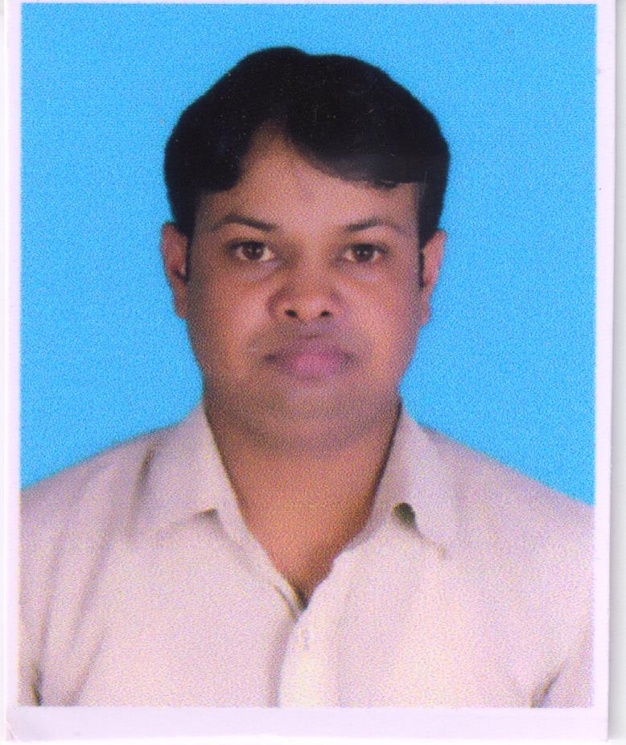
ASHOK KUMAR
Mob: - 9582122543,
Address: - R-Z-B-44
New Janki Puri Gali No-3
New Delhi:-110059
Email:ashok.dev101@yahoo.co.in

CAREER OBJECTIVE:

Excellent accounting skills, with experience in Tally 9 ERP, dealt with customers and high level workloads within strict deadlines. Now looking to start a new challenging position to meet my competencies, capabilities, skills, education and experience

NAME OF THE COMPANY | POSITION | DURATION
Mittal Enterprises | Accountant Asst. | Jun -2010 to 31-Oct-2011
Value Line Interiors Pvt. Ltd. | Accountant / Admin | 01st Nov-2011 To Till Date

PROFESSIONAL SUMMARY:

- Having over 9 years of Experience in the field of Accounts.

- Strong in ERP software (Web- Tell ) and in Accounting Packages

Accounts Experience:

- Expertise in Tally.ERP 9 for the all the modules such as Accounts Payable, Accounts Receivable, , General Ledger
- TDS Return, GST Return, and income tax return.
- Experienced in preparing monthly financials like Trial Balance, Profit & Loss a/c, Balance Sheet,
- Expertise in preparing of weekly Bank, Cash positions
- Expertise in Audit preparation of yearly financials in audit format and submitting to auditors for auditing
- Strong in interaction with Auditors for Finalization of Accounts
- Experienced in preparation of monthly Bank Reconciliation statement
- Expertise in reconciliation of receivable & payables with their respective statements
- Strong in adopt new analytical approaches, tools & environment.

Audit Experience:

- Vouching of Cash and Bank Books, Sale and Purchase Register, Debtors Ledger, Creditors Ledger, General Ledger so as to authenticate the figures appearing in the Books of Accounts of the client.

QUALIFICATIONS:

- B.Com from Shobhit Institute of Engineering & Technology Meerut.

- DIPLOMA in Computer Applications: Ms-Word, Excel and Presentation of Power Point.

- Accounts Receivables
- Accounts Payables
- General Ledger Accounting
- Bank Accounting
- Banking and Finance Accounting

- ACCOUNTING PAKAGES:

Worked in Windows Operating System, MS-Office and, Tally 9 ERP Web- Tel TDS

PERSONAL PROFILE:

Date of birth : 25th Jan, 1984
Nationality : Indian
Sex : Male
Marital Status : Married
Languages Known : English, Hindi,

******

