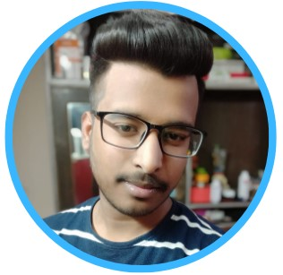 |  |  |  | BHAWUK  DARA  Recruitment Enthusiast
Profile  Disciplined and Enthusiastic associate, conversant with Software Development and Testing.  I am currently honing my skills as a Hiring Expert in Software and IT Domain.  I was commended on multiple occasions by the management and customers themselves for superb service and communication skills.  I am a proud recipient of  The Achieve of Target &  Star Performance of Quarter awards.  Contact  PHONE:  +91 844 704 8865  WEBSITE:  https://www.linkedin.com/in/bhawuk-dara-3213b1176/  EMAIL:  bhawukdara.ihrsindia@gmail.com  Hobbies  Love to Play & Watch Cricket  Writing Fictional Stories  Fusion Cooking  Hiking & Tracking |  |  | EDUCATION  B. Com (Sol)  Delhi University, New Delhi  2018 – To Date  Senior Secondary (12th )  Saraswati Bal Mandir, New Delhi  2017 - 2018  WORK EXPERIENCE  IHRS INDIA Pvt. Ltd as Recruitment Associate  14th May 2018 till Date  I am responsible for handling end to end IT recruitment for various of our clients. I am required to  - Get the requirement from the stakeholder & design hiring strategy  - Source & recruit candidates by using job portals, vendors, referrals  - Screen & categorize candidates resume & job applications  - Taking the initial round of interview (Telephonic & Personal round) & determining the skill sets & fitment to the company  I also possess the Knowledge of posting jobs, Mass Mailing on the job portal. Also, do Follow-ups for the interview process status & Prepare & maintain the interview tracker on an individual basis  Some of my Notable Clients  SKILLS
   | 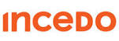 | 
   |  | 
   | 

