RESUME
UMESH KUMAR SHARMA
S/O-JAINATH SHARMA
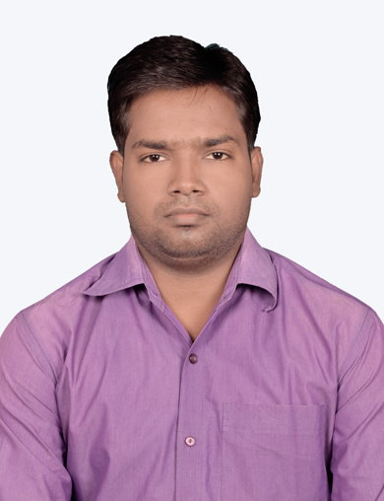
N.C , Road , Mosabani NO.- 3,Jamshedpur
DIST- E.Singhbhum (Jharkhand)
PIN-832104, MOB NO.-7479777783/6200615715
E_MAIL ID-UmeshK.it88@gmail.com

Career Objective
#CAREER OBJECTIVE:-
To join professionally managed organization. Where the compensation is directly related to performance preferred to obtain a good working environment and position to apply my administrative, technical and interpersonal skills and further refine.

Academic Qualification

#ACADEMIC QUALIFICATION :-

Technical Qualification

Matriculation from J.S.E.B , RANCHI in 2002.
Intermediate from J.A.C , RANCHI in 2004.

TECHNICAL QUALIFICATION:-

•Three Years Engineering DIPLOMA in INFORMATION TECHNOLOGY from Govt. polytechnic, Adityapur, Jamshedpur (session 2006-2009).

•Six Month course in Computer Hardware Maintenance & Networking from Jan Shikshan Sansthan,Jamshedpur.

•Online Course from TCSION in Computer Networks.

Work Experience

#Worked as a Team Leader in Aegis Ltd. (BPO) since September 2010 to March, 2014 at Jamshedpur.
#Worked as a Project coordinator of Jharkhand(ATM Project) at Fourth Diemension Solutions Pvt. Ltd. since 12th Jan 2015 to 19th May, 2016 at Ranchi.
•Worked as a Team Leader in BPO Convergence,Bokaro since 26th May 2016 to 21st March 2017.
•Worked as a IT Coordinator in AR Infratech Pvt Ltd to Support Tata Steel Project in Jamshedpur for Wipro from 29th Nov,2017 to 31st August 2018.
•Worked as a IT Coordinator in Wizertech Informatics Pvt Ltd for IBM from 20th August 2018 to 5th May,2019.
•Worked as a Network Engineer in Ultimate Digital Solutions Pvt Ltd for Jharkhand State Wide Area Network(L&T Project) since May,2019 to Jan,2021.
•Working as a Network Cloud Support Executive in Absolute Support & Cloud Hub Pvt Ltd for Lavelle Networks since Jan,2021 at Jamshedpur.

SKILLS:-
•Routing/Switching with Configuration & maintenance
•Desktop Support
•MPLS/VPN/VLAN/Network Tunneling
•BGP/OSPF/EIGRP/RIP Protocols implementation
• LAN/WAN Infrastructure design,Planning with troubleshooting & Maintenance.
• RF & Site Survey with I&C & O&M
• Experienced in tracking and reporting on specific projects and assumed deadlines
• Excellent organizational and time management skills
•Ability to manage complex spreadsheets
#PERSONAL INFORMATION:-
- NAME - UMESH KUMAR SHARMA
- FATHER’S NAME - Mr. JAINATH SHARMA
- MARITAL STATUS - Married
- SEX - MALE
- D.O.B - 3 JAN , 1988
- CATEGORY - O.B.C
- NATIONALITY - INDIAN
- HOBBY - INTERNET SURFING
- LANGUAGE KNOWN - HINDI & ENGLISH
- PERMANENT ADDRESS - S/O – Mr.JAINATH SHARMA
VILL –MOSABONI, P.O.- MOSABONI
DIST. – E . SINGHBHUM
PIN – 832104, (JHARKHAND)
MOB NO.- :- 7479777783/6200615715

#DECLARATION:-

Declaration

Technical Qualification
I here by declare that all the statements made above are true to the best of my knowledge and belief.
PLACE: - SIGNATURE
DATE :-

