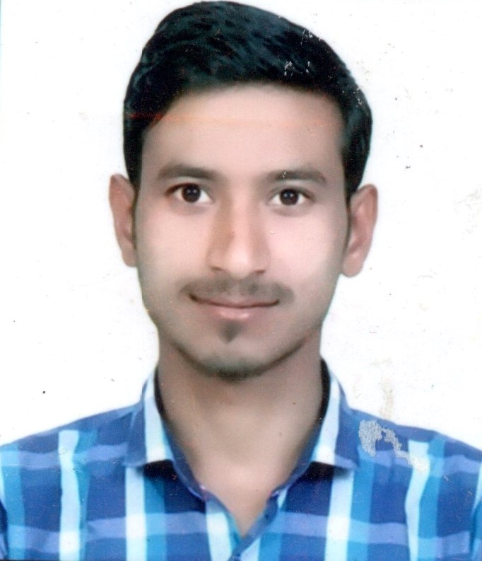
SAGAR BOBDE
Ward No.16, Borgaon
Dist Chhindwara (MP)
Contact: +91-7509790506
Email id: sagarbobde999@gmail.com

Core Competency

- Seeing a career as a PHP,JAVA developer in a progressive based web development company and to effectively utilize the knowledge gained in my academic curriculum & from life for attaining a responsible, challenging and rewarding position.

SPECIALIZATION : COMPUTER APPLICATION

Education
Qualification | Institute | University/Board | Year of Passing | %
MCA | Tecnocrats Institute of tecnology ,Bhopal (MP) | RGPV university Bhopal(MP) | 2019 | 73%
BSC | Govt Bhalerao science college Saoner(MH) | R.T.M university  Nagpur(MH) | 2016 | 51%
XII | Govt H.S school ,(MP) | (MP Board) | 2012 | 54%
X | Govt H.S school (MP) | (MP Board) | 2010 | 62%

Software Skills
- Programming Skills : C, C++, PHP, JAVA
- Web skills : HTML, Java Script, CSS, MySQL.

S Strengths
- Self Confidence, Positive Attitude

- Good Communication Skill,
- Problem solving ,
- Team Work Skill
- Effective Time Management

Project Details
Major project 1 – Online Vegetables Website
I made a website with shopping cart for a vegetables store. The features includes :
- User part – Here user can view the products, choose different vegetables to own cart and
finally can place an order.
- Admin part – Here admin can add, delete, update the products, manage the order and can
also change the password.

Minor project 2 – School Management Project

The main pupose of this website where only authorized person can log in for viewing the details about each school employee and their students. Here the person can add students, add employees, update school details, student details, employee details and picture.

Personal Details
Father Name : Mr. Gendraj Bobde
Nationality : Indian

Gender : Male

D.O.B : 15/06/94

Marital Status : Unmarried

Languages known : Hindi, english, marathi

Hobbies : Listening to Music, Watching movies/TV

Declaration

I hereby declare that all the particulars given above are true to the best of my knowledge and belief.

Place : Signature
Date : Sagar Bobde

