B N MANISH [Dwarka Mor, New Delhi, 110059]
[+918851706260]

[bnmanish006@gmail.com]

[Language Known: Hindi, English and Bhojpuri]

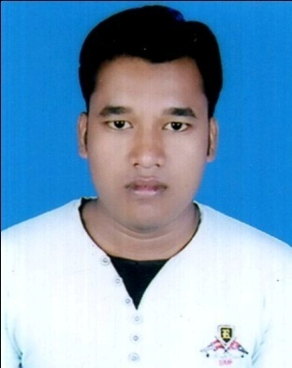

Career Objective

To work in a firm with a professional work driven environment where I can utilize and apply my knowledge, skills which would enable me as a fresh graduate to grow while fulfilling organizational goals.
Working Experience

Company Name: Xuark Technologies Opc Pvt. Ltd.
Address: C1 3rd Floor, D 485, Block D, Palam Extension, Sector 7, Delhi, 110045
Designation: PHP Developer.
Worked: Dec, 2017 to Dec, 2018.
Experience: 1year.

Company Name: Insta Bizmart Private Limited.
Address: A-12, Basement, Main Najafgargh Road, Vikaspuri, Opp. Metro Piller No. 632, New Delhi - 110018
Designation: PHP Developer.
Working : From Mar, 2019.

Skills

- CodeIgniter
- Laravel
- PHP
- jQuery
- CSS
- Bootstrap
- JavaScript
- HTML
Education

[2013-2017] [B.Tech] [Bengal Institute of Technology and Management]

[Stream] [Computer Science & Engineering]

UNIVERSITY: - [Maulana Abul Kalam Azad University of Technology]

SEMESTER |  | SGPA
1st |  | 6.78
2nd |  | 6.62
3rd |  | 7.34
4th |  | 7.42
5th |  | 7.77
6th |  | 7.31
7th |  | 8.19
8th |  | 8.17
DGPA |  | 7.53
EDUCATION | COLLEGE | BOARD | PERCENTAGE
Intermediate(2013) | MVRDE College | Bihar School Examination Board | 64.00
Metric(2010) | High School Dindayalpur | Bihar School Examination Board | 79.40

Hobbies and interests

- Internet Browsing
- Playing Chess
- Reading Newspaper

Declaration

I hereby declare that all the information is given above is true to the best of my knowledge.

22/05/2019 
Date.......................................... ......................................................
Delhi
Place......................................... Signature

