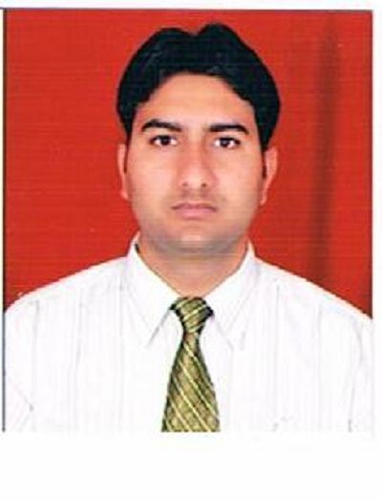
Balram Panday
Mob: 9471150429, 9905751575
E-Mail: balramkiit@gmail.com

CAREER GOAL: I should be able to use my existing skills to add value to the organization, thus getting maximum job satisfaction and optimum career growth.

SYNOPSIS
- An incisive professional in Web technology, Application development.
- In-depth knowledge of .Net Technology, ASP.
- Effective communicator with excellent numerical abilities & ability to work under pressure. Possess a flexible & detail oriented attitude.

TECHNICAL SKILLS

Languages : C, C++
Internet Technologies : Dot Net, C#, XML, HTML
Scripting Languages : Java Script
Database : MS SQL Server 2000
Operating System : Windows XP
Concept : Data structure, Operating System

EDUCATIONAL QUALIFICATIONS

EXAMINATION | UNIVERSITY/BOARD | YEAR OF PASSING | NAME OF INSTIUTION | MARKS (%)
MCA | KIIT University | 2010 | KIIT University,odisha | 78.50
B.SC. | Ranchi University | 2006 | Ranchi College,Ranchi | 51.12
12th | JIEC,Ranchi | 2002 | Govind Inter College | 58.66
10th | BSEB,Patna | 2000 | Govind High School | 64.28

ACADEMIC PROJECTS

Project Title - TASK MERLIN

Role - Team member
Technologies - ASP, .Net, C#, Java Script, XML, HTML.
Database - MS SQL Server 2000
Team size - 2
Duration - 6 months

Description: TASK MERLIN is a project tool that tracks all resource works under Project Leader and manager. It maintains work status daily wise in the form for resource remarks on assigned task. This tool has been developed under the external supervision of Framework Educational & Charitable trust at Bhubaneswar (Odisha). This project management tool can be used by all the IT sector company for their work assignment and resource management.

EXPERIENCE
- More Than Two Years’ Experience in Software Company .
- Company Name : Raygain Technologies PVT LTD
Dwarka. new Delhi

ACHIVEMENTS

- Awarded for BEST VOLUNTEER OF NSS in KIIT University in session 2008-09.
- Participated in 15th National Youth Festival in 2010.
- Commander of NCC (National Cadet Core) in school during year 2000.
- Student Coordinator of NSS (National Service Scheme) in university during year 2007-10.

SEMINAR/ PRESENTATION

- Delivered a presentation on ATM (Automated Teller Machine) during 4th semester MCA.

STRENGHTS

- I am very hardworking individual, with Leadership quality and can prove myself if provided an opportunity.
- Adapts the existing environment fast.

HOBBIES/INTERESTS

- Playing & Watching Cricket and Badminton.

PERSONAL DETAILS

Date of Birth : 6th Nov 1985
Fathers Name : Sri Ram Baran Panday
Address : Nehru Nagar , Chiniya Road,Garhwa Pin-822114
Alt. E-Mail : balramkiit@gmail.com
Gender : Male
Nationality : Indian
Languages known : English,Hindi
Passport number : H4978006

DECLARTION

I hereby declare that all the above information is true and complete to the best of my knowledge.

Date:
Place: (Balram Panday)

