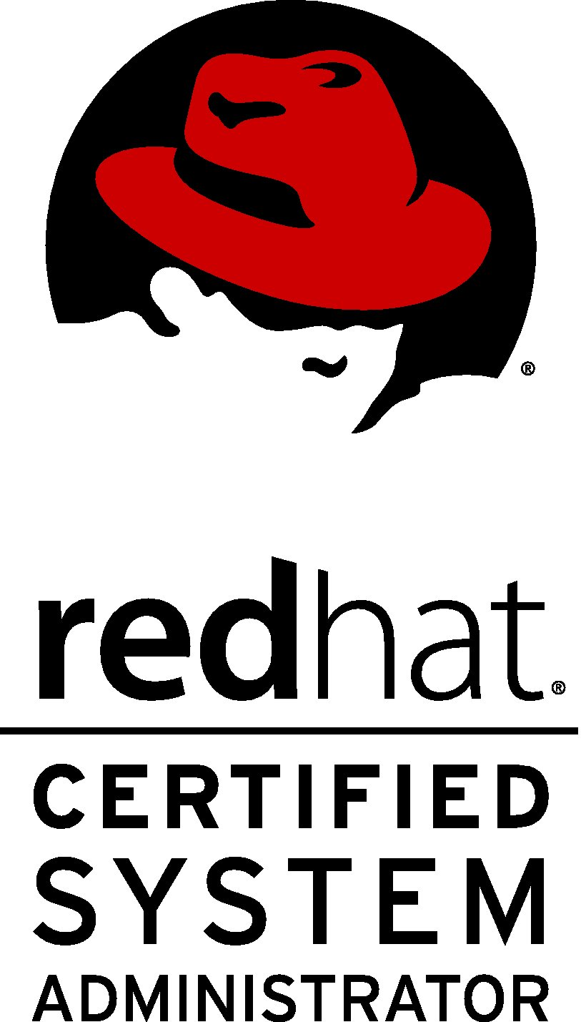
RESUME
Name: Mohd Equbal Alam
New Delhi-11045
Email id: equbalalam12345@gmail.com
Mob: 8745836901
OBJECTIVE
To work in a challenging environment demanding all my skills and efforts to explore and adapt myself in Different fields and realize my potential where I get the opportunity for continuous learning
AREAS OF PROFESSION
- 1 year + Experience in Vcare Infoteh ,Joined Vcare InfoTech service & Solutions Pvt.Ltd as a Linux Administrator from Jan 2020 to till now –cyber security,Firewall (software and Hradware) .Ticketing tool Otrs,OP Manager,Mailing solutions like zimbra,0365 etc ,Vmware Esxi ,Vsphere,Vcenter server management.
- 3 year+ 8 months Working as a Linux system Administrator - Installation and configuration on linux system ,Drivers Installation,Network configuration on Linux system ,Remote control on linux and windows system ,Outlook installation and configuration on a linux system , Zimbra installation/configuration and troubleshooting (Open Source Email Collaboration Solution), DHCP server, Nagios, NTP servers ,Mysql/MariaDB DataBase Server,LAMP Server configuration with PhpMyAdmin. Monitoring Tool- Nagios ,Zabbix and other.
Manage of system Networks (Desktop/laptop,Router,switches and firewall).
Virtualization-Redhat, Vmware Esxi, Windows server 2008/2012/2016, server setup prepared. Windows and linux , webserver Hosting
- 1 year 6 months + working as a system administrator -(all OS installation, all software installation, Outlook Configuration, Backup. Printer installation , System Backup, cc-proxy , Network Configuration on Systems,DNS,DHCP, Folder Sharing, Map Network Drive ,User’s&amp; groups account create/delete/modify , Remote Client systems , TeamViewer).

PROFILE AND SKILLS REQUIRED
Linux Admin Daily Task
- User Management - Disk clean up
- File Permissions -OS Health checks
- Disk Management -OS Issues Troubleshooting
- OS performance -Installation software on Demand
- Installation of OS -Developer support/KT
- Software Management -Review Logs and RCA finding
- Providing Tech Support - Updating software
- Create system Backup -Troubleshooting of Live Issues.
- Maintain system Security -Ensuring Maximum Uptime.

AWS Admin Daily Task
EC2, ELB, Auto Scaling, VPC,S3, -Infra Provision and Termination IAM user/Group
Route 53, RDS, SNS, CloudWatch, and Roll Deploying and Managing VMS updating
IAM, Trusted Advisor compute Optimization Tech Docs ,Implementing New services ,Monitor
Security Groups, NACL AWS Organization, AWS Resources ,Cost Optimization ,Granting/
Managing Aws Resource Life Cycle, Revoking Access ,Maintain system security
Billing, RDS, Ensuring HA

Devops Engineer (Basics Knowledge )
- Git-HUB, Jenkins server, Ansible server etc

PROJECT UNDERTAKEN
Zimbra installation/ configuration and management for global.
March 2016 – April 2016
Client: Ministry of Defense India (Ms4Auto).
Environment & Tools: Upgradation of Zimbra mail server 8.06 open source to Zimbra 8.5 Network Edition and LDAP migration with no change.
Zimbra Installation & Configuration also RHEV
Client: UIDAI CP, New Delhi

• Installing and configuring Hypervisors.
• Implementation of RedHat Enterprise Virtualization 3.5 (Self Hosted) with 2 Hypervisors.
• Configuring storage domains from projected ISCSI Luns. VMS creation
Implementation of RedHat Enterprise Virtualization 3.5 (Self Hosted
Client: NDMC Palika bajar, New Delhi.
• Installing and configuring Hypervisors.
• Implementation of RedHat Enterprise Virtualization 3.5 (Self Hosted) with 2 Hypervisors.
• Configuring storage domains from projected ISCSI Luns.15 VMS create

PROFESSIONAL EXPERIENCE
- 3 year 8 months+ working as Linux system Administrator from Softel Solutions Pvt. Ltd.
( since February 2016 to currently)
E-1002 ,1st floor, Above ICICI Bank ,CR PARK Kalkaji Main Road, CR PARK ,New Delhi - 110019 .India.
Tel: +91- 11-26278264 ,Fax: 011-26277299 ,Email: info@softelnetworks.com
- 1 year 6 months Working as System Administrator from DIP Software solution Pvt Ltd .
IP SOFTECH 217, Hemkunt Chamber Nehru Place, New Delhi-19 Contact No. +91- 9971575135 Email: info@ipsoftech.com Website: www.ipsoftech.com since Nov 2013 to 24 Apr 2015.
- In Bharti Airtel As a Network & DSL Engineer In 2013 (6 Months), Network Engineer.

CERTIFICATION
- Redhat Certified System Administrator (RHCSA)
- Red Hat, License 140-201-294
- Redhat Certified Engineer (RHCE)
- Red Hat, License 140-201-294
- MCSA Certified :G418-5266
- MCSE -Cloud platform and Infrastructure :G418-5270
ACADEMIC
- Master Degree (MBA-IT) In Sikkim Manipal University 2015.
- Engineer's Degree, Computer Science & Engineering (CSE), ICFAI University in the year 2011.

PROFESSIONAL SKILLS
- Linux
- AWS / OpenStack System Administrator .
- Knowledge of Shell scripting .
- Virtualization (KVM, VMware ESXI 6.0 &V-Sphere .)
- Mail server (postfix, send mail, Zimbra Collaboration Suite)

Basic Commands, Installation RPM Packages/Software’s by yum & RPM , User & Group Management, Network Configuration, Yum Configuration & Update, OS Installation / configuration/Update.

Installation and Configuration DNS, DHCP, FTP, NFS, Samba Server, LVM, Swap Partition.

Installation and Configuration Open-LDAP Server & Client,

Web Server (Apache / Nginx), Web-Sites Hosting.

Installation and Configuration MYSQL/Maria dB & Manage Database.
- Installation and Configuration LAMP (Linux, Apache, MySQL, php) with PhpMyAdmin.
- Installation and Configuration Zabbix & Nagios with NRPE.
- Basic Commands firewall, Scp, Tar, Zip, Top, Grep & else.

PERSONAL DETAILS
Date of Birth : 05th jan 1984
Language : English & Hindi, Urdu
Permanent Address : At+Post:- Mockal Chak, Dist.:- Godda (Jharkhand)
Present Address : RZl-52, Vijay Enclav palam, Delhi-110045
HOBBIES : Surfing, Learning, Reading etc.
DECLARATION
I hereby declare that the above information is true and correct to the best of my
Knowledge and belief.

DATE: (EQUBAL)
PLACE

