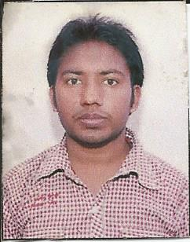
RESUME
PRADEEP
E-mail:-Pradeep8802094001@gmail.com
Mobile no:-9811193650
Address:-1/20 Trilok Puri Delhi-110091

CAREER OBJECTIVE:-
To Be A Part Of An Organization Where Get A Chance To Use My Knowledge And Skills To Contribute In The Progress Of The Organization As Well As Myself.

ACADEMIC QUALIFICATION:-

Education | Board | Year of Passing
M.COM | IGNOU | Pursuing
B.COM | DU | 2014
12th | CBSE | 2011
10th | CBSE | 2009

Professional Qualification:-
- Cma foundation passed
- Cma inter passed
- Cma final pursuing

TECHNICAL SKILLS:-
- Basic Computer Knowledge ( IT Fundamental, MS Word, Excel, Power Point, Outlook, Internet )
- CCC passed from nielit in feb 2017
- Tally erp

Work Expierence:-
- Accountant :
- ABS Tech Services Pvt ltd Present

STRENGTH:-

- GOOD COMMUNICATION SKILL
- EASY TO ADOPT NEW ENVIRONMENT
- OPTIMISTIC
- CURIOUS
- DETERMINISTIC

HOBBIES & ACTIVITIES:-
- Drawing
- Exercise
PERSONNAL INFORMATION:-

Father’s Name : Mr Ram Chander Shukla
Date of Birth : 14 march 1994
Marital Status : Unmarried
Language Known : English, Hindi
Religion : Hindu
Nationality : Indian

This is certified that the above information is correct in my knowledge & belief.

Date:- 12.09.2018
Place:- Delhi

