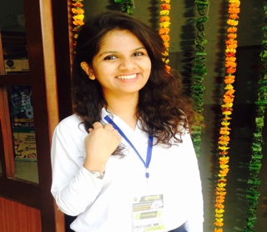
AASTHA CHAUHAN
F-769/A Ganesh Nagar -II, Delhi-110092
+91 9990346633
Email: aasthachauhan3003@gmail.com

OVERVIEW

I am a result oriented and ambitious person and have most actively participated in ICAN 2018 , INTERNATIONAL MEDIA CONFERENCE about India and changing aspects of News as an event coordinator and ALOHA 2018 , Annual fest of college as a team member . Having been a key part of projects has allowed me to develop the necessary skills required to plan and execute large scale events and to build key client and media relationships.
Being passionate about art from the very formative years and having a certificate in FINE ARTS from YMCA,, instilled an attitude of creativity, compassion and patience in me. I am an avid reader and love reading texts that deal with spirituality and peace of mind.

EDUCATIONAL QUALIFICATIONS

Board/University | Degree | Year | Percentage (%)
Delhi Metropolitan Education , IP University | BA (H) JOURNALISM AND MASS COMMUNICATION | 2015-2018 | 82..6%
Queen Mary’s School, Mayur Vihar Ph-1 | 12th | 2013-2014 | 67.6%
Queen Mary’s School, Mayur Vihar Ph-1 | 10th | 2011-2012 | 76%

STRENGTHS

- Ability to keep up to the deadlines.
- Time management and multitasking skills.
- Creative flair of coming up with engaging ideas. .

PROFESSIONAL EXPERIENCES

The Telegraph
Designation: Intern
Duration: June 2016 -July 2016

The political and business daily
Designation : Intern
Duration : 16 July 2016- 31st July

Internship responsibilities:
- In print media, I’ve worked as a feature story writer and assisted my coordinator, this helps me develop a strong rapport with senior journalists and influencers and identify news angles/ content creation opportunities to meet their needs.
- Foster a strong professional relationship with clients and acts as a key client contact on day-to-day tasks
- Manage media briefs with client expectations.

PERSONAL DETAILS
Date of birth: March 30, 1997
Father’s Name : Krishan Kumar Chauhan
Mother’s Name : Lt. Babita Chauhan
Nationality: Indian
Languages known: English and Hindi

