CURRICULUM VITAE

NISHANT RASTOGI
Executive Assistant/ Operation Manager

OBJECTIVE: - Organized and goal-oriented professional environment seeking a good position in the organization using strong analytical skills, knowledge of office administrative procedures and a strong background and vast experience in office management.

PERSONAL DETAILS

PERMANENT ADDRESS : North East, Delhi-110032  GENDER : Male  DATE OF BIRTH : 5th Nov, 1984  LANGUAGES KNOWN : English & Hindi  CONTACT NOs. : 8750122835, 8851027779  E-MAIL s : nishant3020@gmail.com  MARITAL STATUS : Married | 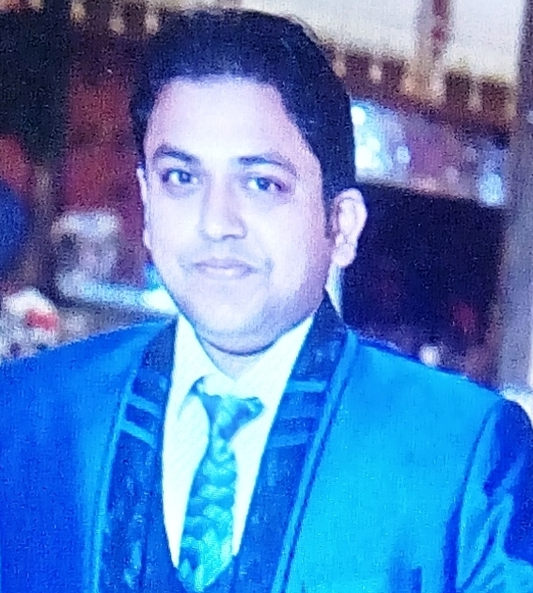

Experiences Summary:
Currently Working

S. No. | Company | Designation | Profile | Duration
1 | Anil Agencies Pvt. Ltd., | Executive Assistant  (MD) | Mentioned in Job Responsibilities | From April’ 17 to Present

Job Responsibilities of Anil Agencies Pvt. Ltd.,
- Managing day-to-day operations to the Managing Director Secretariat.
- Produces information by staff which can data form of Hard copy or soft copy.
- Calendar Management on Google Calendar on daily basis.
- Arranging/fixing meeting from vendor and external staff.
- Presentation, Interviews taking on the behalf of MD office.
- Drafting letter and Email revert on very short time to the behalf of MD.
- Managing Internet Tools for the MD in I-phone/Tablet and Laptop.
- Providing Facilitate External/Internal communication.
- Managing Daily activities of office management.
- Managing in Project Management.
- Manage and maintain executives' schedules, appointments and travel arrangements like Domestic / International flights.

S. No. | Company | Designation | Profile | Duration
1 | Department of Post through National Institute for Smart Government | Executive Assistant | Mentioned in Job Responsibilities | From July’ 16 to March’ 17

Job Responsibilities of Department of Posts, (Dak Bhawan)
- Managing day-to-day operations to the Department of Posts.
- Produces information by transcribing, formatting, inputting, editing, retrieving, copying, and transmitting text, data, and graphics.
- Drafting letters and documents; collecting and analyzing information;
- Initiating telecommunications. Secretarial work and assistance providing Director’s, DDG’s, ADG’s, Chief Secretaries, Members, IAS etc.
- Maintains Director's appointment schedule by planning and scheduling meetings, conferences, teleconferences, travel and Project Management/Vendor Management.
- Represents the ADG by attending meetings in the Director's absence.
- Welcomes guests and customers by greeting them, in person or on the telephone; answering or directing inquiries.
- Maintains Director Confidence and protects operations by keeping information confidential.
- All secretarial responsibilities to the higher-ups.
- Arrange and co-ordinate meetings and events.
- Drafted Hindi Letters for Postal Departments.
- Attending Board Meeting.
- Managed internal communications.
- Managed all travel arrangements like Domestic / International flights.
S. No. | Company | Designation | Profile | Duration
2 | MORD through IAP Infotech | Programming Assistant cum Executive Assistant | Mentioned in Job Responsibilities | From Oct’ 15 to July’ 16

Job Responsibilities of NIC/ MORD (Ministry of Rural Development):

- Managed day-to-day operations in the office of Senior Technical Director.
- Schedule travel dates, make necessary arrangements (International and domestic flights), Coordinate meetings and follow up with consequent post travel procedures and processing of expenses.
- Assist and represent the Director’s Document.
- Organize guest meetings/parties/events, manage schedules, connecting calls, time & Calendar management, and ensure confidentiality.
- Handling all secretarial responsibilities like take calls keeping accountability of routine works etc.
- Manage Sr. Tech. Director Schedule and update online -diary accordingly.
- Create applications and Draft the documents.
- Using a variety of software packages.
- Booking transport and accommodation for HoDs.
- Managing databases & analyzing data.
- Implementing and maintaining procedures/administrative systems.
- Liaising with staff, suppliers and clients.
- Managing/Creating presentations and spreadsheets.
- All secretarial responsibilities like travel arrangements Domestic / International for Directors.
- Coordinating Subordinate staff.
- Assisting the Sr. Tech. Director in day to day activities Handling his personal files and mails/calls/meetings Inter/Intra Departmental coordination, Vendor Management, Project Management.
- Drafted Hindi Letters.
- Presentation and E - mail replies of Director’s
- Communication and Correspondence with the other Head of Departments.
- Preparing monthly reports.
- Documentation, business talks, audits in oracle.
- Manage internal communications.
- Determine and type agendas and correspondence for special events, board meetings, committee meetings and development activities.
- Arranging special meeting amenities like food, PC projector and Video conferencing
- Provide whole telephone coverage - answer executive phones, take accurate messages, handle urgent calls with appropriate judgment.

S. No. | Company | Designation | Profile | Duration
2 | IRCTC through JMD Consultants / ShoMuk Consulting | DEO cum  Executive Assistant | Mentioned in Job Responsibilities | From Mar’ 09 to Sep’ 15

Job Responsibilities of Indian Railway Catering and Tourism Corporation (Railways):

- Managed the day-to-day operations of Director Catering Service’s office.
- Organized and maintained files and records of Railways and Others.
- Planned and scheduled meetings and appointments.
- Managed projects and conducted research.
- Prepared and editing correspondence, reports and presentations.
- Made travel and guest arrangements like Domestic & International flights.
- Providing quality customer service
- Worked in a professional environment and Project Management.
- Drafted of officials letters and Notes.
- Maintenance of officials records on daily basis.
- Financial Analysis and Revenue Accounting, Reporting and General accounting.
- Supervised operational accounting processes, maintained accounting records, general
- Ledgers and accounting statements and Bank reconciliation on periodical basis.
- Preparation of Monthly MCDO (Monthly Confidential Deme Official)
- Preparation and finalization of monthly, quarterly & yearly financial statements.
- Putting up files to be processed of finance department.

S. No. | Company | Designation | Profile | Duration
3 | CGHS through Bretton woods Ltd. | DEO cum EA | Mentioned in Job Responsibilities | From Jan’ 07 To Aug’08

Job Responsibilities of Central Government Health Service (M/o of Health):

- Managed the day-to-day operations of Chief Medical Officer’s office.
- Keeping the records of patients & maintaining the information of patients in Database.
- Drafted of official letters, permission and replies to RTI.
- Maintained the reimbursement bills of patients & check all documents.
- Done Daily basis entries of the patients.
- Supervise the networking problems.
- Maintained the records of office stock in Database.
- Managed travel arrangements like Domestic / International flights.
ACADEMIC RECORD / PROFESSIONAL QUALIFICATION

CLASS / COURSE | INSTITUTION/ SCHOOL | BOARD OF STUDY | YEAR OF passing | %( Percentage)
Matriculation | Diwan Chand Arya | C.B.S.E | 2000 | 53
Intermediate | Diwan Chand Arya | C.B.S.E | 2002 | 45
B.com. (Pass) | School of Open learning | Delhi University | 2005 | 40
M.sc (IT) | Softdot Hi-Tech Educational & Training Institute | Punjab Technical University | 2008 | 65
MCA | Softdot Hi-Tech Educational & Training Institute | Punjab Technical University | 2011 | 82

TECHNICAL SKILLS:

Good Hand on Ms- Office and Typing of Hindi and English.

Professional Certificate in Multimedia and Web Designing from Oxford Software Institute.

- Spoken & Written Languages i.e. English and Hindi

STRENGTHS HOBBIES

Good Team Member. 1. Reading Holy books.

Smart work and think about creative ideas. 2. Listening to music.

Go getter & Positive attitude. 3. Drawing, Cricket etc.

Self Motivating, Disciplined, Dedicated & Honest 4. Computer savvy.

Date : 09/02/2018 (NISHANT RASTOGI)

Place : New Delhi

