RESUME
Contact No. 9926360679
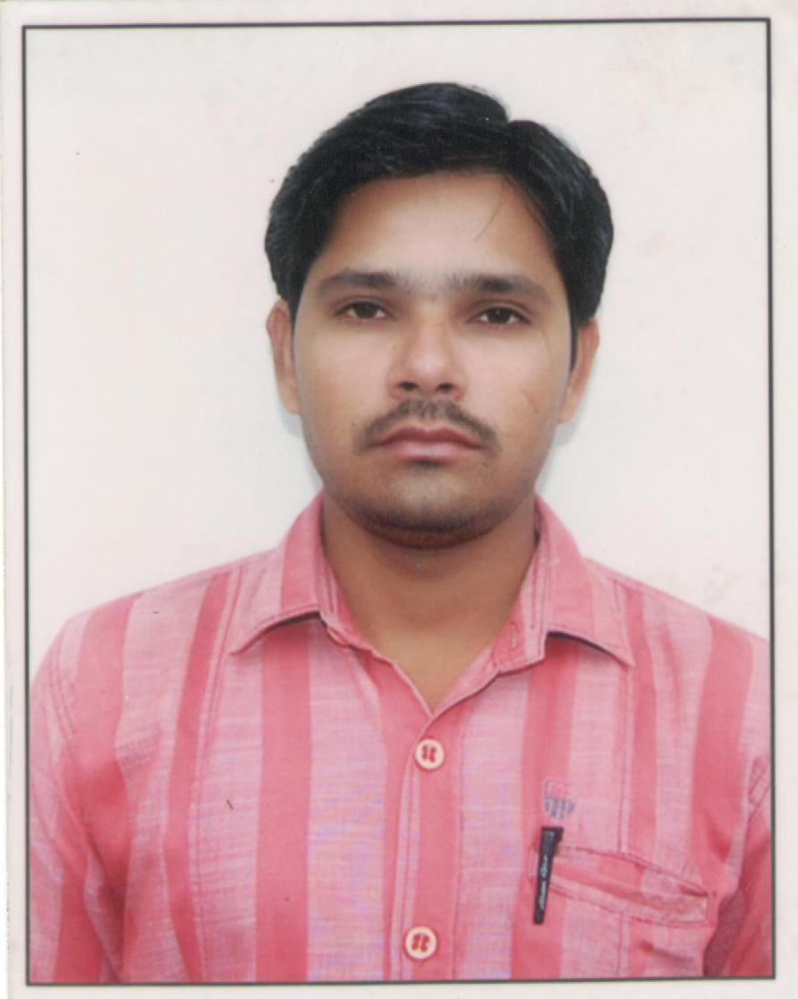
Personal
Name : Gulab Meena
Father’s Name: Mr. Mukesh Babu
Mother’s Name: Mrs. Saraswati
Date of Birth: 15 January, 1988
Address: H.No.113 Gram Bagoniya post Mugaliya haat Bhopal
E-mail: gulabm01@gmail.com
Marital Status: Married
Language Know: Hindi & English
Religion: Hindu
Category: OBC
Nationality: Indian

Educational Qualification :
Passed High School, (10th) from M. P. Board,, Bhopal (M. P.), with 45 Percent.
Passed High Secondary (12th) from M. P. Board, Bhopal (M.P), with 59 Percent on Science Subject.
Passed B.A. Final from B.U. Bhopal, with 52 Percent.

Computer Knowledge
PGDCA from MCU
Knowledge of Internet Explorer
Knowledge of English & Hindi Typing

Personal Skills
- Good communication skills
- Confident about the success and ability to meet deadlines
- Highly organized and dedicated with positive attitude

Working Experience
Three year Work Experience in Computer Operator-Cum-Office assistance from Indian Institute of Soil Science Nabibagh Berasia road Bhopal.

Declaration
I do hereby declare that all the statement made in this application are true, complete and correct to the best of my knowledge and belief. I understand and agree that in the event of any information being found flash or incorrect/incomplete or ineligibly being detected at any time before or after selection/interview, my candidature is liable to be rejected.

Date: 11.11.2014
Place: Bhopal Signature:-Gulab meena

