Resume
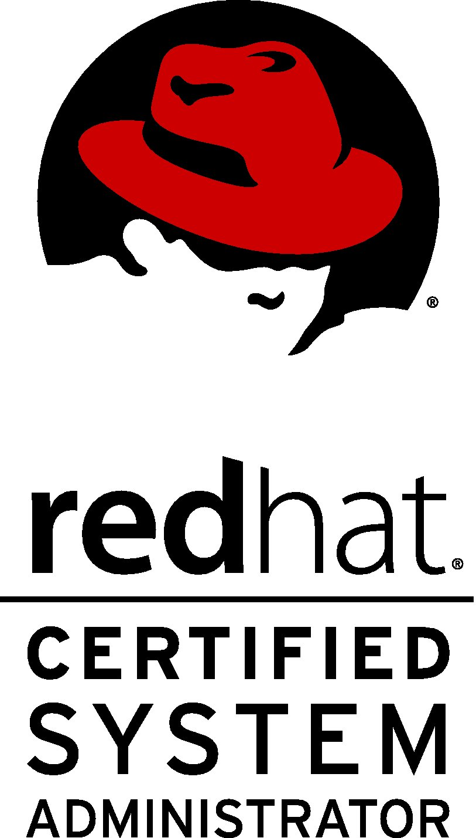
SAJAN PRASAD
Dept.:- BE (Electronics & Communication Engineering)
E-mail:- sajanprasad96@gmail.com
Mobile no: - 9599537978, 8789264178
Local address-Sec – 27 block- F Noida
An Overview:
To be associated with an organization which give me an opportunity to learn skills attainted with the latest trends and to be a part of team that work dynamically toward growth of the organization and self-confidence
. Scholastics:
- BE-ECE from V.M.K.V Engineering College(VINAYAKA MISSION UNIVERSITY), with aggregate 67
- 12th (C.B.S.C) from J.N.M.SR.SC.SCHOOL in 2009 with 67%.
- 10th (C.B.S.C) from J.N.M.SR.SC.SCHOOL in 2007 with 70%.
Employment Details:
Current Employer NAME :-Raygain technologies pvt ltd (gurgoan)
Designation : Server Administrator
From 1st Aug 19 to till
Previous Employer Name :-GVR TECHNOLABS PVT LTD (Kerala)
Designation : - Technical support Engineer
From : - 3rd Oct 2017 to 27may 2019
Previous Employer Name : - HI TECH INFPORMATIC PVT LTD (GURUGRAM)
Designation : - Technical support Engineer
From : - 27TH March 2017 to 30th sep. 2017
Previous Employer Name : - Green Valliey Industries Limited (1000 TPD cement plant)(Meghalaya)
Designation : - Assistant Engineer (IT –DEPT)
From : - 22nd Sep 2014 – 13th June 2016
Previous Employer Name : - orient technologies pvt ltd (NAVI MUMBAI)
Designation : - NETWORK SUPPORT ENGINEER
From : - 3RD Jan 2014 – 19th sep. 2014
Employment Recital: RAYGAIN RECL(NXTRA DATA CENTRE) Responsibility-
- Hardware & Software Monitoring of Server (DELL,HP) through Idrac , ILO
- Installations of OS (Linux, window server) upgrade & install the packages.
- Analysis the fault and rectify it with the help of team.
- Maintain health report of the server on daily bases.
Employment Recital: (BEL) INDIAN AIR FORCE (SALUA) Responsibility-
- Hardware installation, OS installation red hat 7.1, software installation and up gradation of software in client and server system as per instruction by BEL (BHARAT ELECTRONIC LIMITED) in node and agency.
- Troubleshooting and monitoring of LAN (optical fiber &cat 6) inside Indian air force (under IACCS PROJECT) ,Cisco switch ,FDF box.
- Configure NETWORK TIME DISPLAY .monitoring and troubleshooting database server 11g, MST server, ADA server, GIS server.
- Yum server, ftp server, rpm, bond, kde installation, basic scripting, zenwork, Network management system.
- Kvm,static switch, crimping ,croning,
- Remotely software installation in all agencies of air force.
- Software integration in radar (THD, ROHINI, LLLWR, SRE and ETC).
Employment Recital: (Wipro) DRDO DEAL Dehradun Responsibility-
- Installation, configure, maintenance of Linux operating environment.
- Changing the disk usage and creating label and swap partition, creating, extending & reducing file system using LVM. and RPM , YUM management,
- Resolve technical issue with the support of ISRO and WIPRO team
- Maintenance DAQLS Server, RTPS Server And support in daily passes.
- Maintenance switches ,NAS Server,NTP,Local LAN(Linux based networking) Resolve hardware and packages issue in WORKSTATION PC(server) ,Maintain the log file for troubleshoot the issue.
Employment Recital: (MAX CEMENT) max technical services
Responsibility-
- Monitoring or Maintenance of mail server(vpop3), internet server, antivirus server, proxy server
- Troubleshooting of LAN Network (internal network) and troubleshoots the printer on LAN network.
- Handle different network and communicate with link provider if external link is down.
- Knowledge in NAS, Data backup, Repair and Maintenance of desktop, laptop Hardware and software issue &configure Microsoft outlook.
- Install and Maintenance of wired Network (cat 6 & optical fiber cable)&wireless Network
- Handle Video conferencing between HO and plant location, Handle biometric machine.
Employment Recital :( ORIENT TECHNOLOGIES PVT LTD)
Responsibility-
- Remote Monitoring of Network & Client End Connectivity via various NMS Tools such as Flex
Master, Zone director, Telnet, etc
- Access of Core Routers via telnet installed in operational cities to check the ping response of
Serving Access Point and client end device in order to determine drop in connectivity as well
As speed related issues.
- Taking necessary action on complaints received from clients based on technical data available
By using Siebel application
Industrial training & certification:
- 4 weeks summer training in BSNL,CTTC Patna
- I have done RHCSA & RHCE course from aptron (noida)
- RED HAT CERTIFIED SYSTEM ADMINISTRATOR in LINUX 7
- I have done HARDWARE AND NETWORKING course from IT-SOURCE (MUMBAI)
Extracurricular activities and hobbies:
- Participated in interschool handball Championship
- Participated in bodybuilding championship,siinging,cooking
Skills:-
Application known : MS word, Excel, Power point.
Operating Platform : Windows xp, Vista, window server 8, Windows 7,8,10, red hat 6, 7
Ubuntu
Subject of interest : network, IT, Hardware, Linux, cloud
Personal details:
Father Name : Mr. Arjun Prasad
Date of Birth : 04.09.1992
Sex : Male
Nationality : Indian
Language Known : English, Hindi
Permanent Address : digwadih no 12, dhanbad Jharkhand
Declaration:
All the information provided above are true to the best of my knowledge.

Date: 8-Nov-26
Place-Noida SAJAN PRASAD

