Curriculum Vitae
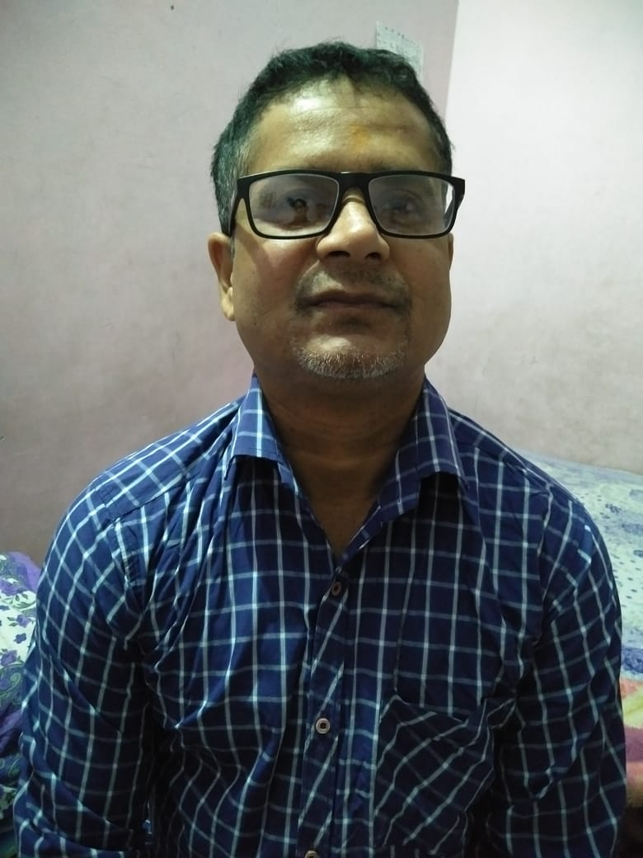
Sudarshan Jha
House No. 2/708, Gali No. 13, Gamri Extension
Delhi – 110053.
Mobile: - 9871233102, 8744846828
E-mail: Sudarshanjha86@gmail.com

Career Objective.
To pursue growth of my career in a competitive and challenging work environment which will enable me to learn, grow and substantially build on my knowledge acquired during the course of my study and at the same time give me an opportunity to contribute to the growth of organization where I work.
Education Qualification
- 10th from Bihar board in 1993.
- 12th from Bihar board in 1995.
- B.com (A/C Honors.) From LNMU Bihar in 1998.
Organizational Experience

Duration –15-05-2016 to Till date.
Swati Trading Company (Manufacturers of P.P.Battery container, Battery Parts, Accessories & House Hold items.)

Designation: - Accounts Manager
Job Responsibility:-
- Daily Maintain Books Of Accounts.
- Stock Reconciliation of all stores & Events.
- Bank related all work & Cash Related all work.
- Inventory Control, Stock Maintenance & Stock auditing.
- TDS Related all work & Return Filing, Sale reconciling
- GST Related all work.
- GSTR 3B & GSTR 1Calcullation & Return Filling.
- Reconciliation of 3B Bill with Books of Accounts.
- Reconciliation of R-1Bill with Books of Accounts.
- Reconciliation of 2A with purchase in Books of Accounts.
- Reconciliation of Debit / Credit notes.
- Reconciliation of input tax with 2A + 3B as claimed with Goods & Services with details & Reconciliation of output tax with R-1 & Books of Accounts.
- HSN wise details of purchase & sale.
- Summary of all Reconciliation & job work Return ITC 04
- Reconciliation of E-way Bill inward & outward.
- GST Annual Return GSTR 9 & Reconciliation GSTR 9C
- GST Reconciliation Cash & Credit ledger.
- Balance Sheet
Direct Tax:
Prepared Income Tax returns, E-TDS returns for corporate and non-corporate assesses.
Advance tax, income tax, deferred tax calculation and return submissions.
- ALL Kind of Accounting, reporting & finales.
Duration ––06-07-2014 to 01.05.2016
Tresor Systems Pvt.Ltd.

Designation: - Senior Accountant
Job Responsibility:-
- Daily Maintain Books Of Accounts.
- Sale Tax Related all work & E-Filing Return.
- Bank Related all work & Cash Related all work
- Service Tax Related all work & Return Filling.
- EPF & ESI Related all work.
- Balance sheet.
- Preparing sales invoices & the upkeep of an accurate accounts filing system.
- Preparation and input of month end journal vouchers.
- Inputting, matching, batching and coding of invoices.
- Debtor and Creditor reconciliations.
- Preparation of various reports for senior managers.
- Responsible for financial accounts including budgets and cash-flow.
- Supervising junior financial staff.
- Responsible for KPI analysis and evaluation of costs and margins.
- Conversant with PAYE and VAT reconciliations.
- Conducting regular business reviews of financial performance.
- Proactively identifying business improvement opportunities.
- Fixed Asset accounting, reconciliations and depreciation journals.
- Ensuring that information is accurately collated & entered into systems.
- Preparation of bi-weekly invoice and expense claim payment runs.
- Assist in the preparation of monthly balance sheet account reconciliations.
- Inputting of supplier invoices and employee expense claims to the ledgers.
- Duration –25-03-2007 to 05.06.2014
Dolphin Softech Pvt.Ltd.

Designation: - Senior Accountant
Job Responsibility:-
- Daily Maintain Books Of Accounts.
- Sale Tax Related all work & E-Filing Return.
- Bank Related all work & Cash Related all work
- Service Tax Related all work & Return Filling.
- EPF & ESI Related all work.
- TDS Related all work & Return Filing.
- Supporting the business by assisting to produce accurate financial and management accounting information on which financial decisions are based. Also involved in compiling financial reports and analyses, whilst working to strict deadlines.
- Preparing sales invoices & the upkeep of an accurate accounts filing system.
- Preparation and input of month end journal vouchers.
- Inputting, matching, batching and coding of invoices.
- Debtor and Creditor reconciliations.
- Preparation of various reports for senior managers.
- Responsible for financial accounts including budgets and cash-flow.
- Supervising junior financial staff.
- Responsible for KPI analysis and evaluation of costs and margins.
- Conversant with PAYE and VAT reconciliations.
- Conducting regular business reviews of financial performance.
- Proactively identifying business improvement opportunities.
- Fixed Asset accounting, reconciliations and depreciation journals.
- Ensuring that information is accurately collated & entered into systems.
- Preparation of bi-weekly invoice and expense claim payment runs.
- Assist in the preparation of monthly balance sheet account reconciliations.
- Inputting of supplier invoices and employee expense claims to the ledgers.
- Daily Maintain Books Of Accounts.
- Sale Tax Related all work & E-Filing Return.
- Bank Related all work & Cash Related all work
- Service Tax Related all work & Return Filling.
Duration –05-05-2001 to 10-03-2007
CFC Carriers Pvt.Ltd.

Designation: - Accountant
Job Responsibility:-
- Daily Maintain Books Of Accounts.
- Stock Reconciliation of all stores & Events
- Bank Related all work & Cash Related all work
- Inventory Control, Stock Maintenance
- TDS Related all work & Return Filing, Sale reconciling
- Indirect Tax:
- Excise
  - Reviewing of Input & Consumables items for Excisable goods and various Forms like, ARE-1& 3 and ER-1, 4, 5, 6, 7 & Dealer Return
Service Tax
  - Calculating Service Tax & Filling ST returns (Half yearly) for clients
  - Maintaining Register of Service Tax Input Service Tax & Reconciliation with Books of A/C.
- Sales Tax & Others
  - Filling VAT & CST, Entry Tax, return and preparation of such assessment.
  - Customer Master Registration ,Customer Master display & Quality Report in SAP
  - Destination & Grade wise pricing. In SAP.
  - Make the payment & Report the payment in SAP.
  - Purchase Report, Sale Report & Account Balance Report In SAP.
  - Direct Sales order – Create, Change & display in SAP.
  - Receive Consignment – Purchase received & displays the stock in SAP.
  - Sale - Sales order no., delivery order no. & Invoice no.

Computer Skills
- Basic of computer
- Working Knowledge of MS-Office.
- Working Knowledge of Internet.
- Financial accounting on Various Software (Tally 4.5, 5.4, 6.3, 7.2, 9 ERP, BUSY, MARG & SAP.)
Personality Traits
Hobbies: Listening music, Traveling, Net surfing, Playing (Cricket)
Qualities: Disciplined, Honest, Smart working.
Strengths
- Analytical mind to identify problems effective solution.
- Flexible by nature.
- Positive Attitude.
- Hard working & Self Confident.
- Capable to work in Team.
Personal Profile
Name : Sudarshan Jha
Father’s Name : Let. Radha Krishna Jha
Date of Birth : 15/06/1977
Marital Status : Married
Nationality : Indian
Religion : Hinduism
Language Known : English, Hindi & Maithili
Present Address : H. NO.A-2/708, Street No. 13, Gamri Extension, North East Delhi Pin Code : 110053
Salary Expected : Negotiable
Personal Profile
I hereby declare that the above-mentioned information is correct up to my knowledge and I bear the responsibility for the correctness of the above-mentioned particulars.

Date:
Place: New Delhi (SUDARSHAN JHA)

