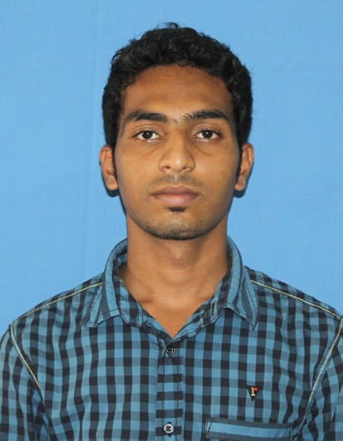
M.MOHAMED YASEEN
Chennai, TamilNadu
Contact: +91 9790811157
Email: yaseenyas614@gmail.com

CAREER OBJECTIVE
Aspiring to work with an organization that offers responsible position where I can utilize my skills and capabilities to carve a niche for myself and effectively deliver towards contributing to the organization’s aspirations and also enhance my personal growth through continual upgrading of knowledge.
TECHNICAL SKILLS
PROGRAMMING LANGUAGES | : | Java, C, C++, VB.NET, ASP.NET, PHP, C#.NET
SCRIPTING LANGUAGES | : | JavaScript, JQuery
DATABASE | : | SQL,
O.S. | : | Windows Family(XP, 7,8)
WEB TECHNOLOGY | : | HTML, CSS
QUALIFICATION
LATEST ONE:
MASTERS:
Master Of Computer Science-June-2017 Pursuing
BACHELORS:
Bachelor of Computer Science – August 2014-April 2017 Percentage : 74%
The New College, Chennai-14
HSC (Science Stream):
The Muthialpet Higher Secondary school-March 2014
Percentage: 72%
SSLC:
The Muthialpet Higher Secondary school-March 2012
Percentage: 76%
CERTIFICATIONS

Symposium Participate in E-Revelation
National Level Symposium 2nd Prize in Code Hunt

WORK EXPERIENCE
Operation Executive In Mtandt Ltd: Experince 2 years

ACADEMIC PROJECT EXPERIENCE
- Final Year Project as Part of the B.sc computer science Ongoing
Project Name : | Courier & Cargo Management System
Descirption : | Making Courier Booking & Tracking easy

EXTERNAL PROJECT EXPERIENCE
Project Name : | Login Form
Description : | The Website focusing on Login Page
Technology : | HTML, CSS, JavaScript
Team Size : | 1
STRENGTH

Interpersonal:

- Good communication and interpersonal skills,
- strong written and spoken communication,
- Multi lingual (Tamil,English, Urdu,Hindi,Arabic)
- Soft-spoken,
- Problem solving and decision making,
- Ability to work in challenging environment and learning from adverse situations,
- Meticulous and a Quick-learner.
PERSONAL INFORMATION
Father’s name | : | M.Moosa
Date of Birth | : | 05:04:1997
Marital Status | : | Unmarried
Languages Known | : | Tamil,English,Urdu,Hindi, Arabic.
Permanent Address | : | No:4/2 kuppamal st, Old Washermenpet,ch-21

I hereby declare that above mentioned information is correct and best to my knowledge.

Thanking you
PLACE: CHENNAI M.MOHAMED YASEEN

