CURRICULUM VITAE
GRADUATE ENGINEER TRAINEE PETROLEUM UPSTREAM (DRILLING)

 | Name | : | Abhishek Dhanik | 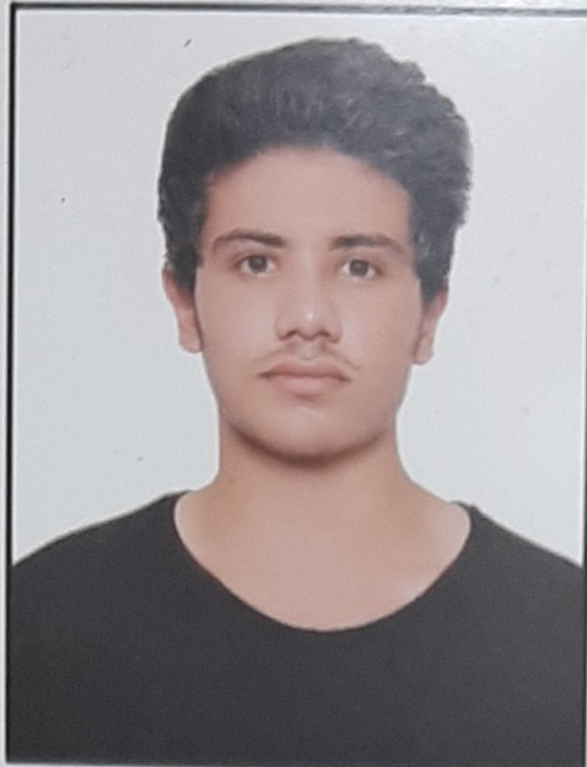
 | Date of Birth | : | 02/12/1998
 | Gender | : | Male
 | Category | : | General
 | Height | : | 6 Feet
 | Nationality | : | Indian
 | Religion/Caste/Category |  | Hindu/Rajput/General
 | Marital Status | : | Unmarried
 | Address | : | House No 889 Sector 13 LIC Near Maharaja Agaresen School, Vasundhra, Ghaziabad (Uttar Pradesh) Pin Code : 201012
 | E-mail Id | : | dhanikabhishek97@gmail.com
 | Mobile No | : | 8810602684
 | Landline Number | : | 0120-4306284
 | Aadhar Card Number | : | 7694 1246 1096
 | Passport Number | : | Z6085329 Valid upto 25/08/2030
 | Pan Number | : | CRUPD5520K
 | Driving License | : | UP14 20200040107 Valid upto 01/12/2038 (Light Motor Vehicle)
 | Police Clearance Certificate(PCC) | : | Police Clearance Certificate (PCC) No 316812008009 Dated 29/12/2020 issued by SSP Ghaziabad (Uttar Pradesh) and valid upto 28/12/2021
 | Language –read/write | : | English/Hindi/Punjabi
 | Computer Knowledge | : | Familiar with Computer operation
 | Academic Qualifications | :

 | Name of Certification | Institution | Board/  University | Year of passing | Percentage Marks/  CGPA
 | 10th | Guru Harikishan Public School Karkardooma Delhi (India) | CBSE | 2014 | 8.6
 | 12th Science stream | Bharat National Public School Ram Vihar Karkardooma Delhi (India) | CBSE | 2016 | 74%
 | B Tech Petroleum  + Upstream | University of Petroleum & Energy Studies Dehradun Uttarakhand (India) | UPES | 2016-2020 | 5.86

21. | Extra Technical Qualifications :-
 | Internship |  | 6 week Internship (familiarization to Drilling process and Slick Line in Oil & Gas sector) from Rig Tech Oil Field Training Centre Private Limited, Kochi, Kerala (India).
 | Certification in Exploration & Production |  | 3 Month Course on Certification in Exploration & Production with practical from Rig Tech Oilfield Practical Training Center, Sathyamangalam, Coimbatore, Tamilnadu (India).
 | IWCF |  | 1 | International Well Control Forum (IWCF) Level -1 Programme  (Certificate No L1P_6398017082020)
 |  |  | 2 | International Well Control Well Operations Crew Resource Management (WOCRM) (Certificate No WOCR_654717082020)
 | Safety | IADC | 1 | IADC HSE Rig Pass (Onshore & Offshore) Certificate No SXX000183862
 | Safety | BOSIET | 2 | Basic Offshore Safety Induction and Emergency Training (BOSIET) Certificate valid upto 22/12/2024.
 | Safety | HLA | 3 | Helicopter landing Assistant (HLA) Certificate valid upto 10/01/2025.
 | Coursera |  | 1 | Oil & Gas Industry Operations and Markets
 |  |  | 2 | Politics and Economics of International Energy
 |  |  | 3 | Presentation skills: Effective Presentation Delivery
 |  |  | 4 | Artificial Intelligence (AI) for Everyone
 |  |  | 5 | Business Implications of AI : A Nano Course
22 | Aim |  |  | To pursue a challenging career and be a part of progressive organization that gives me scope to enhance my knowledge and utilizing my skills towards the growth of the organization and to achieve my goals.

(Abhishek Dhanik)
Signature of the Applicant

