CURRICULUM-VITAE

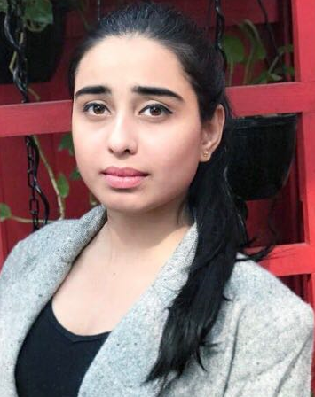
SAKSHI CHAUDHARY

C-91
R.K Puram, Govindpuram
Ghaziabad, UP -201013
 sakshichoudhary589@gmail.com
 8527557089

Objective
Seeking a challenging career in reputed organization, which can provide me the learning opportunities for making positive contribution through team efforts and to be a person with good moral values.

Education Qualifications
Degree | Institution | Subject/Specialization | % / CGPA | Passing Year
10th Class | DDPS | All | 76℅ | 2010
12th Class | DDPS | Science | 64℅ | 2012
Graduation | IMS  Ghaziabad | BCA | 65℅ | 2015
MBA | AKTU | Human Resource/IT |  | 2018

Certification
1. "C" LANGUAGE
2. "C++" LANGUAGE

Achievements
- Have been an ardent participation in Cultural Program held at school level as well as University level.
- Active participation in the cultural festivals, workshops conducted by the department.

Strengths
- Quick Lear n and Co-ordination Skills.
- Hardworking
- Honest and
- Self-motivated.

Personal Details
Name: Sakshi Chaudhary
Father’s Name: Dharmandhar Kumar
Date of Birth: 23 March 1995
Hobbies: Racing, Listening Music
Languages Known: English, Hindi.

Declaration N

I hereby declare that all the information provided here is correct to the best of my knowledge.

Place: Ghaziabad
Date:

(Sakshi Chaudhary)

