Name : Javed Khan  Address : Ho.No. 1410/ Azijgunj Pasiyana Shastri Ward  Jabalpur, Madhya Pradesh  Pin code- 482002  Phone Number : 08878941233, 08839579276  E-mail ID : javedkhancosmic@gmail.com | 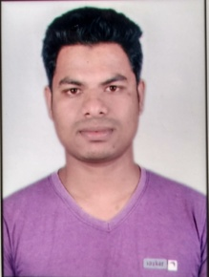

Career Objective:
I want to work in a reputed firm with my dedication and hard work and want to contribute in the successful and profitable operation of the firm.

Educational Profile:

S.NO. | Class/Sem. | Board/University | School/College | Aggregate/Percentage
1 | B. Com | RDVV | Janki Raman Collage Jabalpur | First Division
2 | ITI (Electrician) | NCVT | Govt. ITI Bargi | First Division
3 | 12th | M.P. Board of Secondary Education, Bhopal | Panchsheel Higher Secondary School, Jabalpur | First Division
4 | 10th | M.P. Board of Secondary Education, Bhopal | Panchsheel Higher Secondary School, Jabalpur | First Division

Work Experience:

- I have worked at SAG IT Solution, Jabalpur, M.P. for One Year as Process Associate.
- Hindi & English Typing.

Vocational Training:

- Title : Vocational Training
Organization : MPPTC Limited, Jabalpur
Tenure : Two weak

Hobbies:

- I like photo editing using adobe Photoshop.
- I like meeting new people.

Extra Curricular Activities:

- I participated in Workshop organized by SOFCON.

Strength:

- Time Management
- Punctuality
- Friendly nature
- Disciplined

Personal Profile

Date of Birth : 24/09/1995
Father’s name : Mr. Asger khan
Marital Status : Single
Languages Known : Hindi, English
Nationality : Indian

I hereby declare that the above information is true to best of my knowledge.


Place: Jabalpur

Javed khan

