CURRICULAM VITAE
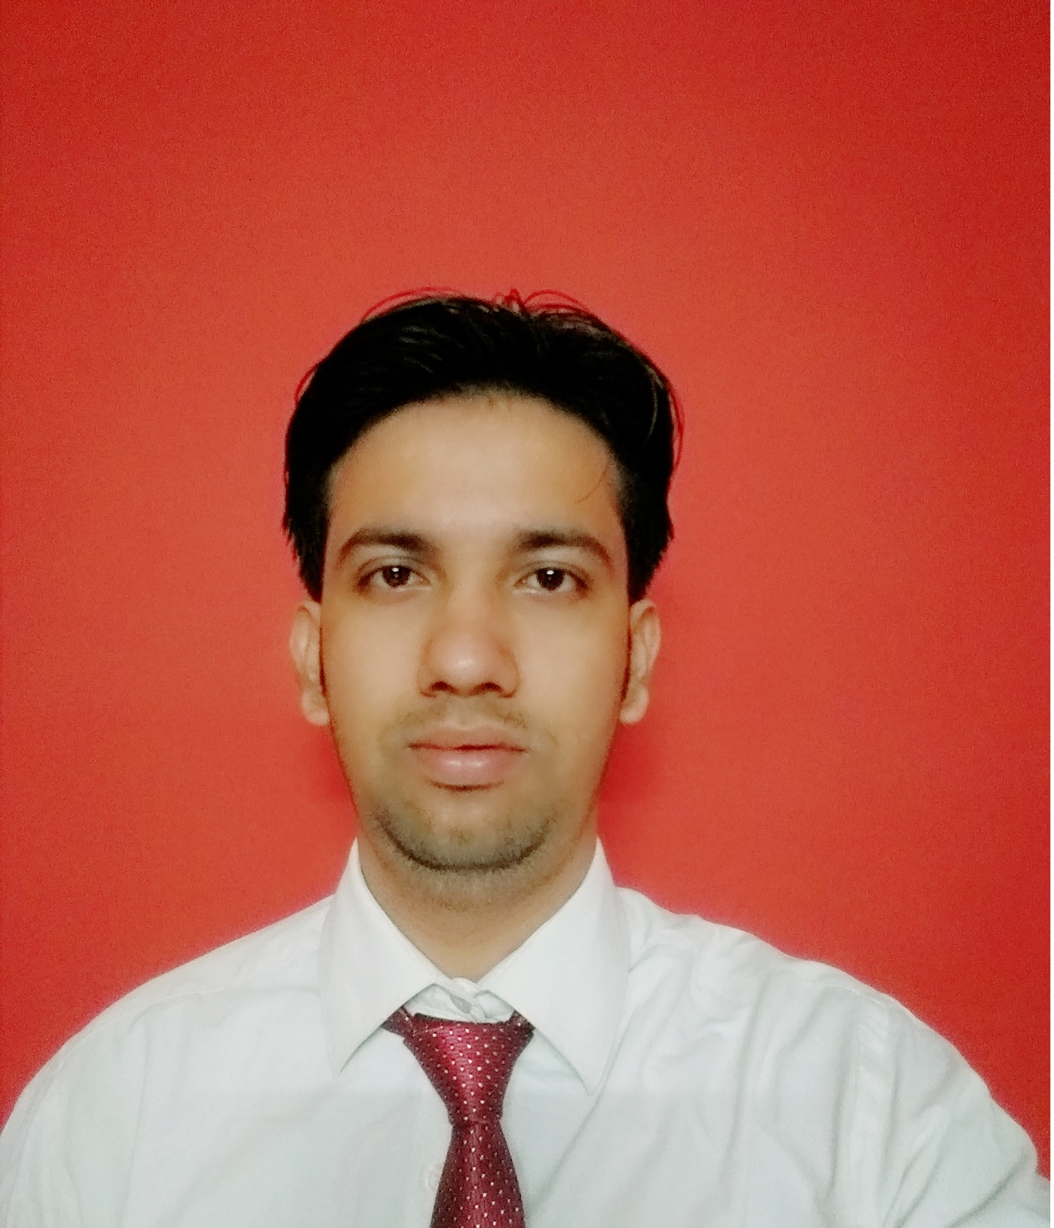
Address: S/o Adhir Dubey
43/3 Shivkuti Teliyarganj
Abhishek Dubey Dist.-Allahabad

Abhishek27ec@gmail.com India.
Pin Code-211004
Mobile No+919748245558
+919792441676

CAREER OBJECTIVE:

To excel in the field of Electrical & Electronics and related technologies through conceptual and analytical insights and to contribute in achieving the company’s goal and enhance my knowledge with sharpening the skills.

WORK EXPERIENCE:

Year : Eight Year
Company Name : Suryaday Pvt. Ltd.
: 1.2 Year - Solar Project Installation
Designation : Asst. Manager – Construction
Working Project : Military Engineering Service -2MW (Assam & West Bengal) – Ground Mounting
NTPC – 1MW (Chhattisgarh) - Roof Top (RCC) Mounting
Patanjali – 2MW (Himachal Pradesh) – Roof Top (Tin Shade) Mounting
Worked Project : HAL – 1MW (Luck now) Roof Top (RCC) Mounting
HAL – 1MW (Korwa) Roof Top (RCC) Mounting
LMRC – 1MW (Luck now) Roof Top (Tin Shade) Mounting
Railway Workshop & BSNL – 1MW (Liluah, Kolkata) Roof Top Mounting
Bharti Water – 625 KW (NCR New Delhi) Roof Top (RCC) Mounting
Metro Tiers – 725KW (Punjab) Roof Top (RCC) Mounting
Company Name : Esko Die Casting Pvt. Ltd.
: 7 Year – Pressure Die Casting
PDC Worked : Electrical Instrument (PLC, Starter, Blower, Compressor, PID Connection, Motor
Protection Etc...) Pressure die casting Machine, Hydraulic System, and Pneumatic
System, Spectra Metal analysis.

PROFESSIONAL QUALIFICATIION:
.2013 – 2017: Bachelor of Engineering in Electrical Engineering from Rajasthan Vidyapeeth University.

2008– 2011: Polytechnique in Electronic and communication engineering from Integral University Luck now.

EDUCATIONAL QUALIFICATION:

Academics:

High School from U.P Board
Diploma: Electronic and Communication
B.E: Electrical Engineering

SUBJECT OF INTEREST

1) Transmission & Distribution
2) Switchgear & Protection
3) Solar System

EXTRA KNOWLEDGE:

1) Hydraulic Circuit & maintenance
2) Spectra Operation

SOFTWARE EXPOSURE:

. Formatting Tools : MS Office, MS-Excel, Power Point, and sound understanding of
Internet Tools.
Working Environment : Windows8/7/98/2000/XP

Professional Training

PLC: SIEMENS, ALLEN BRADLEY, SCADA; SIEMENS, ALLEN BRADLEY

Technical Skills:

PLC Programming:
AB-RSLogix 500 (Training)
Siemens-S7 (Training)

SCADA-Designing:
AB-RSview32 works (Project down)
Siemens: Windows Control Center

SUMMER TRANING:

Name of Organization : Dynamic Transmission Ltd. Gurgaon
Duration : 60 days.

PROJECT:

►Regulator Power Supply

INTRODUCTION:
Almost all electronic devices used in electronic circuits need a dc source of power to operate. The source of dc power is used to establish the dc operating points (Q-points) for the passive and active electronic devices incorporated in the system. The dc power supply is typically connected to each and every stage in an electronic system. It means that the single requirement common to all phases of electronics is the need for a supply of dc power. For portable low-power systems batteries may be used, but their operating period is limited. Thus for long time operation frequent recharging or replacement of batteries become much costlier and complicated.
More frequently, however, electronic equipment is energized by a power supply, derived from the standard industrial or domestic ac supply by transformation, rectification, and filtering.(The combination of a transformer, a rectifier and a filter constitutes an ordinary dc power supply, also called an unregulated power supply).

EXTRA CURRICULAR ACTIVITIES & ACHIVEMENTS:

- Represented College cricket team at College level.
- Took part in a campaign against Smoking & Drug addiction in rural areas of West UP and visited more then 100 villages.

ASSETS TO COMPANY:

- Ability to grasp new ideas, concepts and challenges, well strongly motivated and result-
- Oriented. Excellent interpersonal skills.
- Strong determination to grow in an organization.
- I can adjust myself to any adverse situation.
- I believe to work in team.
- Handles responsibilities well.
- Willing to relocate easily.

PERSONAL PROFILE:

Date of Birth : 27th April, 1992.
- Father’s Name : Mr.Adhir Dubey.

Marital Status : Married
- Hobbies : Playing cricket & Listening to music.
- Nationality : Indian.
- Personal Strength : Positive Attitude.
- Permanent Address : S/o Adhir Dubey
43/4 Shivkuti
Allahabad.
India.
Pin Code-211004

Declaration:

I hereby declare that the above written particulars are true to the best of my knowledge and belief.

Date: 10 Sep 2019 (Abhishek Dubey)
Place: Delhi

