C. V of ….
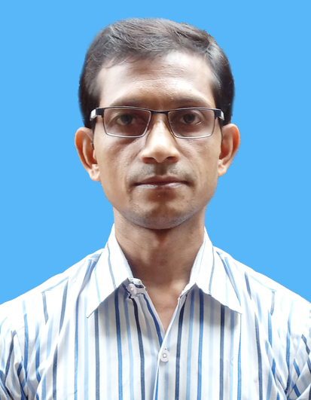

ATANU MUKHERJEE
23, Kali Krishna Thakur Road, P.O – Alambazar, Kolkata-700035, Mobile – 9038834866
E-mail – atanuiam@gmail.com

JOB EXPERIENCE

- Presently working under control of National Informatics Centre (NIC-WBSC) for various e-governance projects from March, 2013 to till date

KEY ROLE & RESPONSIBILITY
- Providing technical support through voice and e-mail to users
- Providing training on the online software to grass root level stakeholders
- Requirement analyzing of new projects from client side
- Participating in meeting and brainstorming sessions with the officials of client side for implementing new modules
- Preparing different kinds of documentation like Implementation Status Report, Presentation on the project, Concept note of new modules, Data Capturing Format of new modules, Work Flow of new module, SRS etc.
- Sharing domain knowledge with other team member regarding the new modules
- Handling different kinds of administrative issues
- Worked in West Bengal Task Force (Maintained by Department of Child Development and Department of Women Development & Social Welfare and Funded by UNICEF) from July, 2010 to February, 2013 as Support Staff.

KEY ROLE & RESPONSIBILITY
- Documentation, analyses and generation of the report
- Maintaining and archiving case management documentation
- Supporting meeting and communicating between stake holders
- Submission of monthly report to the Task Force members
COMPUTER LITERACY
Certified in BASIC COMPUTER and FINANCIAL ACCOUNT (TALLY 5.4-7.2, EX-NEXT-GEN, ACCORD)

System Software
WINDOWS XP, WINDOWS 2000, WINDOWS 95 and WINDOS 2007

Application software
MS OFFICE 98/2000/XP/2003/2007 (MS WORD, EXCEL, POWER POINT), VISION +, FINACLE, JAGUAR

ACADEMIC QUALIFICATIONS

B. COM
Passed B. COM under Calcutta University in 2003

HIGHER SECONDARY
Passed Higher Secondary in the year 1999 from W.B.C.H.S.E (West Bengal Council of Higher Secondary Education)

MATRICULATION
Passed Matriculation in the year 1997 under W.B.B.S.E (WEST BENGAL Board of Secondary Education)

LANGUAGES KNOWN
Bengali, Hindi & English

HOBBIES
Listen music, Book reading and Making friend

PERSONAL DETAILS

Date of Birth : 28th January, 1981
Father’s Name : Manoranjan Mukherjee
Gender : Male
Marital Status : Married

OTHER DETAILS

CURRENT SALARY: Rs. 28,000/-
EXPECTED TAKE HOME SALARY: Rs. 32,000/- (Negotiable)
Declaration
The above written statement is true and honest to the best of my knowledge. If the opportunity is given to me I will try my best under the rules and regulations of your organization.
Date:-
Place: - Kolkata (Atanu Mukherjee)

