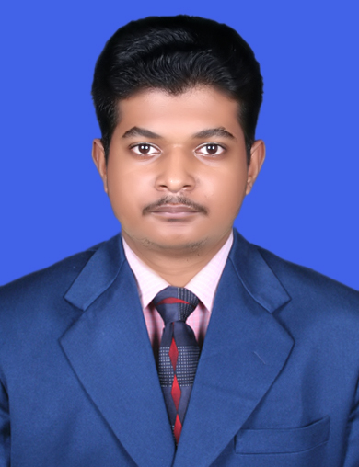

Shakti Prasad Sarangi
BTech- Computer Science
shakti.prasad426@gmail.com
+91- 9853243775 (M)
Bhubaneswar, India

OBJECTIVE

To work in an organization where I can get an opportunity to contribute to the organization’s growth and profitability by exploring my skill and knowledge and learn to the maximum extent which would help me building a strong and successful career as well.

EDUCATIONAL QUALIFICATIONS

Degree/ Certificate | Institution | Year of Passing | Board / University | Mark (%)
BTECH Computer Science | Vivekananda Institute of Technology | 2015 | BPUT | 62%
12th | Kendriya Vidyalaya No.1 Bhubaneswar | 2011 | CBSE | 49%
10th | Ruchika High School, Bhubaneswar | 2009 | ICSE | 70%

PROJECTS AND TRAINING

Sl. No. | Title | Organization | Period
1. | Trainee –  System Support | Luminous Infoways, Bhubaneswar | April- June 2016
2. | Android | Sathya Technologies, Hyderabad | June 2016 to September 2016
3. | Computer Programmer | Shrestha Consultancy (P) Ltd., Bhubaneswar | 1st August 2016 to 31st July 2017
4. | Software Developer | National Informatics Centre | 1st August 2017 to till date

IT SKILLS
- Android (Native)
- Java (Spring, Spring Boot)
- Android Studio
- J2ME
- SQLite, Postgresql
- XML
- MS Office (Excel, Powerpoint, Word)
- Eclipse, STS

PROJECT EXPERIENCE

Project 1
Title: DDUGKY(https://kaushalpanjee.nic.in)
Module: Web Application, Mobile Application
Technologies: Spring MVC, java, Hibernate, Android
Client: Ministry of Rural Development, Govt. of Odisha

Role And Responsibilities :

- Developed on these modules Mobile app, Trainer Module, Employer Module, Candidate Module, Web Services.
- UI Development using JSP, HTML,CSS, Bootstrap, XML
- As a Team Member of the project , working in Business and Web Layer
- Writing Business Logic as well as Controller Classes with database management.

Descriptions:

- It facilitates employment to rural youth unemployed and job seekers.
- Admin level report generation with sms integrations.
- Mobile application for registration of candidates in different sector and trades.
- Searching of Training Centres with gallery view.

REFERENCES
- Ramakrishna Sahoo (Scientist D) , NIC, Bhubaneswar ,Odisha (8280000062)

ACHIEVEMENTS

- Second position in onsite zonal of Mini Chakravyuh Dec 2012.
- Champion in 54th State Schools Basketball Championship 2008.
- Participated in All Odisha Inter District School Level Football Tournament at district level 2007.
- Participated in 53rd State School Autumn Championship at national level 2007.
- Participated in 53rd National School Games under 14 at national level 2007.

STRENGTHS

- Result Oriented Professional
- Quick learner with good grasping ability
- A high tolerance of stress and enjoys responsibilities
- Great time management skill
INTERESTS

- Playing football
- Programming on mobile apps
PERSONAL DETAILS

Date of Birth : 26/10/1993
Gender : Male
Language Known : English, Hindi, Odia
Permanent Address : Qr No. IIR-105, Unit-6 Bhubaneswar, Odisha,
Pin- 751001
Marital Status : Single

Place: Bhubaneswar
Date: (Shakti Prasad Sarangi)

