JAGJEET SINGH
Mobile: +91-8010620691 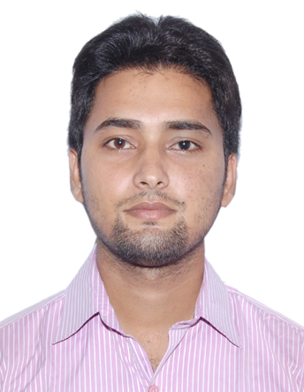
E-Mail: jagjeetsingh866@gmail.com

Career Objective
With my hard work and dedication I want to reach a position where I earn respect for my work and knowledge while making a positive contribution to the organization. I look forward to a challenging job, which helps me to grow professionally as well as individually.

Professional Experience & Exposure

Company name: Puredot India (Google Trusted Agency) Noida from FEB. 2014 to MAY 2015.
Designation: Sr. Executive Sales.

Responsibility
- Selling the services like Google virtual tour and internet marketing services.
- Find out the data from primary and secondary sources.
- Conduct the meeting with clients, describes them services.
- To schedule the photo shoot with the co-ordination of clients.
- Also handle the 3 sales executive under my team.
- To take their daily reporting, maintain the MIS.
- Finalize the queries of existing or new clients.
- Update daily data of meeting’s in google docs.
- To work in co-ordination and Ensuring my availability/guidance and support to my team mates.

Personal Skills and Qualities
- Efficiency in multitasking.
- Quick decision making.
- Negotiating and Problem solving skills.
- Creativity and adaptability.
- Expertise in handling B2B Sales
- Proficiency in computer and technology.
- Ability to work under stress and deadlines

Research Projects Undertaken
- Company Name: - Getit Infomedia Pvt Ltd
- Project Title : - “Market Survey of Prospective Customers for Getit Infomedia”
- Duration : - Two months

Academic Qualification
Year | Degree/Certificate | Institute/School, City | Percentage/CGPA
2014 | PGDM(Marketing & IT) | APEEJAY  School of Management | 60
2012 | BCA | SMU | 65
2009 | 12th | U.P. Board | 64
2006 | 10th | U.P. Board | 46

Extra-Curricular Activities and Achievements

- Participated in Pulse Polio immunization camps and Blood donation camps.
- Conducted Management Events in College level.

Personal Data

Full Name Jagjeet singh
Date of birth 27 July, 1992
Language English, Hindi, Panjabi.
Nationality Indian
Current Address 1141, s/f, lig housing, DDA flats, mayur vihar phase -3, delhi- 110096

DECLARATION

Working with your company will help me greatly in developing my career and getting valuable experience. Owing to my interest and enthusing I will prove worthy to the opportunity given and will try to come up to the expectations. I will perform to the best of my abilities and prove a valuable asset to your Company.

Jagjeet Singh

