CURRICULUM VITAE
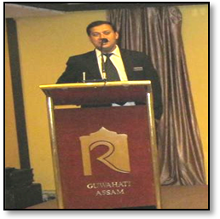
CHANCHAL BANERJEE
S/O-BHABANI BANERJEE
PARK ST-KOLKATA, 16
WEST BENGAL-INDIA
chanchalbanerjeeonly@yahoo.co.in
- banerjee1978chanchal
LinkedIn- Chanchal Banerjee
Skype –chanchal.banerjee15
[Kolkata]- 08017827088
Mobile 08582863670
Date of Birth- 07 FEB 1978
Mother’s name - Mamata Banerjee
Position in family- One Brother
Permanent Address- Hooghly.W.B
Language Known- English/Hindi/ Bengali
Nationality Indian
Sex - Male
Religion - Hindu status – Married

Career Objective
Looking forward for an Opportunity Where I will implement My Ideas & Contribute toward 100 % Growth of Organization Day to Day
^{General activity}
          - To Promote Sales & Handling MIS, Budget, p&l account,
          - Creating Team Work, Motivating staff, Training Subordinates
          - SOP, Menu planning, Sales promotion, Festival planning, Banqueting,
          - Software knowledge- Ids/Shawman/ Micros/Prologic
          - Handling License-Excise/ESI/PF/PPL/Fire/Food/Trade/FHARI
          - Marketing focus -Lsm, online portal, off line portal, State wise TTF,
          - Face book, Google, Red FM, Hooding placement, news pepper add,
Free write-ups. Kiosk placement.
^{Vendor Management}
- H k Associate [Lords, Hind ware, Lords, Ess, Jaguar, Samsung
Ifb, Amantra, Bombay Dyeing, Anchor, Phillips ETC]
- F&B [Coke, Pepsi, Red bull, Ub, Budweiser, Four Seasons
Gorvashow, Bharat, Feather touch, Tata, Ocean, Clay craft, Venus]
- Maintenance [Kirloskar, Otis, Mitsubishi, Bpl, Wifonic, Boiler, Filter
Plant Cooling Tower, Eureka Force.koni ETC]
- Kitchen [cell frost, Blue star, Bosch, Tata, Lg, Butler,
Radhakrishna, Zenith.Thermax.Supreme.ETC ]
^{National Corporate activity-}
Air India, Bhel, CCI.ONGC,, Stazila,Make my trip .Travel Guru. Clear Trip. Booking .com.Agoda.Easy Go.Kauni.Yatra.Just dial. Group on. Go Ibibo. Room to nite,.Fci.Bank of Baroda.Sbi life insurance.Jindal.Ranboxy.IIT. Oil india.Let see.Hdfc life. Dalmia cement. Bridge n Roof.Gamon.L&T, Om Metal.SAIL.Birla Sun Life.
^{Knowledge at a Glance}
- Project planning & development
- Human resources management
- Ecrm-Customer relations & satisfaction
- P&l management
- Inventory control & Monitoring Haccp
- Recruiting, training,& monitoring staff
- Managing pre opening & operating budget,
- Cost control
- Sop for all departments
- Daily Mis report
- Market analyses
- Budgeting for achieving GOP
- 90% score in guest satisfaction
- Guest loyalty programme
- Maintaining daily sales recap
- Ebitda- b2b, b2c
- Menu planning
- Store- Fifo & lifo
- Yield management
- Handling Payment gateway

Academic Qualification
1. Passed Class [X] Examination-W.B.B.S.E.-1994
2. Passed Class [XII] Examination –W.B.C.H.S.E-1996
3. Completed Graduation under Kolkata University [B.A PASS]-1998

Professional Qualification
Completed Diploma Hotel Management Catering Technology & Applied Nutrition, From- R.G.I. H.C .T
[Regional Institute of Hotel Management Catering Technology]
Sakchi-Jamshedpur - 2001.-AICT Approved

Industrial Training/Exposure
Eight Months Industrial Training at –Great Eastern Hotel- Kolkata
Esplanade, Kolkata - 1999

Eight Months L. T- At the Fort Radisson -Raichok, Kolakata-2000
Food and Beverage Service
F&B Production
House keeping
Front office operation
Computer knowledge-MS Office .Corel paint pro x6, .Internet

Personal profile
NAME : CHANCHAL BANERJEE
DATE OF BIRTH : 07 FEB 1978
FATHER’S NAME : Bhabani Banerjee
POSITION INFAMILY : One brother
PERMANENT ADRESS Kolkata, Hooghly, West Bengal
LANGUAGE KNOWN: English. Hindi Bengali
NATIONALITY: Indian

SEX : Male
MATERIALSTATUS : Married
PASSPORT NUM: L2021731 Valid till 22/05/2023
Driving License: AS/01/LL/14503/2014


Working experience
Hotel Inter Continental The Grand. Connaught place, New Delhi
Reporting to Mr Vivek Sukhla - HOD
Worked as a Steward in Hotel Inter Continental The Grand- [24/7-Coffee Shop] Baluchi, The Authentic Indian
Restaurant, New Delhi-Barakhamba Avenue, 240 Rooms Hotel-Connaught Place. New Delhi
[March 2001- February 2002]


Le Meriden Kukas, Jaipur
Reporting to Mrs Shane Bauguna -F&B Manager
Worked as a F&B Captain in LE -MERIDEN, Jaipur, 126 ROOMS, Capri Coffee Shop, Palki Bar, Surva Villas-
Tradional Rajput Cuisine, Rajmandir, Jaipur-Rajasthan Operated By
Starwood Hotels and Resorts Worldwide
[February 2002- January 2004]


Majestic Park Plaza Ludhiana
Reporting to Mr.Nipun Vig Operation Head – Sarovar Group
Worked as a F&B Executive & Restaurant Manager in Majestic park plaza & Geoffrey’s the
British Pub, Champs sports Bar, Darbar 1200 Pax Capacity, Kohinoor, 123 Rooms-
Operated by Sarovar Group, Ferozpur Road .Ludhiana-
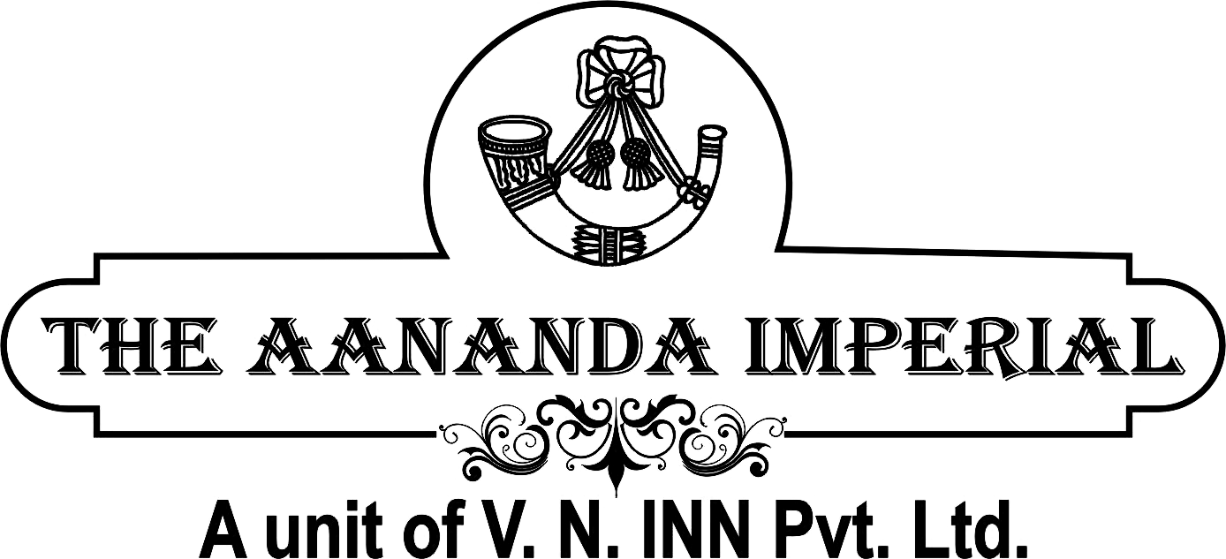
[February 2004- June 2006]

Hotel Ananda Imperial – Bilaspur. CG
Reporting to Mr Debashis Banerjee- GM/Mr Sumit Vadhani CEO
Worked as a F&B Manager in Hotel Ananda Imperial Bilaspur-overall Responsibility 65- Rooms,
Gourmet Restaurant, o zone Bar. The cafe, Banqueting - Bilas, The Emperor.Lincon
Banqueting & Conference facility- A unit of V.N.INN Pvt Ltd,
Vyapar Vihar Road, Bilaspur .Chhattisgarh
[June 2006 TO July 2007]

Best Western Peace Valley-Goa World Largest Hotel Chain
Reporting to Mr. Jaison Hadeson- Corporate Hrd
Worked as a Operation Manager- Best Western Peas Valley-Deumol, Goa- Overall Responsibility
80 Rooms Fine Dining Multicuisine Restaurant, Grill & live Barbeque, Spa, Disco
Pool Side Sinking Bar, In House Laundry, Online Booking System
[August 2007 TO March 2010]

The India Hotels–Awadh, Mussorie, Varanasi
Reporting to Mr Prasenjit Guwahathakurta- Sr GM
Worked As a General Manager –The India Group of Hotels Varanasi unit .U.P
64 - Rooms, 500 Pax Banqueting- (300, 150, 50), Conference facility 120 pax
Tequila the Gup Chup Bar, Palm Spring The Fine Dining Multi Cuisine Restaurant, Golden Dragon - Speciality
Chinese Restaurant, Gardenia- Roof Tof Bar - 59 Patel Nagar, Cantt, Varanasi-02. UP. INDIA
[March-2010- to 2012 February]
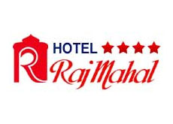
Hotel Rajmahal- Guwahati
Reporting to - Mr.Manoj Sethia & Sunil Sethia- MD
Worked As a General Manager Hotel Rajmahal, [4 star approved] Guwahati. Assam
71 Rooms, Baithak -24/7 Coffee Shop, Banzaara Fine Dining Multi Cuisine Restaurant- 80 covers. Madhushala
Bar -40 Covers .Raj palace 1ST Floor-800 Pax, 9TH Floor 500 Pax, 10th Floor 1000 Pax. Banqueting
& 2ND Floor –Conference Facility 80 Pax. At Road, Paltan Bazaar- Guwahati
[2012 February TO March 2013]

Polo Towers Group of Hotels– Polo Towers Shilong
Reporting to - Mr.Deval Tribubal- CEO
General Manager Hotel Polo Towers Shilong –Look after Shilong, from March 2013- April 2015
Total 52 Rooms, Multicuisine Restaurant Ginger, Sky Grill the open Barbeque, Milano and Irish Pub
Hotel Polo Max (A - unit of Polo Towers Group of Hotels) - Allahabad and Jabalpur,
Pre opening 110 Keys Responsibility, Polo Food Court .Savour yoghurt, Sigh Bros .Banquet and conferencing
Civil line, Allahabad and Railway compound Jabalpur
[April 2015 to Till Date]
With warmed Regards
Chanchal Banerjee
banerjee1978chanchal@gmail.com
Skype- chanchal.banerjee15
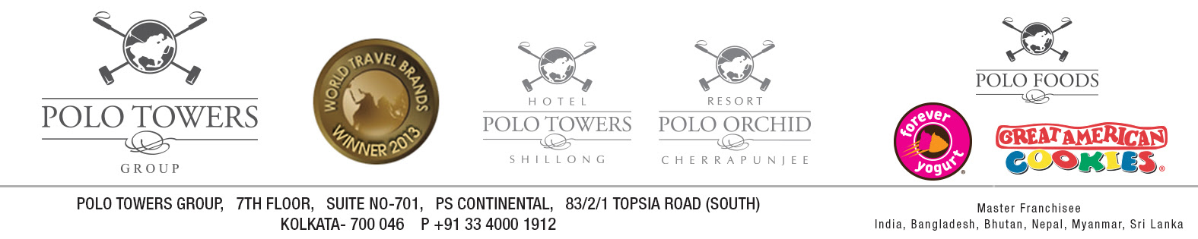
Whatsapp- 8582863670
+91- 8582863670 /9830375939

