CURRICULUM -VITAE
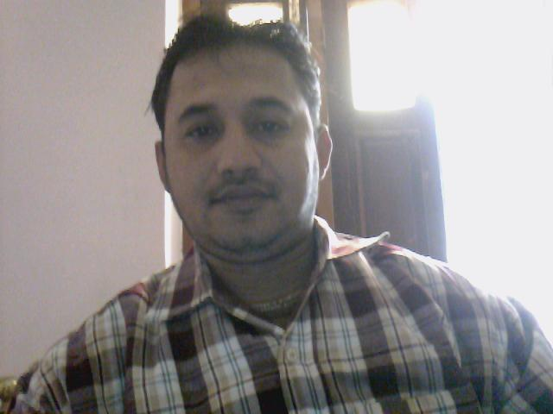
Sitaram Jha Shree
(M)+91-8797184999,
radhagovind_2007@rediffmail.com
PERMANENT ADDRESS: PRESENT ADDRESS:
C/o-Sri Hanuman Jha C/o-Sri A.K.Jha,
At+P.O-Wari, via-Singhia Plot No-763, Bank colony
Distt.-Samastipur Manjhi Tola, Adityapur
Bihar-848209 Jamshedpur Pin-831013

OBJECTIVE-
To work with an organization where I can develop my skill, leadership & knowledge and make use of my learning’s to contribute to the organization.

Work Experience

- Recently Working with Artson Engg. Ltd.(A subsidiary of Tata Projects Ltd) at Tata Steel Growth Shop -Jamshedpur, Jharkhand, as an “Engg.Quality Control” for 6 million ton integrated steel plant of kaling nagar projects of Tata steel in NDT section as well as fabrication of Structural Steel work
From 14th Dec-2012..

- Worked as a“ Assistant Manager- Quality control at Abhijeet Projects Ltd-(270x4 MW) Latehar, Jharkhand Looking Inspection QA/QC activities in Pre &Final alignment of structural and pressure part of Power House, Boiler, ESP,WTP,CHP,AHP,CW/ACW Pipeline, RW Pipeline, Coal &Mill Bunker , from 20th August 2010 to October- 2012 .

- Worked in Quality Evaluation and System Team Pvt. Ltd.-Bangalore
- Sr.FQA Engineer on behalf of BHEL (2x500 MW)-Mejia,DVC,Bankura
- Sr.FQA Engineer on behalf of BHEL (1x726.6 MW)-OTPC,Palatana(Tripura)
- Deputy Manager on behalf of BHEL (2x500 MW)-Andal, DVC, Durgapur
(From June-2006 to August-2010

- Worked as Assistant Engineer in Gajanand Udyog Pvt. Ltd.-Jamshedpur for
(Production and Planning) of Fabrication of crane girder, Arc structure, Furnace shell,
Chassis back structure, water cooling panel and assemblies.
(From 20.06.2002 to 19.05.2006)

- Worked as Maintenance supervisor in Prima Agro Products Ltd- Cochin looking
Daily, weekly, Monthly maintenance of hammer mill, mixing mill, motors,
Gear box, Generator, pipeline, Milling machine, Shaper, Lathe (From 20.04.1996 to 19.04.1998)

- Worked as Trainee Supervisor in Pragati Equipments & Technological services Pvt Ltd.-
Bangalore at KCP cements Ltd-Guntur (A.P) and Malabar Cements Ltd.
Palghat (Kerala) From 29.05.1995 to 10.04.1996

INTERNSHIP & CERTIFICATE-

- Certificate in NDE-Level-II-Radiography Test: in 2006 from IMET-Kolkata with 81.67% marks.

- Certificate in NDE-Level-II-Ultrasonic Test: in 2007 from IMET-Kolkata with 82% marks.

- Certificate in Network computing in 1999 From NIIT-Jamshedpur with 64% marks.
EDUCATION QUALIFICATION-

- Diploma in Mechanical Engineering from Acharya Polytechnic (Board of Technical Examination-Karnataka) with second class in 1995.

- Intermediate in Science passed in 1992 From C.M.Science College Darbhanga (B.I.E.C-Patna)
with First class.

- Matriculation Passed in 1990 from High School Mahinam –Pohaddi (B.S.E.B-Patna) with first class

INTERESTS AND HOBBIE
- Singing and playing musical Instrument like Harmonium, Tabla,Piano,Violin.
- Watching Information-oriented channels in T.V
- Reading magazines of Science & Research.
- Travelling different places.

EXTRA CURRICULAR ACTIVITIES –

- Leadership.

- Participated in blood donation camp in Abhijeet Power Project ,Jharkhand.

Key Skills-

- Self motivated, Team Player, Leadership qualities, Good communication and Motivational skills.

Job Profile –
- Inspection activities in pre & final alignment of structural and pressure part of power house ,Boiler, ESP,CW/ACW pipeline, RW piping, WTP, chimney, Fuel piping,coal bunker ,CHP,etc

- In charge and co-ordination of welding inspection of all QC activities for fabrication shop piping and structural.
- Inspection of welding process, base metal, filler metals, and welding electrodes,
- Reviewing of NDT reports and preparation of punch list& As-built drawings. Planning and organizing Non destructive Testing(RT,UT,DPT,MPT), Interpretation of welding and radiography film.

- Carry out practical sessions with explanation about the purpose of the experiment and the procedures that follow to seek results.
- Expediting work to vendors and following to seek the result .

- Preparing BOM (Bill Of Material)

- Final assembly of product.

- Conducting Welder Qualification Test and engaging their respective job. Final approval of WPS,PQR,QAP,FQP .
- Review and inspection of all common welding process like SMAW,GTAW,SAW,GMAW of steel structure of Boiler,TG section,ESP ,Storage tank,piping,etc

- Conducting NDT for the Welding surveillance of Piping & Structures and Q.C Documentation and reporting to QA Head.

PERSONAL DETAILS-
Name : Sitaram Jha Shree
Father's Name : Sri Hanuman Jha
Date of Birth : 30.10.1975
Language Known : English, Hindi, Bengali, and Oriya Nationality : Indian
Religion : Hindu
Sex : Male
Marital status : Married
Present Salary : RS 43,200 per Month
Expected Salary : Negotiable

DECLARATION-

I do hereby declare that all the particulars mentioned above are true to the best of my knowledge and belief.
PLACE- Jamshedpur (Sitaram Jha shree)
DATE- 02.07.2015 SIGNATURE

