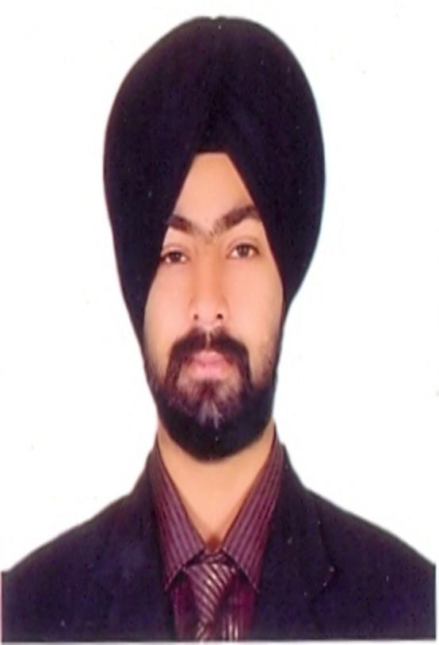

INDERPAL SINGH MADAN
Career Objective

I wish to work in an organization that would give me adequate exposure and experience to grow and excel in my career as well as to make a positive contribution towards the objectives of the organization.
Overview

- Specialization in HR, Strategic Management and Project Management.
- Over 1 year of experience in Technical core field of Electronics.
- Over 1 year 6 months of experience in placements/Recruitment from Education Industry.
- Over 1 year 4 months of experience in HR from Manufacturing Industry.
- Over 1 Year 6 months of experience HR from Recruitment Industry.
- Proficient in managing, motivating, and influencing team members for running successful business with proven ability of achieving Service Delivery and Process Targets.
- Done 6 weeks training in networking field from TCIL-IT, Chandigarh .
- Done 6 months training in the field of security systems (core electronics field) from Blue Beacon Security Systems, Mohali.
Qualification
I have done B.TECH in ECE Trade from CT INSTITUTE of Engg, Mgmt, & Technology Jalandhar and MBA (HR) from Sikkim Manipal University.
Education

Academic Records:

Qualification | Institution | Board/University | Year | Mode | Percentage
MBA(HR) | Lipika Infotech(LC) | Sikkim Manipal University | 2010-12 | Distance | 63%
B.Tech(ECE) | CTIEMT,Jalandhar | PTU | 2006-2010 | Regular | 70.80%
10+2 | DMS Jalandhar | C.B.S.E Board | 2006 | Regular | 65.20%
Matric | DMS jalandhar | C.B.S.E Board | 2004 | Regular | 52.80%
PROFESSIONAL EXPERIENCE:
Total Experience: 5Yrs Approx
- “Trainee Engineer” with Blue Beacon Electronic Security System P.ltd, Mohali since 21 Jan,2010 to July, . During the initial training period extensively being trained on technology aspects of various electronic security systems i.e.

CCTV surveillance systems, Access control systems, Intrusion Detection systems, Fire detection systems and Alarm systems at Blue Beacon”Carreer development centre-NISS” in Mohali.

(2) I worked as Training & Placement Executive from 16 March,2011 to 31 Aug, 2012 in CT
Group of Institutions.

(3) I worked as HR Cum Production Manager at Krishna Engineering Works Limited (Auto Part
Manufacturing), Jalandhar from September 2012 to Feb 2013.

(4) I worked as a HR Manager at RFH Solutions Pvt Ltd. Jalandhar from Feb 2013 to
November 2013.

(5) I worked as a HR Manager at Vendor plus Consultants Pvt Ltd. Delhi from November
2013 to September 2014.

(6) Currently I am working as a HR & Marketing Manager at Sharp Educational Services, Delhi.
Key Responsibilities
- To maintain and develop HR policies
- Recruitment, Volume Hiring.
- To develop the HR team, to ensure the provision of a professional HR
service to the organization. Manage a team of staff.
- To ensure timely recruitment of required level / quality of Management
staff
- Ensure appropriate communication at all staff levels
- Check the monthly salary and maintain leave records.
- To maintain and develop leading edge HR systems and processes to
address the effective management of people in relation to the following
in order to maintain competitive advantage for:
Performance Management.
Staff Induction.
Reward and Recognition
Staff Retention
Management Development / Career Development
- Oversee the central HR Administration –
Employee offer letters
Salary letters and employment contracts
Maintain complete / accurate personnel records.
- Check the lists of PF, ESI, Wages, Bonus etc.
- Handle the legal labor court cases related to PF under the guidance of lawyer of organization.
- Client handling and develop relations with client for business development.

Strengths

- Never give up Spirit and adaptability to change.
- Having a calm temperament to work under stress.
- Positive Attitude
- Hardworking
Personal

Name : Inderpal Singh Madan

Father’s Name : S.Jagmohan Singh Madan

Marital Status: Married
Date of Birth : 29-05-1988
Permanent Address: Hno.1349, Urban Estate Phase-2, Jalandhar.
Temporary Address: Pandav Nagar, Delhi-92
Mobile : 09990812937, 09855601349
Email : ipsmadan@gmail.com

Hobbies

- Attending Events & Motivational workshops.
- Traveling
- Listen to music.
- Play games like Cricket, hockey etc.

(Inderpal Singh)

