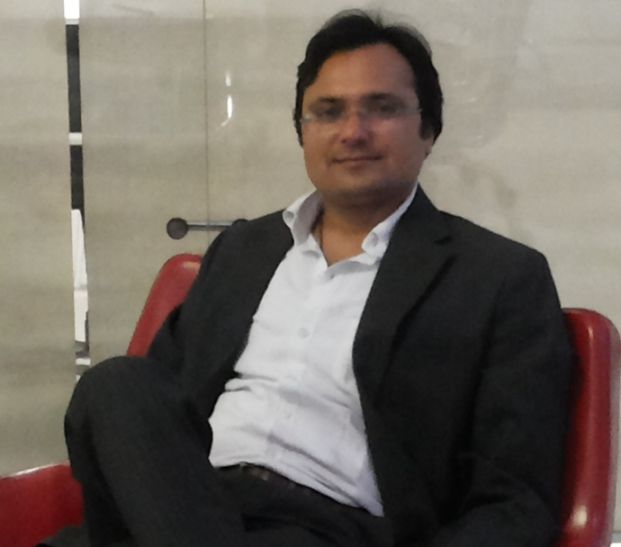
KAPIL NAYAK
- +91-9990790489
d.kapil05@yahoo.com
Flat No.344, Rose Apartment, Sector -18 B, Dwarka, New Delhi.

EXPERIENCE SUMMARY
I have Eight years of experience into HR Generalist role. I am presently working as Assistant Manager - HR. I have been responsible for the HR functions such as Recruitment, Operation, Employee Relation, Talent Engagement, statutory compliance, PMS, Administration.


Current Organization : Netafim Irrigation India Pvt. Ltd.
Designation : Assistant Manager – HR
Period : February 2012 onwards
(Netafim is the world's largest and leading company in the field of smart irrigation solutions for agriculture and landscaping)
Profile Summary:
  - Handling North India.
  - Taking care of 200+ Manpower in North India.
  - Taking care of General Administration of 01 Regional Office & 02 Warehouse.
Recruitment and Selection:
- Streamlined Recruitment & Selection process and recruited 100 +positions across levels.
- Management of the complete recruitment life-cycle for sourcing the best talent from diverse sources after identification of manpower requirements.

HR Operation:
- Responsible for handling monthly HR MIS, Attrition Trends and Manpower Dashboard for North India.
- Implement HR notice board, HR Newsletter & HR Suggestion Box.

Talent Engagement:
- Organization Structure: Defined framework for Organization Structure, prepared Organization Structure for North India.
- Performance appraisal: Responsible for driving the performance appraisal exercise for 200+ employees for North India.
- Reward & Recognition: implemented “Rewards & Recognition” scheme for Sales workforce and launched “Employee Club” for Officer Cadre Employees of North India. “Employee of the month” for Sales & Non Sales workforce.
- Training & Development: Instrumental in establishing Training & Development process for 200 employees.
Payroll:
- Gathering & Verification of Monthly Attendance from Employees.
- Maintaining a Leave Database and generating Monthly Leave Sheet.
- Take care of Compliance related to Office & Warehouses.
Welfare Activities:
- Induction & Orientation of new Employees.
- Grievance Handling & Counseling of the employees.
- Counseling / communicating Company policies to Employees.
Separation /Exit process:
- Exit interview, No Objection Certificate.
- Full & Final statement.
- Issuance of resignation acceptance, experience & relieving letter.

General Administration:
- Have exposure in setting up New Office & Warehouse.
- Co-ordination with placement cell/ recruitment agencies/Campus for various vacancies.
- Vendor Management – Hotels/Cabs/Stationary etc.
- Asset Management.


Previous employer : Lilliput Kidswear Limited.
Designation : Senior Executive -HR
Period : March 2010 – February 2012
(One of the dominating players in the Indian Branded Kidswear segment)
Profile Summary:
  - Handled North region with 5 States (J & K/H.P. /Punjab/Haryana/U.K&U.P.).
  - Handled 47 Stores with 350 manpower.
  - Done the recruitment for 16 upcoming stores through Head Hunting, Portal & Campus.
  - Done the recruitment for General Manager Level for Operation Department.
Recruitment and Selection: Streamlined Recruitment & Selection process and recruited for positions across levels. Have exposure in bulk hiring.
HR Operation: Responsible for driving transactional HR from Offer letter, onboarding, personnel record management, induction, data management and grievance handling.


Previous employer : Vishal Retail Limited.
Designation : Executive -HR
Period : February 2007 – February 2010
(One of the largest retail chains named “Vishal Mega Mart” spread all over India)
Profile Summary:
  - Was taking care of recruitment for PAN India including FMCG, Apparels, and General Merchandising etc. departments.
  - Done the recruitment till Vice President Level for CDIT Department.
Recruitment and Selection: Streamlined Recruitment & Selection process and recruited from Executive till VP level positions across India.
Talent Engagement:
- Involved in making and modification of Organization Structure.
- Co-ordination with functional team for making Job Description.
- Developing & maintaining KRA’s of the respective Department’s.

Academic & Professional Qualification

- Masters in Business Administration (Year 2005-2007) Specialization: Human Resource Management from ICFAI – INC.
- Masters in Arts (Year 2000-2002) Specialization: History
- Bachelors of Arts (Year 1997-2000) from Allahabad University.

Date:
Place: KAPIL NAYAK

