RESUME
N. MURALI
Email : muralineeladme@gmail.com
Mobile No: 9789711488
Mobile No: 7418507149.
Career Objective:
Desire to work in a company that uses my knowledge, talent, hard work, dedication and sincerity in a well manner. I am looking for the great opportunity as a production engineer that offers me challenging assignments, professional development and career growth.
To obtain a NDT Technician position in an organization with potential to expand and grow.
Educational Qualification:
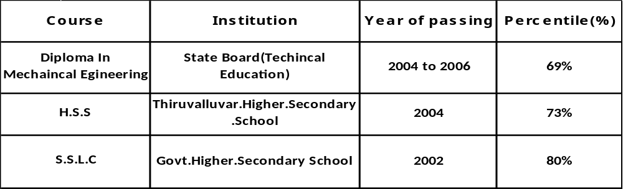
Certifications:
Level-II RT ASNT SNT-TC-1A
Level-II UT ASNT SNT-TC-1A
Level-II PT ASNT SNT-TC-1A
Level-II MT ASNT SNT-TC-1A
Offshore Survival Course
Familiar With Following NDT Equipment / Methods:

MT - Electromagnetic Yoke with wet Florescent.
UT - Modsonic
PT - Carried our fluorescent Dye Penetrate Testing of welding, nuzzles,
Heat exchangers tube bundles including Ferrous and non ferrous metals
Using solvent removal and water washable methods
Hardness testing of welds joints with hardness test.
RT - Interpreting the films.

NVH INDIA AUTO PART PRIVATE LTD
CHENNAI

Date of Joining :06rd Sep 2012

Position : Production Junior Engineer
From 06rd sep 2012 to Still date.
Role of Responsibility
- Knowledge on FIFO(First In, First Out)
- Follow up with customer.
- Plan to Setting Hydraulic Press Machine such as 200T, 100T
- Planning day to day production to achieve maximum production.
- Arranging, repairing and maintaining tools.
- Increased Direct Labor Performance in this area from 62% to 88%
- Decreased Rework in this area from 13% to 5%
- Troubleshooting and solving technical problems.
- Handling skilled manpower and administration of shop floor.
- Record preparation of tool history coordinating with purchase, planning, stores, tool room.
- Responsible for suggestion and Kaizen activities.
- Removing useless work.
- Development of operator through multi skill.
Work Experience;

Sharda Motor Industries Ltd., Located at Mahindra World City Near Chennai.

Date of Joining :23rd April 2007

Position : Production Engineer
From 23rd April 2007 to 25rd Aug 2012.

I have involved all kind of activities in Production sequences and quality based production. Those project is major kind of operation is carried out in pipe shop and press shop.

Role of Responsibility

- I have responsible PIPE SHOP UNIT AND PRESS SHOP UNIT.
- PIPE BENDING MACHINE with using CNC,.Bansaw cutting Machine And TooolSetting And Solving Techincal Problem.
- Knowledge Setting Press Machines Such As 630T,250T,200T.100T,80T And
Tool Setting And Solving Techincal Problem.
- Distribution of work load to operators in order to achieve daily production target.
- Reponsible for suggestion to KAIZAN ACTIVITIES.
- Conducting continuous improvement projects.
- Arranging certain training programs to enhance productivity using improvement techniques such as 3c and 5s.
- Analyze overall eguipment effectivenss(OEE)& line effectivens (OLE) and prepare action plans to improve the machine effectivenss.

Planning:
- Knowledge on FIFO.(frist in ,first out)
- Follow up with Customer.
- Planning day to day production to achieve maximum production.
- Record preparation of tool history coordinating with planning,tool room.(production based)
- Preparing all documentation to TS16949(QMS).

Work Experience
Organization : M/s Greeves Cotton Petrol Engine Unit.,
Designation : Trainee
Duration : .6 Months

Personal Profile:-

Father Name : Mr. M. Neelakandan

Permanent Address : No.6/71, Kamatchiamman Pet,
K.V. Kuppam, Katpadi (Taluk),
Vellore (Dist),
Pin – 632 201.

Date of Birth : 24.07.1986

Language : Tamil & English

Address for Communication : No.30, Baskar Iyer Complex,
Kollaimettu Street,
Singaperumal Koil,
Kancheepuram District,
Pin – 603 204.

Emerancey No : 7708460159

Passport Details:-

Passport No : G2107863

Date of Issue : 29.03.2007 To 28.03.2017

Declaration

I hereby declare that the above – furnished information’s true to the best of my knowledge and belief.

Place: Chennai N.MURALI
Date :

