ANISH KUMAR
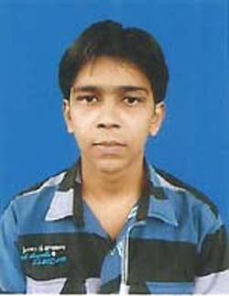
SANJAY PRASAD
VILLAGE – Jealgora No. 07, Near 7 Pit
Post – Jealgora, PS – Jorapokhar, Dhanbad
Jharkhand (828110)
Contact No. 8210957535 Email ID – mailanish21@gmail.com
PERSONAL DETAILS
Father’s Name – Sanjay Prasad
Mother’s Name – Mala Kumari
Postal Address – Jealgora No. 07, Near 7 Pit, Post – Jealgora, PS – Jorapokhar, Dhanbad, Jharkhand (828110)
D.O.B. – 20th April 1995
Language - Hindi, English
EDUCATIONAL QUALIFICATION
- Secondary- Kisan high school,nawada with 56% marks.
- Diploma- Electronics and Telecommunication Engineeering from W.B.S.C.T.E with 73.5% marks.
- Engineering- Electronics and Communication FromAryabhatta Institute Of Engineering and Management Durgapur (West Bengal) with 7.5 Cgpa
TECHNICAL SKILLS
- Installation and ConfigurationDesktop PC,OS Installation,Formating, Software Installation etc.
- Crimping Cables and Connectors. Managing workgroup and Domain Env
- Concept of OSI Layer and IP Adressing.
- Installation of Windows XP,Windows 2007,2003 Server,2008 Server, Exchange Server 2003
- Knowledge of AD, DNS, DHCP,VPN,FTP,SMTP,NTFS,FAT32.
- Diskquota,Volume shadow copy,RAID,Mounting etc.
- User account policy,Grouppolicy and User profile management.
- File Folder Sharing,InternetSharing,Printer Sharing.
Languages
- MATLAB, C, HTML, CSS, JAVASCRIPT
Academic Projects
1.Company- InfolabPvt Ltd 45 days (From 10/04/2016 to 25/05/2016)
Project- Domain Name System (DNS).
2.2G/GSM & Network Operator (GNTS Pvt Ltd) 45 days (From 05/08/2012 to 22/9/2012)
GSM Basics,RFSurvey,Drive Test
ACHIEVEMENTS & PARTICIPATION
- Participated in Technical fest of Graduation College.
HOBBIES
- Reading Books, Internet Surfing, Listening to Music and Playing Cricket.

Anish Kumar
Signature

