BIBEKANAND PANDEY 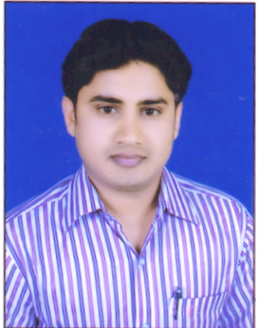
Address:- C/O B.K. singh
Post +P.S. - Namkum .
Dist. – Ranchi .Pin: -834010
Mobile No: - 09162183017.9155687337
Email: -bibekanand.pandey@yahoo.co.in
bibekanand.dsmindia@gmail.com
Objective: -
To work in challenging Embedded Systems environment that gives me an opportunity for contributing towards Technology and overall professional development of the organization

Work Experience 1 : -
DSM INFOCOM PVT. LTD. (April 2010 to May 2015) in base of networking lease line ISDN Line and V-Set, Router & Switch Configuration.
Bhartia airtel LTD. In base of verification of the lease circuits & line tested.

Work Experience 2 : -
Working as Network Engineer at UTL Pvt. Ltd., in JHARNET NOC, Ranchi since April, 2015.

Job Responsibility: -
Technical:
- Loop Testing
- Creating VLAN Configuration of CISCO Switches
- IP Configuration of CISCO Routers
- Troubleshooting basic problems related to Networks.
- Creating and Troubleshooting of LAN.

Non- Technical:
- Maintaining Register.
- Making of Govt. Reports for JAPIT.
- NMS Reporting .

Academic Credentials:-
- B. Tech from Ranchi University in year 2010 with 1st Class.
- I. Sc. From J I E C, Ranchi in year 2003.
- Metric from B S E B, Patna in year 2000.

Technical Skills: -

Have a good knowledge of CORE NETWORKING & TROUBLESHOOTING.

- Network configuring and troubleshooting.
- Configuring CISCO Switches & Routers.
- Creating and Troubleshooting of LAN.
- Basic switching and Routing.
- Configuring and troubleshooting Ethernet related issues.

Certifications:-
- Completed CCNA and CCNP from IHT Institute Technology , Ranchi .

Academic Project: -
- Title:-Implementation of Information System for Library of HINDALCO INDUSTRIES LTD, Renukot, Utter Pradesh.
- Assign Project in College for ONLINE EXAMINATION

Personal Dossier:-
Father’s Name : BholaNath Pandey
Occupation : Business
Date of Birth : 22 .Dec, 1984
Marital Status : married
Sex : Male
Religion : Hindu
Language Known : Hindi & English
Permanent Address : S/0:-BholaNath Pandey .
Vill+P.O. : –Ranka Raj.
Dist. Garhwa (Jharkhand ). Pin – 822125,
Strengths : Hard Working, Quick learner and good listener
Self motivated and enthusiastic personality

Hobbies : Very friendly and communicate with people easily

Place: Ranchi Bibekanand Pandey Date:-……………… (Signature)

