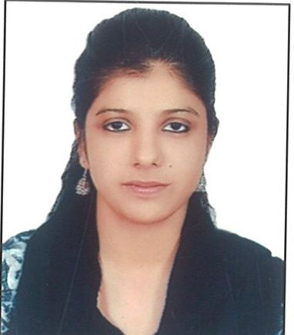
CURRICULUM VITAE

NAME - Mariyam Mansoor
PERMANENT ADDRESS- 6/3007, Chippiyan Street, Khumran Road, Saharanpur(UP)
E- MAIL- mariyammansoor101@gmail.com
CONTACT- 8077850704

OBJECTIVE:
Aspiring for a job in a growth oriented organization, where my organization skills can be used for making a positive contribution in the human resources department by putting in maximum efforts.

EDUCATIONAL BACKGROUND

Post Graduation in Organizational Behaviour | Amity University | 1stDiv
Graduation (Hons. Psychology) | Kurukshetra University, 2013 | 1st Div
Intermediate | CBSE Board, 2010 | 1st Div
Matriculation | CBSE Board, 2008 | 2nd Div

WORK EXPERIENCE
- Research Assistant at STAR SHINE MEDIA Pvt. Ltd, DEHRADUN

- Internship at RAJIV GANDHI CANCER INSTITUTE, ROHINI, NEW DELHI

- Internship at ADVANCE INDIA PROJECT LTD, GURGAON

- Internship at WHEEBOX, GURGAON

- Project with IIT DELHI

EXTRA CURRICULUM ACHIEVEMENTS
Certificates in Science Olympiad, G.K, Sports, Singing, Debate, Medals, Trophies, Merit Certificate

PERSONAL DETAILS
Father Name: Mr. Mansoor- Ul- Haq
Mother Name- Mrs. Fatima Mansoor
Date of Birth- 30/06/1991
Nationality- Indian
Marital Status- Single
Languages known- Hindi, Urdu, Arabic, English, German
STRENGTHS
- Dedicated towards work and goals.
- Ability to adapt in accordance with dynamic environment.
- Willingness to learn new skills and tasks.
- Ability to work in team and be cooperative with every team member.
- Mastering written and verbal communication skills.
- Confidence of performing to a high standard in a role requiring good process management skills, attention to detail and ability to juggle multiple tasks and priorities.
- Proficient computer skills: Word, Excel, Powerpoint, Outlook
- Belief in Diversity

HOBBIES
Working, Eating, Shopping, Reading, Adventure, Learning, Sports.

DECLARATION
I hereby declare that the above information is best of my knowledge.

