Vishal Sehgal  Father’s Name:  Mr.Sanjeev Kumar Sehgal  D.O.B : 1992-10-08  Gender : Male  Contact No: 9045371849  Languages Known: English, Hindi,  Urdu and Punjabi  Email: vishal.sehgal9713@gmail.com | Permanent Address  H. No. 3/2, Islamabad Bhatta Laxmi Bai Marg, Aligarh | 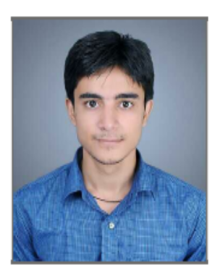
OBJECTIVE:
To reach the highest echelons in an organization with hard work, dedication and constant endeavor to perform better and give results.

ACADEMIC:
Examination | Year | School/College | Board | CPI/%
B.E. Mechanical | 2015 | ZHCET | AMU | 6.9
Diploma Engineering  (Mechanical RAC) | 2011 | University Polytechnic | AMU | 79.66%
High School | 2008 | AMU City High School | AMU | 66.6%

TECHNICAL SKILLS:
Designing software: AutoCAD.
Windows: Windows 7, XP, 98.
Microsoft packages: MS Office.

ACHIEVEMENTS:
- Student Placement Coordinator at Training Placement Office AMU during session 2014-2015.
- Qualified Graduate Aptitude Test in Engineering (GATE) 2015.
- Medal during School Days in Cyber Olympiad Competition.
- Organized Workshop on Animation, AutoCAD and Catia.
- Core team member of Recrufest’15 Job Fair.

HOBBIES/EXTRACURRICULAR ACTIVITIES:

- Sports.
- Dancing.
- Active participation in various quiz competitions.

STRENGTH:
- Quick grasping power.
- Team worker.
- Patience.

PROJECT:
- Effect of Buoyancy on Laminar Flow Past Array of Heaters in A 2-D Adiabatic Channel in Diploma final year.
- Testing of engine as per EURO IV norms at Indianoil R&D center, Faridabad.
- Designing of Human Powered Freight Tricycle in BE final year.

SUMMER TRAINING:

One month summer training at Research and Development centre, Indianoil Corporation Limited, Faridabad.

DECLARATION:

I do hereby declare that the above furnished information is true to the best of my knowledge.

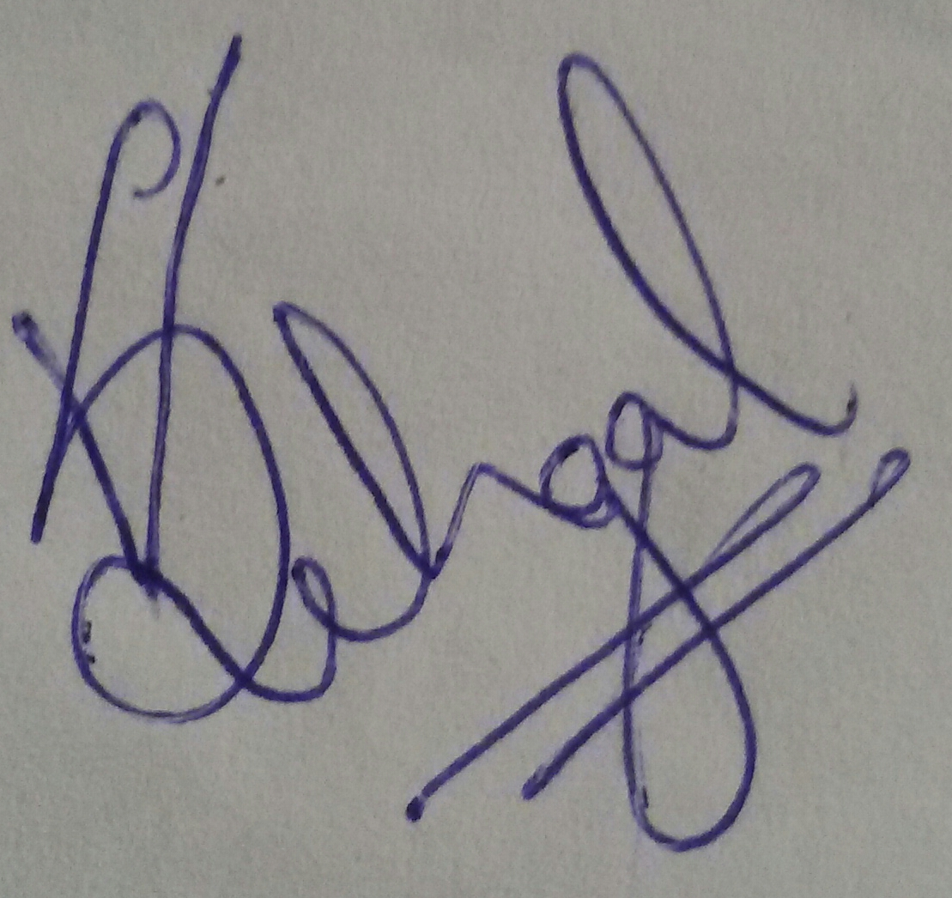
(Vishal Sehgal)

