CURRICULUM VITAE

Amarjeet sing 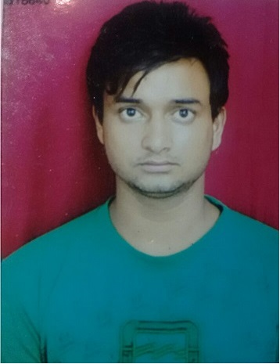
91-8303040988
E-Mail:amarjeet123123@gmail.com

Career objective

To associate with a professional organization where in all the organizational related knowledge and all the skills like team work flexibility, are shared and enriched for the growth of organization as well as personal career.

Educational qualification
- Done BBA from Seth Vishambhar Nath institute of higher studied during 2012-15
- Passed Intermediate from Govt. Boys Se. Sec. School Nangloi Delhi
- Passed high school from from Govt. Boys Se. Sec. School Nangloi Delhi

Summer Training Programs & Projects
- Completed 2 months summer training in “coco cola barabanki ” operations , marketing & sales. (target market research and consumer relation )

- Completed 2 months summer training in “Omrays media Pvt. Ltd.” Operations , HR. (Employee compensation system.)

SNAPSHOT
- A result-oriented professional with 2 years of experience in Logistics, Supply Chain Management.
- Presently associated with Grofers India PVT. LTD. as Station Manager
- Adroit at handling day to day administrative activities in co-ordination with internal/ external agencies for smooth business operations.
- Deft at planning and monitoring E-commerce operations.
- Well versed with ERP on execution of Order Management and Dispatches.

PRESENT EMPLOYMENT STATUS

Since Auguest’11th Asst. Station Manager .
Company profile

We are a local mobile e-commerce platform that is transforming the shopping experience for people like you, by connecting them to local stores. We aim to become the one-stop shop for all your daily needs. Users can order through the app and get everything delivered to their doorstep, with in 90 mins.

We offer a wide assortment of groceries, fruits and vegetables, cosmetics, electronics, bakery items, flowers , pet care , baby care, skin care, and much more.
JOB RESPONSIBILITIES
- Formulating the Logistics strategy for daily operations.
- Handling the procurement and fulfillment issues.
- Ensuring proper collaboration among multiple delivery fulfillment centers.
- Preparation of delivery and inventory report on weekly basis.
- Managing the cash/accounts of Station
- Order Processing and ensuring on time Delivery.
- Ability to hire and manage a distributed team.
- Meeting the company’s performance expectations and ensuring timely reporting & invoicing.
- Lead a team of more than 50 order fulfilment executives an ensuring on time product deliveries.

Previous Company

The Gamba Group(from November 2013 till August 2015) As team leader
Company profile

The Gamba Group is a leading, Lucknow based, real estate development group, with over 6 years of experience in developing residential and commercial projects. Established in 2009, it has a diverse portfolio of over many completed projects. Backed by extensive experience in developing world class properties in India, we ensure that our projects deliver true value to our customers in return for their investment in real estate. Gamba Group is one of the leading real estate development companies in India, Developing various commercial as well as residential projects in various cities.

Computer Literacy:

Environments : MS DOS, Windows
Office Applications : MS-Office , MS Word , Order deliver dashboard Oracle

Strengths:
- Result Oriented & Problem Solving attitude
- Flexibility & Team Player
- Working under pressure till deadline

Achievements & extra-curricular activities:
- Attend the Indian Traditional dress competition, seth vishambhar nath institute of higher studies and covered 1st position.
- Participate in organizing committee of different events like quiz, games, college competition in SVN. Barabanki
- Industrial Visit to coca cola barabanki , Barabanki (U.P)

Personal information

Date of birth : 15th jun, 1993
Father Name : Talukdar singh
Mother Name : Kamlesh singh
Permanent Address : D 519 nangloi Camp No. 2 DELHI - 110041

Gender & Marital status :Male & Single
Interests : Domestic traveling ,Computer Gaming , listen music
Languages known : English, Hindi

Date Amarjeet Singh

