ANJALI RAI
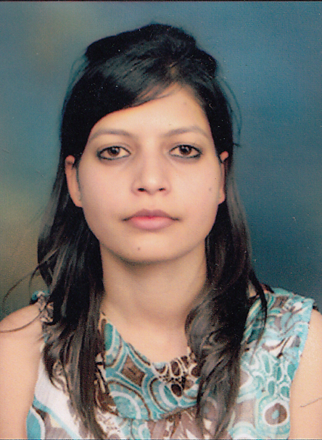

H.NO. 21
Vill Samaspur Jagir Mobile : 9459412422,9599281859
Near F Block , Pandav nagar Email:anji.times67@gmail.com
Delhi 110091
CARRIER OBJECTIVE
To enhance my knowledge acquired from my engineering degree and to best utilize my capabilities, I would like to pursue a growth in an organization/company. This will bring evolution to my learning plus gaining practical experience.
ACHEIVEMENTS

- Yearly Scholarship from Directorate Himachal Government for academic excellence
- Achieved certificate of participation in 2 Days MATLAB workshop held by NIT Hamirpur (H.P).
- Achieved completion certificate of SCILAB online test by IIT, Bombay.
- Achieved completion certificate in The Design And Analyses Of Algorithm (DAA) online course administered by Microsoft Research, Bangalore India from January 2014 to May 2014.
- Achieved certificate of participation in Arduino Microcontroller workshop at JNGEC, Sundernagar (H.P.).
- Active member in College Electronics Club.
- General Secretary in College Indian Society for Technical Education (ISTE).
SOFTWARE AND HARDWARE SKILLS

- Programming Languages : C , basics of JAVA
- Software worked on : MS Office, MS Powerpoint, MATLAB, CodeVision AVR, Tina and Proteus 8 profession for simulation, FLASH.
- Basic knowledge of : Microcontroller 8051, AVR, microprocessor
8085,8086 ,embedded system (Basic and Advanced).
ACADEMIC CREDENTIALS

Course | College/University | Year | Aggregate
B.TECH  (Electronics and Communication) | Jawahar Lal Nehru  Govt. Engineering College  Sundernagar (H.P) | 2011-2015 | Agg.- 76%
Senior Secondary School examination(Class XII) | Govt. Sr. Sec.  Model School  Sundernagar (H.P)  (CBSE) | 2011 | 85.8%
Secondary School examination(Class X) | Govt. Sr. Sec.  Model School,  Sundernagar (H.P)  (CBSE) | 2009 | 90.6%

- Pursued 6 weeks Training in Embedded Systems using 8051 microcontroller Eureka Electrosoft Solutions Pvt. Ltd, Chandigarh where I interfaced LED, DC Motor, Relay, Stepper Motor, Seven Segment LCD .
PROFESSIONAL TRAININGS
- Pursued 6 weeks training in Advanced Embedded system with basic Matlab
in White Matter, Shimla.

PROJECTS UNDERTAKEN

- An Embedded Password Security Door Lock System and Fire Alarm system using microcontroller IC (AT89C51).
- An RFID based Attendance System using Atmega16
MAJOR PROJECT

- ACCELLEROMETER based Gesture Controlled WHEEL CHAIR

EXTRA CURRICULUM ACTIVITIES

- Actively participated in debate and speech competitions in school and college
- Member of College Dramatics club
- Member in College Fest Quiz competition
- Got 3rd prize in making and flying of Hot Air Balloon during Tech Fest.
- Got 2nd prize in Slogan Writing competition.

STRENGTHS

- Self disciplined , self- confident and hardworking
- Co-operative and adjustable nature
- Strongly self motivated. I thrive on challenges and a committed profession

- Willing to learn new things

PERSONAL DOSSIER

Father’s Name : Mr. Chuni Lal Rai
Mother’s Name : Mrs. Rita Rani
Date of Birth : 30-06-1992
Nationality : Indian
Marital Status : Unmarried
Sex : Female
Languages Known : English, Hindi, Punjabi
Hobbies : Painting, Reading Novels, Listening Music, Cooking

ANJALI RAI

