CURRICULUM VITAE
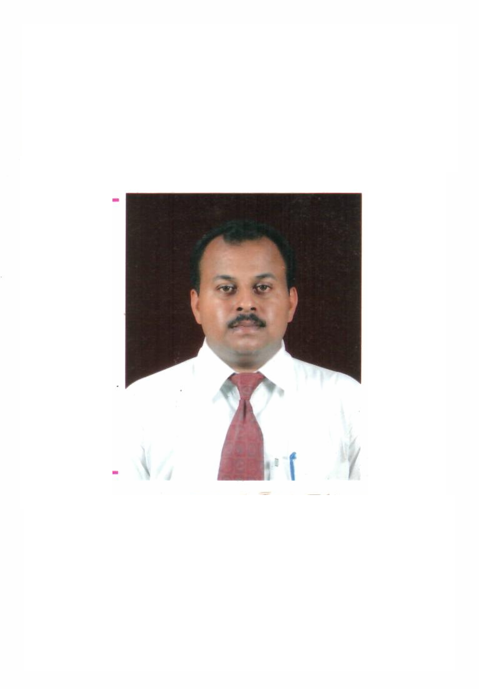

Ashina Le Residency , Golf Link
G-Tower,G- 908, Ghaziabad-201001
Mob: 9818963138,0120-6609391
VIJAY SRIVASTAVA
Email: Vijaysri9@rediffmail.com
Skype id : vijay.srivastava65

OBJECTIVE

To work hard in your reputed Organization & to make it to peak by using my self-talent & coordination of other employees effectively to achieve the objective of the Organization.

Organization : SRMB Srijan pvt. ltd. (2ND APRIL 2016 – till date)
Durgapur works (Construction material division-rebar manufacturing) : The plant is located at Durgapur (West Bengal) and is one of the most modern rebar rolling units in the country today incorporating Block Mill technology, TEMPCORE quenching technology from CRM, Belgium. The plant is BIS & IMS Certified (ISO: 9001, ISO : 14001 & OHSAS :18001). The division has a lot of firsts to its credit in the steel industry. Some of the major ones are as follows: It is the one of the leading integrated primary producer of steel that manufactures finished steel from iron ore. It is the first to obtain DGS&D rate contract for TMT Bars. It is one of the first to introduce TMT Bars in the Indian market. It is the first organization in INDIA to deploy recognized TMT Process control technology i.e. "Tempcore" from CRM, Belgium, for manufacturing TMT Bars beyond Fe 500 grade. SRMB Srijan Private Ltd is the first and only company in INDIA till date to be granted TMT Process control technology up to Fe 550 grade. SRMB Srijan Private Ltd is one of the first steel manufacturers in INDIA to have achieved IMS (Integrated Management System) which comprises of ISO 9001, ISO 14001 and OHSAS 18001 for Quality Control / Environmental Management / Operational safety and security System. SRMB Srijan Private Ltd is one of the first steel manufacturer in INDIA to install "no twist V Block mill "a high precision rolling mill for manufacturing of TMT Bars. It is currently one of the very few manufacturers in ASIA and INDIA having a capacity of manufacturing up to 50 mm TMT bars. SRMB's quality control system is equipped with highly sophisticated Digital Universal Testing Machines for both on line and offline testing of mechanical properties of TMT Bars. Chemical parameters of raw materials & SRMB TMT Bars are measured through imported German spectrometers. The following are the product lines from Durgapur unit:

Job Profile:

- To develop TMT & Structure Dealer in U.P. ( East & West), and Delhi- NCR (Deals in OE Customers & Dealer Network).
- Looking after the OEM Parties (Original Equipment of Manufacturer) and Local Dealers.
- Develop market and plan marketing strategy for all state.
- Plan Mason , Fabricator ,Contractor , Engg. and Arch. Meeting.
- Plan sales promotion activities .
- Check all executives and manager working time to time.
- Liaison with the works for execution of orders and Govt. dept.
- Work with Project.

  - Post : AGM. ( Retail Marketing )
  - Nature of Job : Marketing

Organization : Rathi industries (11 may 2015 – 18th march 2016)

Company Profile : Rathi Industries Ltd. is part of the RATHI STEELS group, which has been the pioneer in the field of manufacturing reinforcement steel bars (REBARS) for past more than 70 years. The combined Rathi group has an installed capacity of nearly one million tons of bars and rods with a market share of 45% in North India and overall production of 10% of steel rolling capacity on all-India basis.
Due to the sheer size and scale of operations of the entire group as a whole, every consumer of steel in the country is familiar with the brand "RATHI". The Group was the first in the country to create brand equity in steel bars and rods way back in 1965. Established in 1942, the RATHI STEELS group has been the pioneer and market leader in manufacturing of high quality steel bars. Continuing the legacy, RATHI has emerged as the largest selling brand in steel bars and rods

Job Profile:

- To develop TMT Dealer in U.P. Uttranchal and Delhi- NCR (Deals in OE Customers & Dealer Network).
- Looking after the OEM Parties (Original Equipment of Manufacturer) and Local Dealers.
- Devlop market and plan marketing strategy for all state.
- Plan sales promotion activities like dealer meet. Dealer training , Arch. Meet etc.
- Follow ups the Customers time to time & collect the payments on time.
- Liaison with the works for execution of orders and Govt. dept.
- Work with Project.

  - Post : G.M. (Sales and Marketing )
  - Nature of Job : Sales & Marketing

Organization: LOHA ISPAAT LTD (29th july 2013 – 10th may 2015 )

Company Profile : Loha Ispaat Limited has been providing exemplary steel processing and services for our esteemed clients since 1985. We are one of the most reputed Independent Steel Service Centre (SSC) in India, and we have built a strong credibility among our customers, with unparalleled quality and services.
Our company has developed a much diversified portfolio in the field of steel processing and finishing services like Cut to Length, Slitting, Cold Rolled and Hot Rolled pickling, galvanized painted cold rolled steel, flattened steel etc, in accordance to the specifications provided by our valued customers.
Our company is rated among the top Steel Service Centers in India that operates independently. Our services act as the perfect liaison between main metal producers who supply huge volumes of limited configurations and sizes, and the end customers who require customized steel products in small quantities.
Currently our production units are located in Khopoli and Taloja, which stretches beyond 23 acres of land area in the state of Maharashtra. The outstanding quality that we provide is facilitated with the cutting edge new techniques, state of art infrastructure, and the most sophisticated equipment that we use. Our primary focus is to exceed the customer expectations on each and every given instance.
Our brand is synonymous to dependability, quality, exceptional commitment and efficient leadership. These qualities have made it possible for us to become one of India’s leading one stop solution providers for steel processing. The credit of our success also goes to our employees who have efficiently managed to exceed customer expectations on every given opportunity.

Job Profile:

- To develop CRCA and HR Consumers in U.P. Uttranchal and Delhi- NCR (Deals in OE Customers & Dealer Network).
- Looking after the OEM Parties (Original Equipment of Manufacturer) and Local Dealers.
- Follow ups the Customers time to time & collect the payments on time.
- Liaison with the works for execution of orders.

  - Post : Sr. Sales Manager
  - Nature of Job : Sales & Marketing

Organization: R. S. Steels ( 9thJune 2003 – 28-07-2013 )

Company Profile: ‘R. S. Steels’ is an authorized distributor of TATA STEEL LTD in territorial area of Western U.P. & Uttranchal. R. S. Steels is an ISO: 9001-2000 Certified and deals with Branded Flat Product (CRCA Sheet)
Job Profile:

- To develop CRCA Consumers for TATA STEEL in West U.P. & Uttranchal. (Deals in OE Customers & Dealer Network).

- Looking after the OEM Parties (Original Equipment of Manufacturer) and Local Dealers.

- Liaison with the works for execution of orders.

- Sales Promotion Campaign by organizing OE & Retail Meet.

- To provide Technical support to our customer with Technical Engg. Of TATA STEEL.

- To organize Knowledge Sharing Sessions to refresh our customers’ knowledge regarding Product Quality.

- Follow ups the Customers time to time & collect the payments on time.

  - Post : Sales Manager
  - Nature of Job : Sales & Marketing

Academic Qualification

- B.A. from M.J.P. Rohil Khand University. Bareilly.
- MBA from M.J.P. Rohil Khand University. Bareilly.
Computer Skills

- One year Diploma in computer software from SCEC Bareilly.
(MS Office, Excel. Power Point packages & Net Surf Tools)
- One year Diploma in computer Hardware from jet king Institute, Noida.
STRENGTH

- Positive Attitude
- Confident & Soft Behavior
- Good Relations Building Capability.

Personal Details

Date of Birth : 20th Oct, 1976
Father’s Name : Retd. Col. N.P. Srivastava
Father’s Occupation : Doctor
Marital Status : Married
Language Known : Hindi, English
Current CTC : 9 Lac pa + 5 Lac medical Insurance + Four wheeler expenses @5.75/-per Km + maintenance.

Date :

Place :
[VIJAY SRIVASTAVA]

