RESUME | 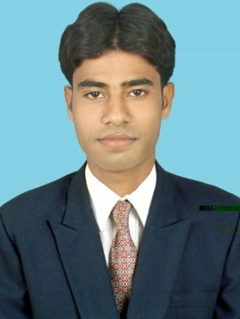

Asish Kumar Bhadra Mobile – 918457869253, 8599001957

E-mail- asish.kumar33@gmail.com

CAREER OBJECTIVE

To leverage my skills towards the organization with a desire to work in a Professional Environment and relate my growth with the organization I work for.

PROFESSIONAL QUALIFICATION

Diploma in computer hardware & networking form JETKING.

Skill:

- Installation : WIN 98,WIN XP, WIN 2000, WIN SERVER 2008, Windows 7/8
- Installation of LAN and Wi-fi
- Configuration of MS Outlook
- Installation of CCTV Camera
- Fortinet Firewall configuration
- Installing configuring and Administrating active directory, installing and managing domain trees and forests, IP addressing and subneting, OSI layers.

Key Responsibilities:

- Maintain troubleshooting the Hardware problems & installation administration and configuring of O/S (WIN 98,WIN XP,WIN 2000,WIN SERVER 2008)

EXPERIENCE

- Now working SMV BEVERAGES PVT & LTD ,BARGARH (PEPSI).as a Executive IT from 1st Jan 2017 to Onward.

- AUTHARISED SONY SERVICE CENTER M/S FORTUNE, RANCHI as a COMPUTER OPERATOR & COMPUTER INCHARGE from January 2011 to august 2011.
- RAJCOMM COMUNICATIONS SYSTEM PVT & LTD,JAMSHEDPUR as a SYSTEM ADMIN form July-2013 to November-2015
- UIDAI Office at HCL Info system Ltd. as a sr. Associate Engineer.

ACADEMIC CREDENTIALS

DEGREE/CERTIFICATE | BOARD/COLLEGE | TIME OF COMPLETION
B.A.(Political Science) | Ranchi University Ranchi | 2006-2009
I.A. | JAC, Ranchi | 2006
Matriculation | JAC, Ranchi | 2004

PERSONAL INFORMATION

Name: Asish Kumar Bhadra

Address: C/o.- Debasis Kumar Bhadra
At: Chandra, P.O- Kumardubi, P.S- Barsole
Dist- East Singhbhum, Jharkhand

Father Name: Late Ashok Kumar Bhadra

DOB: 14th September-1987

Sex: Male

Marital Status: Single

Nationality: Indian

Language Known: Hindi, English & Bangla

Date:

Signature:

