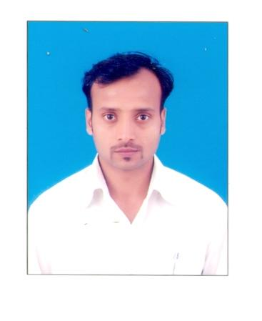
RESUME

PAWAN KUMAR
Address :-
BARIGORA (JANTA ROAD)
P.O:- RAHARGORA, JSR
JHARKHAND-831016
Mob. - 09431951960, 07870396954
E-mail: pawan24373@gmail.com

Work Experience:

- M/S.MAN SINGH, JAMSHEDPUR
(Civil and Structural Contractors and General Order Suppliers, registered with LAFARGE
INDIA LTD. TATA MOTORS, TATA STEEL, TRF,TINPLATE & TATA BLUE SCOPE)

Worked as a Billing Accountant cum Computer Operator from August 2004 to July 2006.

Job Profile
- Making Challan
- Maintaining day-to-day transaction.
- Working in Tally 9.0
- Banking work
- Making Attendance of Labour

- ICICI BANK LTD. JAMSHEDPUR

Worked as a CPA Executive (Car Loan) from July 2006 to December 2007.

Job Profile
- File Login
- Making Dedupe
- Disbursement

- M/S.MAN SINGH & SONS, JAMSHEDPUR.
(Civil and Structural Contractors and General Order Suppliers, registered with LAFARGE
INDIA LTD. TATA MOTORS, TATA STEEL, TRF,TINPLATE & TATA BLUE SCOPE)

Worked as a Billing Accountant cum Computer Operator since January 2008 to Sep’2012

Job Profile
- Making Challan
- Maintaining day-to-day transaction.
- Working in Tally 9.0
- Banking work
- Making Attendance of Labour
- Making PF & ESI

- HIND AUTO PVT. LTD. ADITYAPUR, JSR
(Ancillary of TATA MOTORS)

Worked as an assistant accountant from October 2012 to June’15

Job Profile
- Challan preparation
- Checking of bill (Payables & Receivables)
- Vouching
- VAT Sheet preparation.
- Making all entries in Tally.
- All kind of banking work.
- Bank reconciliation

Educational Qualifications:

- I have passed B.Com. (A/Cs Honor’s) from RANCHI UNIVERSITY, RANCHI in the year of 2004 with 1st Class.
- I have passed the Intermediate Examination from B.I.E.Council Patna in the year of 2001.
- I have passed the Matriculation Examination from.B.S.E.B Patna in the year of 1998.

IT SKILLS:
- Operating System: - WINDOWS XP, VISTA.
- Ms-Office
- Internet
- Financial Package Tally ERP.9

Strengths: I am punctual & sincere
I am self confident & innovative

PERSONAL DETAILS

- FATHER’S NAME : MR. MUNSHI PRASAD
- DATE OF BIRTH : 20th April 1981
- SEX : Male
- MARITAL STATUS : Married
- NATIONALITY : Indian
- HOBBIES : Listening to music, Watching & playing Cricket.

DECLARATION

I do hereby deceleration that particular above mentioned true correct and complete to the best of my knowledge and believe.

Place: Jamshedpur (Pawan Kumar)

