Curriculum vitae

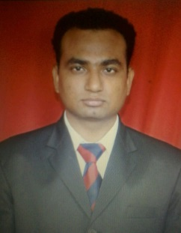 ABHILEKH DWIVEDI
68/26 N Gandhi nagar chitwa pur husainganj lko 226001
MOB -91-8081402655 9451854071 abhilekh.dwivedi@redifffmail.com
Professional Profile
Objective:
A position as an active employee, involving responsibility and working with others as a team member to achieve advancement and growth for the company.
Profile
- Experience in responsible Accounts Payable and Quality job.
- Achieve the giving targets.
- Maintaining the S.O.P which is set the company.
- Nice behaver with sir’s or juniors

Training Undertaken
6 months training from ITC Chola Hotel, Chennai. Learning includes-
- Observing the team handling by supervisor.
- To help the supervisor and assistant manager in serving customers.
- How to manage a party or event with effective manner.
- To solve the customers problem.
- Understanding the administration activities

Employment History
- I am working with T.G.I.F form lest Aug. (THANK GOD IT’S FRIEDAY).
- 4 year handling a newspaper’s publication.
- 6+ months working with Vishal Mega Mart.

Education
College & School
- 1years Post graduate diploma in hotel management from Amrapali institute of hotel management, year 2014-2015.
- Arts graduate from Kanpur University.
- Passed Senior Secondary from NIOS board
- Passed Secondary school from NIOS board.

Technical: Compatible with Ms-Office and basic computer knowledge

Awards

- Won Bronze award by Vichar Suchak for taking extra responsibilities and efforts..
- Submitted three lean Ideas for process Improvement.

Personal Details

Date of Birth 14 April 1989
Mother's name Smt. Sarla Dwivedi
Father's name Mr. Vinay Kumar Dwivedi
Permanent Address 565 KA/53 Amrudhibagh Sringar Nagar,
Alambagh, Lucknow-226005,

Date:

Place: Sincerely Yours’s,
Abhilekh Kumar Dwivedi

