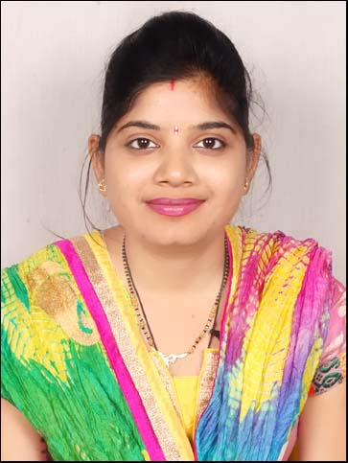
MRS. RUPANJALI GUPTA
C/o Sahajram Sherawat ,
Sector 17,Gurgaon
Pin. No.122001
Email id: guptarupanjali@gmail.com
Mob. No. +91-8588899464

CAREER OBJECTIVE:
My aim is to work innovatively for the enhancement and betterment of education. I aspire to work for an institution which offers career growth and chances to learn and improve my knowledge.

ACADEMIC DETAILS:

B.E. | Vedica Institute Of Technology, Bhopal | R.G.P.V. | 2013 | 69.40
HSSC | T.R. Gandhi Public School,Morena | M.P. Board | 2008 | 64.60
HSC | Govt. Excellent H.S. School, Morena | M.P. Board | 2006 | 71.56

Examination | College/School | University/Board | Year of passing | Percentage  (%)

EXPERIENCE:

1.Working as the Life Skill Trainer with Bridge Point Skills & Network
- Involved in developing curriculum on Life Skills & Interpersonal Skills and inculcate it in Schools Pan India.
- Imparting Training to Corporate, College & School Students on life Skills, Interpersonal Skills & prepare them for the professional world
- Organize workshops for Teachers.

2. Worked as a PRT & Counselor in ‘‘Neiil World School’’ ,Morena M.P.
3. Worked as a counselor in “Academic Heights Public School”, Morena, M.P.

SKILLS:

- Good interpersonal skills
- Develop amiable relations
- Liaison / Coordination, Strategy Planning,
- Flexible team player,
- Good listening skills

TECHNICAL SKILLS:
Languages | C, C++, Dot Net
Software/Packages | MS Office, Paint, Packet tracer, Net beans
Operating Systems | Windows 98/2000/XP/07
Technical Subjects | Computer networks , oops

EXTRA CURRICULAR ACTIVITIES:

- Attended 9 days training on “Words Worth” at Neiil World School.
- Member in organizing committee of “Neiil World School” to organize annual festival.
- Participated in Dance & Ramp walk at ‘SAMAGAM’,VIT,Bhopal
- Member of Anti-ragging committee in VIT, Bhopal.
- Member in organizing committee of ‘SAMAGAM’.
• Event organizer in school and college level functions and other technical events

OTHER ACHIEVEMENTS:
- Won 1st prize in Mehandi and Rangoli.
- Won on the spot award for best dressing on Teacher’s day.
- Won prizes in various Dance competition at school and college level.

HOBBIES:

- Cooking
- Writing diary
- Dancing
- Playing Chess

PERSONAL INFORMATION:
Name : Rupanjali Gupta
Date of Birth : 25^{th,} july,1991
Husband’s Name : Mr. Ankush Gupta (Software Engineer)
Gender : Female
Marital Status : Married
Nationality : Indian
Languages Known : English, Hindi

DECLARATION:

I hereby declare that all the information mentioned here are true and best of my knowledge.

Place: RUPANJALI GUPTA
Date:

