Curriculum Vitae
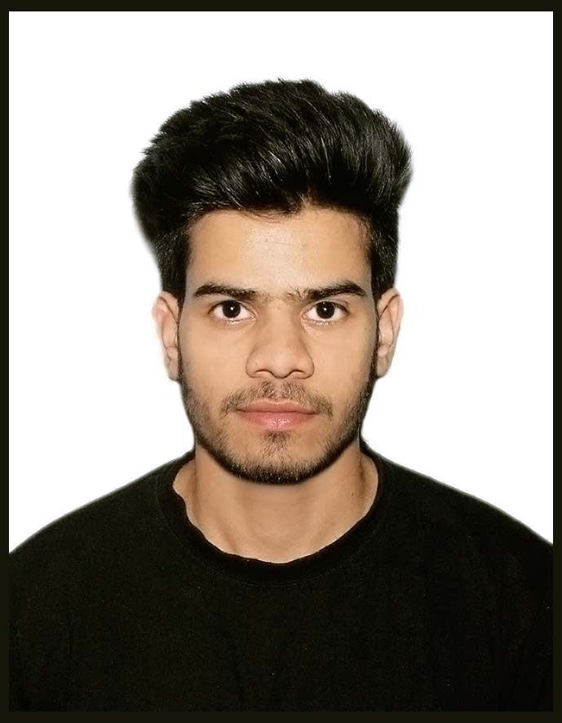

SAMEER NIZAMI
Email: nizamisameer@gmail.com
Mobile: +91-9873594306

CAREER OBJECTIVE:
To join a world renowned organization in the tourism sector to enhance my skills and reputation and also help to aid me with a bright future, with a focus on sales and client relations.
Work experience (Internship):

- Company Name : HotelBestDeals

Designation : Customer Service Executive

Job Profile:

- Front Line Customer Services, handle all telephonic and walking enquiries by providing information or directing requests to others who can supply the necessary information or service.
- Ensure that customer problems and complaints are handled professionally, effectively, maintained at a minimum level and resolved up to the highest level of customer satisfaction.
- Responsible for travel arrangements like train or air tickets, hotel booking and local transportation etc.
- Responsible for marketing and selling the special packages and hotel related products.
- Responsible for providing travel guidance and packages according to the customers requirement and budget.
- Provides clear information for each choice so that the clients can decide properly.
- Accounting report check reconciliation statement and other accounts voucher analysis.
- Update on Server & Create Client Database, Documents controller.

Key Skills

- Excellent administrative and management skills.
- Excellent geographical knowledge.
- Proficiency in computer skills like ms word, excel and internet etc.
- The ability to work under stressful conditions and meet deadlines.
- The ability to work in a team environment.

Educational Qualification
1. High school : Greenwood.Sr.Sec (CBSE), Rampur (UP) (2011)
2. Intermediate : Greenwood.Sr.Sec (CBSE), Rampur (UP) (2013)
3. B.A (Tourism Administration) : Amity University, New Delhi (2013 - 2016)

Personal Details:
Father's name : Meraj Ahmed Nizami
Date of Birth : 14/07/1995
Nationality : Indian
Languages : English, Urdu, Hindi and Spanish

