Saranjit Singh
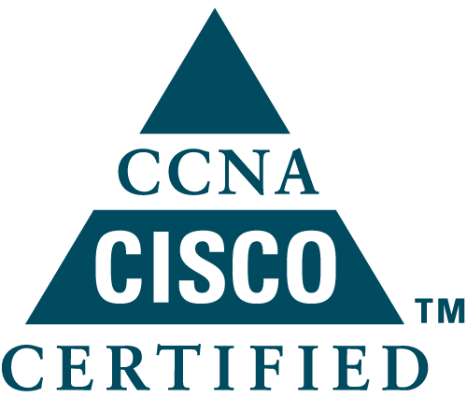U 10/36 DLF phase 3 , Gurgaon-122002 , Phone: 09654789990
E-mail: Singhsaranjit70@gmail.com

OBJECTIVE:

Intend to build a career with leading corporate of hi-tech environment with committed & dedicated people, and consequently enhance my knowledge and skills. Willing to work as a key player in challenging & creative environment.

Technical Skills:

Data :
- Troubleshoot LAN and WAN networks
- Technologies: Frame Relay, ISDN, ATM , Metro-Ethernet.
- Protocols: RIP v1 & v2, IGRP, EIGRP, OSPF, HSRP, BGP,VTP ,STP,VRRP, LDP.
- Managing and troubleshooting VLANS & IP address Scheme.
- MPLS-VPN, Inter-AS, Carrier Supporting Carrier.
- Managing CISCO 1600, 2500, 2600, 2800 series routers.
- Operating Systems: Win XP/2000 Professional, MAC OS.

VOIP :
- Call Agent : Cisco Unified Communication Manager (7.x, 8.x, 9.x, 10.x,11.X)
- Monitoring : Real Time Monitoring Tool (RTMT)
- Gateways : SIP, H323, MGCP
- Collaboration Apps : Jabber, Web Ex.
- Protocols : H.323, MCGP, SIP, SCCP.
- Ticketing Tools : BMC Remedy, EM7, Casemon, Webmon
- Other Tools : Putty, Secure CRT, Wire Shark
- Integration of Unity ,CER with call manager.
- Basic Integration of UCCX.

CAREER PROFILE:

Current Company : Aricent Technologies, (Gurgaon)
Designation : Network Engineer (Voip)
Duration : Since 05-March-2015

Roles & Responsibilities:

- Working as Network Engineer for Cisco-TAC
- Provide support and troubleshooting on CUCM 8.x, 9.x and 10.x Call Manager.
- Real-time troubleshooting on various features such as Call Routing (Route Pattern, Translation Pattern, CSS), IP phones and its features, Media Resources (MOH, conference bridges, MTP, Annunciator), licenses, upgrades, backup.
- Real-time troubleshooting on Cisco Gateways (H.323, MGCP and SIP).
- Troubleshooting complex issues through call manager traces and logs
- Providing support and troubleshooting over email and call on severity cases.
- Basic troubleshooting on Cisco unity connection.

Company :Orange Business Services, Gurgaon.
Designation: Technical Support Engineer.
04th July 2012 – 01 Dec 2014

Orange Business Services, Europe’s Largest Telecom Giant in Global network service providing, having world's largest data network in terms of geographic coverage, spanning 166 countries using Nortel and Cisco technology provides effective and secure business communications. It is reckoned as Global Communication Service Provider and is appreciated among biggest corporate of the world for providing end-to-end solutions.

The Key responsibilities were:

- Troubleshooting and debugging of Networks (LAN & WAN) comprising ATM, FR and Metro Ethernet Leased Lines, ISDN, (Backup and primary circuits) terminating on NORTEL PASSPORT.
- Hands on Cisco routers and Nortel passports.
- Resolving issues like link down, high RTD, packet drops, low reliability and error issue etc.
- Case management utilizing the global CRM tool ‘Clarify’; including real time case updates in-line with global case handling procedures.
- Completely responsible for troubleshooting network issues for the high value customer on Layer1,2 & 3 level.
- Coordinating the field engineer’s activities with respect to customer site visits for hardware interventions include modem replacement, serial card/port/slot replacement.
- Using Utilization Monitoring tools and NMS like Link Load, Exceed, Glink etc.

Coordinating with cross-functional departments, vendors, Associate Partners and International Carriers like Telstra, BT, AT&T, VERIZON and Colt etc. & follow the escalation matrix.

Achieving our Key focus area i.e. Customer Delight by maintaining good relations with Higher Management of customer.
- Maintaining the Team KPI’s as per the target set for the team

Training Attended

- Trainings on Team Building, Personal Effectiveness, Problem Solving & Decision Making, Service Excellence, Outbound Learning with Company Training Program.
- Training attended for Ticket Management Tools-Clarify.
- Training on Nortel passports overview, troubleshooting and configuration.
- Frame Relay, ATM, Metro Ethernet, ISDN and DSL .
- CCNA, CCNP , CCNA (Voice )

PROFESSIONAL/ACADEMIC QUALIFICATION:

Cisco Certified Network Professional(CCNP).
- Cisco certified Network Associate (CCNA)
- B.Tech from Haryana Engineering College, Kurukshetra University ( Aggregate 70% )
- 12th from St. Thomas School , ISC Board ( 82 % )
- 10th from St. Thomas School , ICSE Board ( 87% )

PERSONAL INFORMATION:

Interests:
- Reading
- Playing Chess
- Playing Volley-Ball, Cricket.
- Swimming.

Strengths :
- Quick learner
- Ambitious
- Self-Motivated
- Good Communication Skills.
- Open to learn new technologies.

Personal Info:
Father's Name : Mr. Onkar Singh
Permanent Address : #C-4, 1807 Civil Lines , Jagadhri , Haryana ( 135003 )
Phone : 09654789990
Date of Birth : 1st Oct 1989

I hereby declare the information furnished above is true to the best of my knowledge and belief.

Saranjit Singh

